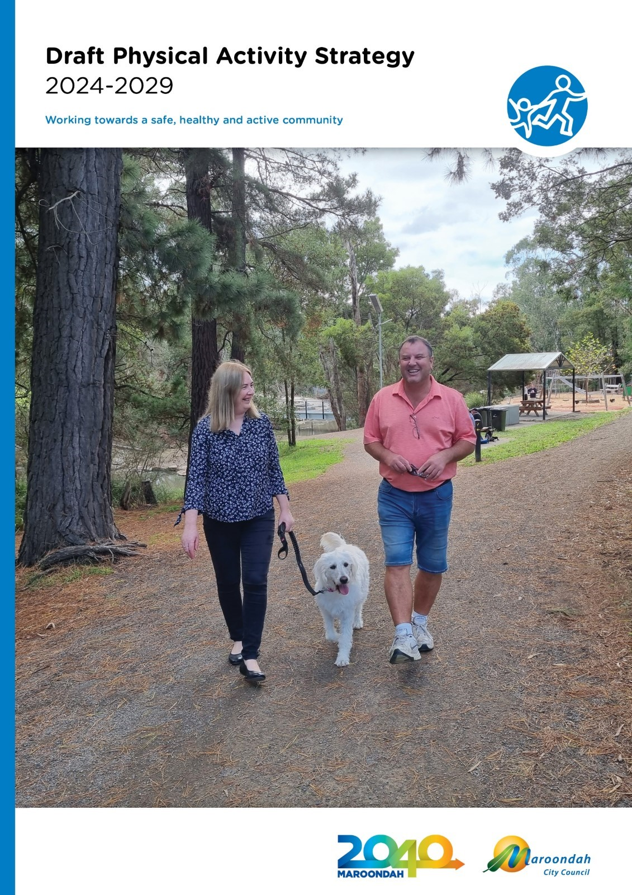

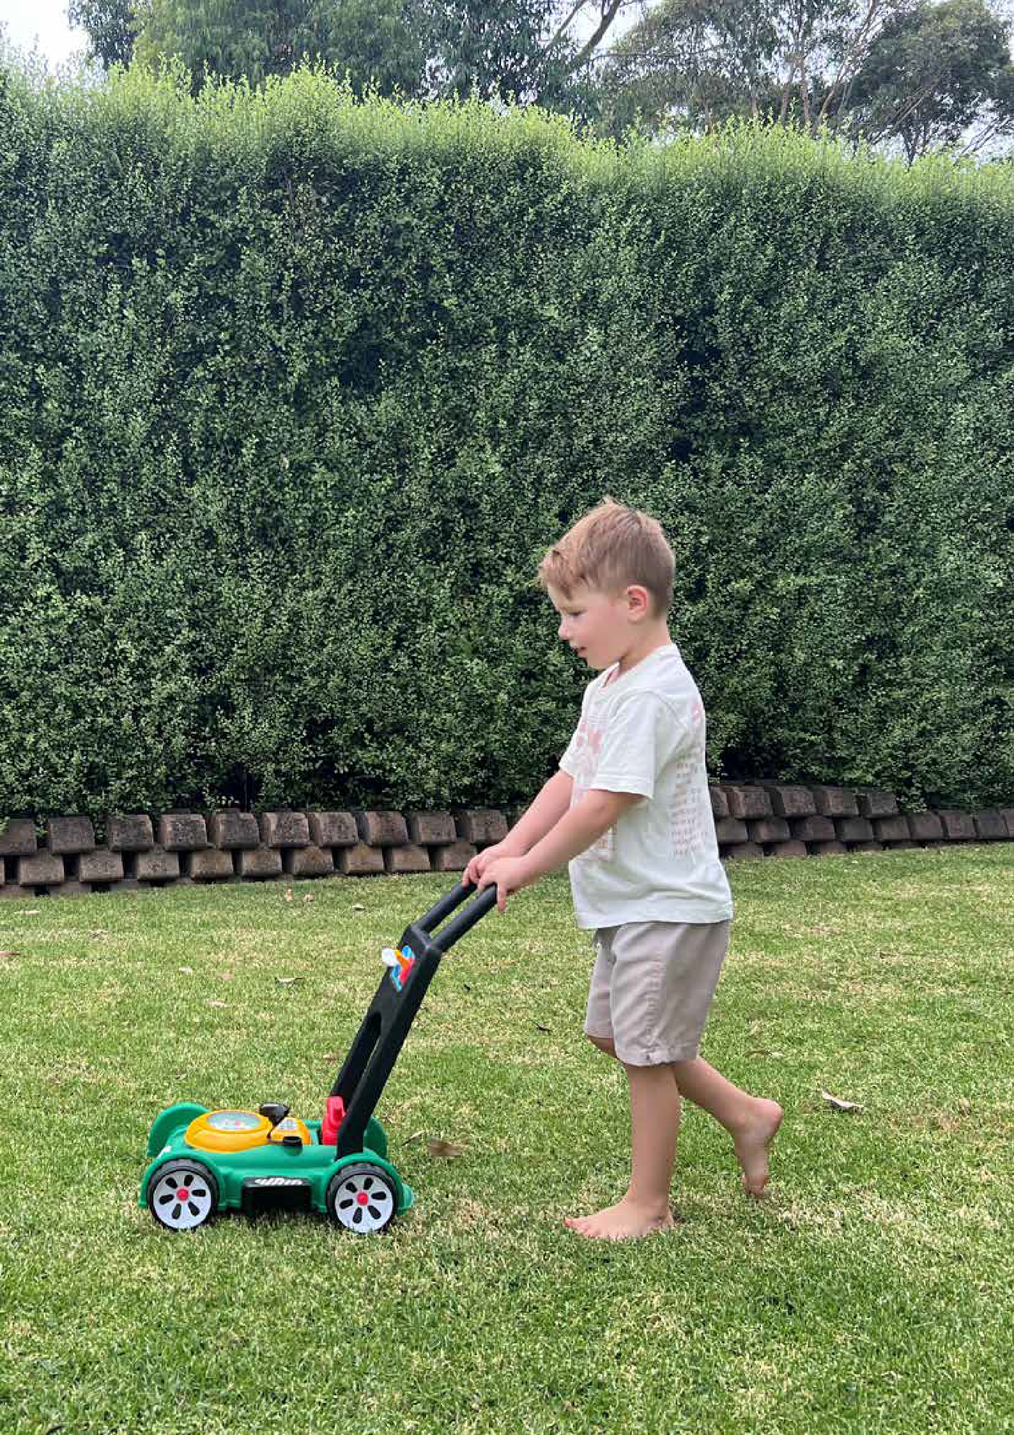

Working towards a safe, healthy and active community

Contents
Executive summary 4
Why is increasing physical activity levels important? 6
Notable achievements of the
Physical Activity Strategy 2015-2020 7
Strategic context 8
Maroondah – a snapshot of active opportunities 10
State and federal priorities 12
How much is enough activity? 14
What has changed since the 2015 Strategy? 16
What has not changed since 2015? 18
Community engagement summary 20
How active are we? 22
What motivates us to be active? 24
Challenges affecting physical activity levels 26
A strategy for a more active future 34
Increasing active travel 36
Spaces and places that encourage physical activity 40
Supporting diversity in sport 42
Connecting with our least active residents 46
Tracking our progress 48
Glossary and references 48

Acknowledgment of Country
We, in the spirit of Reconciliation, acknowledge the Wurundjeri People of the Kulin Nation as Traditional Custodians of the land now known as the City of Maroondah, where Indigenous Australians have performed age old ceremonies. We acknowledge and respect their unique ability to care for Country and their deep spiritual connection to it. We pay our respects to their Elders, past, present and emerging.

Executive summary

The majority of Maroondah residents do not undertake enough physical activity.

Based on the latest available Australian Bureau of Statistics data, 35 per cent of adults aged 18 to 64 are insufficiently physically active. More women (39 per cent) than men (32 per cent) did not do the recommended amount of physical activity (ABS 2022b). Increasing the level of physical activity in the Maroondah community is likely to have a major impact on public health and therefore Council will prioritise the development and/or improvement of environments to support physical activity and active lifestyles.
The Physical Activity Strategy 2024-2029 builds on the recommendations of Maroondah’s Maroondah Liveability Wellbeing and Resilience Strategy and input from the Maroondah 2050 community vision, setting actions for the next five years to address levels of inactivity.
A perceived lack of time is reported as a primary reason Maroondah residents do not undertake enough regular physical activity. This reasoning indicates the need to ensure that there is an extensive range of accessible spaces, places and opportunities to make it easier to move, more often. Furthermore, information and education are

essential to reframing the message that achieving the daily 30 minutes can be incremental movement and may be of greater health benefit, regardless of intensity, when used to break up long periods of inactivity. The top five activities undertaken by Maroondah residents were reported as walking, fitness class/gym, running/jogging, cycling and yoga/pilates, acknowledging the preference for physical activity pursuits that are non-competitive, informal or unstructured, and/or can be undertaken in one’s own time.
There are different factors that affect the physical activity levels of specific populations and therefore different strategies are required to overcome these. The Physical Activity Strategy 2024-2029 highlights the challenges and opportunities being experienced by the general community and identifies seven low participatory cohorts to target, with actions that will have a positive impact on participation. To address the highlighted challenges, and make physical activity an easier option, the strategy focuses on four key outcome areas which highlight opportunities for Council action.

Key outcome areas

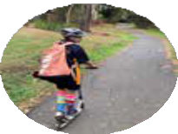
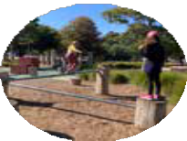
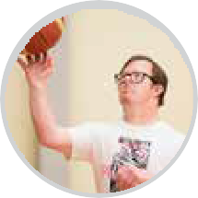
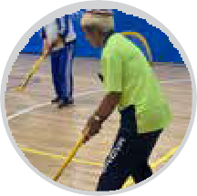

Increasing Active Travel
Encourage and support walking, cycling and use of public transport

Spaces and places that encourage physical activity
Create vibrant, active public open
spaces, where people feel safe, welcomed and motivated

Supporting Diversity in Sport
Support inclusive sporting settings to achieve participation that reflects our increasingly diverse community.

Connecting with our least active residents
Design and promotion of accessible opportunities, infrastructure and positive messaging

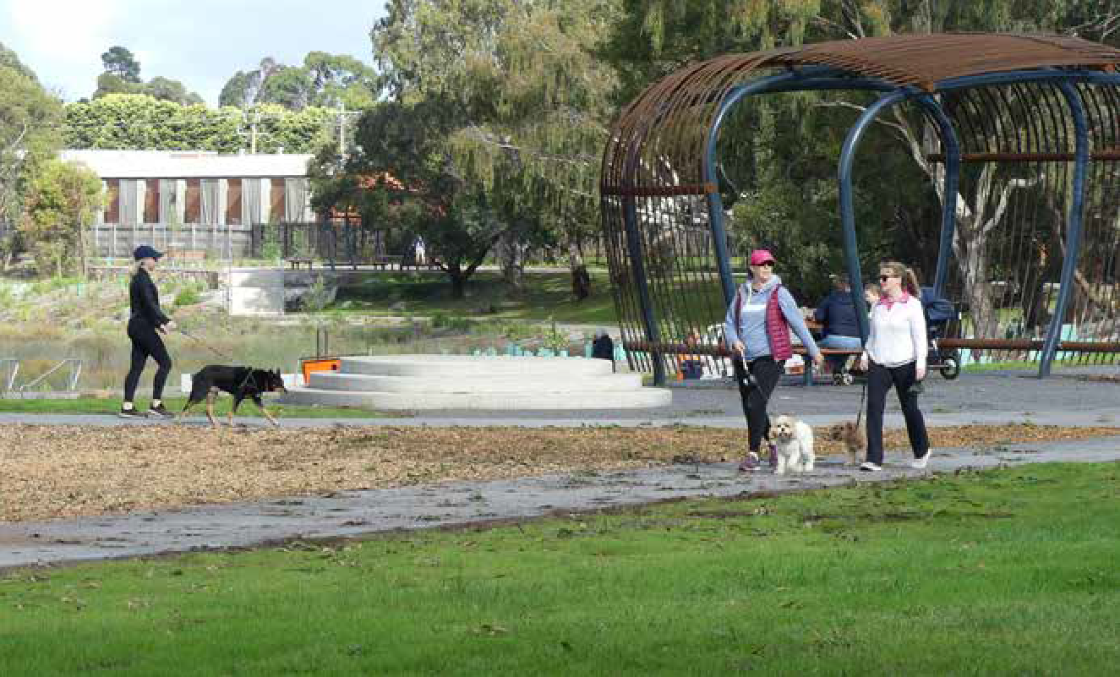

Tarralla Creek

Consultation
In preparation for the development of Council’s Physical Activity Strategy, a range of consultation methods were undertaken to establish a clear picture of Maroondah’s current participation levels, reasons for non-participation and community needs. There was also a wide range of recent data and extensive community feedback obtained for the Maroondah Liveability Wellbeing and Resilience Strategy and in preparation for the Maroondah Play and Gathering Places Strategy and the Maroondah 2050 visioning project.

Action
In order to address levels of inactivity, Council must consider the barriers and opportunities outlined in this strategy and undertake measurable actions over the next 5 years.
The key directions and priority actions will guide the development of new policies, infrastructure improvements, programs and collaborative initiatives which will improve practices, respond to demonstrated need, increase access and encourage residents to prioritise physical activity in their daily routine.
Priority actions will be led by a range of Council service areas. The implementation will be the responsibility of each lead area with support from relevant service areas detailed in the plan.
Reporting will be undertaken annually under the facilitation of Council’s Sport and Recreation Team.

Why is increasing physical activity levels important?
Physical activity is important at any age for good physical and mental health and wellbeing. All forms of physical activity can provide health benefits if undertaken regularly. Physical inactivity and sedentary behaviours are a risk factor for a variety of mental illnesses including depression, anxiety, and age-related cognitive decline.
Research has highlighted that any increased movement is beneficial and that incorporating greater movement throughout the day, which breaks up periods
of sitting, may in fact be more valuable than extended periods of sitting followed
by a large block of moderate to intensive activity.
As well as the health gains by regular movement in preventing chronic disease and promoting mental wellbeing, other benefits include making social connections, increasing productivity, and positive changes to the environments, such as reduced traffic congestion and safer neighbourhoods1.
Active living is incorporating regular physical activity into daily routine. It includes active travel, play, gardening, incidental exercise as well as participating in sport or an active pursuit for pleasure and fitness. Prioritising physical activity as

an individual, an organisation and as a community has multiple benefits to overall health, social, economic and environmental benefits.
Increasing the level of physical activity in the Maroondah community is likely to have a major impact on public health and therefore Council will prioritise the provision of supportive environments for physical activity to assist residents to adopt an active living lifestyle.
Maroondah residents self-report that the key reason that their level of regular physical activity is impeded, is ‘lack of time’.2 This reasoning indicates the need to shift the mindset in those that are least active to view increasing activity levels as moving more often, even if in small increments.
Council must continue to provide and enhance environments for physical activity in public open space and recognise that while sport and organised recreation is a key component, informal recreation and incidental exercise is of primary importance to increasing overall activity levels as only 17.39 per cent of Maroondah residents engage in organised sport3. Council should support the provision of a range of accessible opportunities to make moving more often, easier to achieve.
Furthermore, accessible information and education are essential to ensure that residents understand what options are available and to support inclusion within these environments.

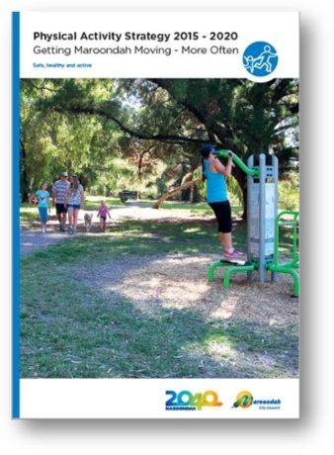
Background
The Physical Activity Strategy 2015-2020 has been of great benefit for Council, both in terms of a strong rationale for investment in sports and recreation infrastructure and for creating greater opportunities for physical activity. The strategy has been an integral component to the success of many State and Federal grant submissions
providing evidence to support requests for investment in sport and recreation.
Within the 5 year timeframe of the strategy, all three levels of government have placed greater importance on supporting increased physical activity levels for social, physical and mental benefit. There has been a significant increase in policy and financial investment to support new initiatives which has been prompted by the greater awareness of the impacts of physical activity on health and wellbeing and the relationship between women and girls’ inclusion in traditionally male dominated sport as a primary intervention in the prevention of violence against women.

Notable achievements of the Physical Activity Strategy 2015–2020
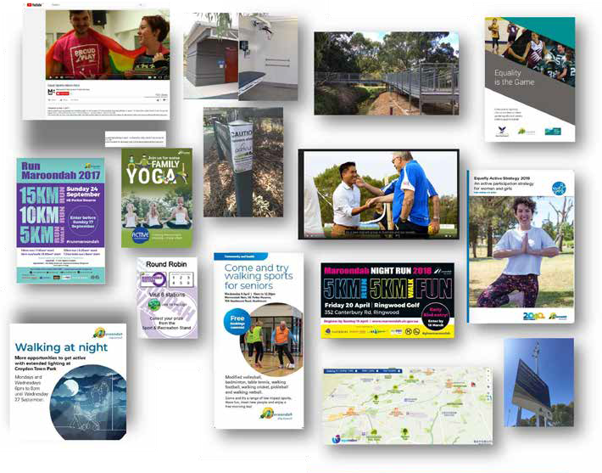
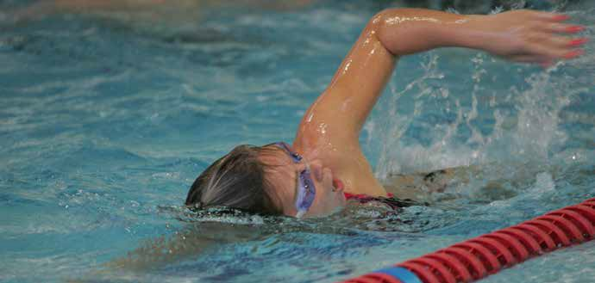
Online interactive map
Inclusive initiatives
Community partnerships
Changing places amenities

Strategic context

To fully understand the context for the strategy as it relates to Maroondah City Council, the document must highlight the relevant links between current Council policies and the provision of planning, design, infrastructure, programs and services and information that support active living.
Fundamental to the implementation of Council’s roles and responsibilities, is Maroondah’s Integrated Planning Framework. The framework sets out the relationship and priority order of Council’s strategic documents that will guide the development and implementation of the Physical Activity Strategy. The primary documents include:








Council Plan 2021-2025

Liveability Wellbeing and Resilience Strategy 2021-2031
Other related Council strategic documents
- Arts and Cultural Development

Associated social policies
- Affordable and Social Housing Policy
- Gambling Policy
- Gender Equity Policy
Associated action plans
- Positive Ageing Framework
- Disability Action Plan
- Gender Equality Action Plan
- Health and Wellbeing Action Plan
- Reconciliation Plan
Strategy
- Asset Plan
- Climate Change Risk Adaption and Mitigation Strategy
- Children and Families Strategy
- COVID Recovery Plan
- Croydon Structure Plan
- Equally Active Strategy
- Habitat Corridors Strategy
- Heathmont Structure Plan
- Housing Strategy

Associated Council advisory committees
- Maroondah Access, Equity and Inclusion Advisory Committee
- Maroondah Disability Advisory Committee
- Maroondah Health and Wellbeing Advisory Committee
- Maroondah Liveability, Safety and Amenity Advisory Committee
- Municipal Emergency Management Plan
- Ringwood MAC Masterplan
- Ringwood East Structure Plan
- Road Management Plan
- Open Space Strategy
- Physical Activity Strategy
- Sustainability Strategy
- Vegetation Strategy
- Youth Strategy

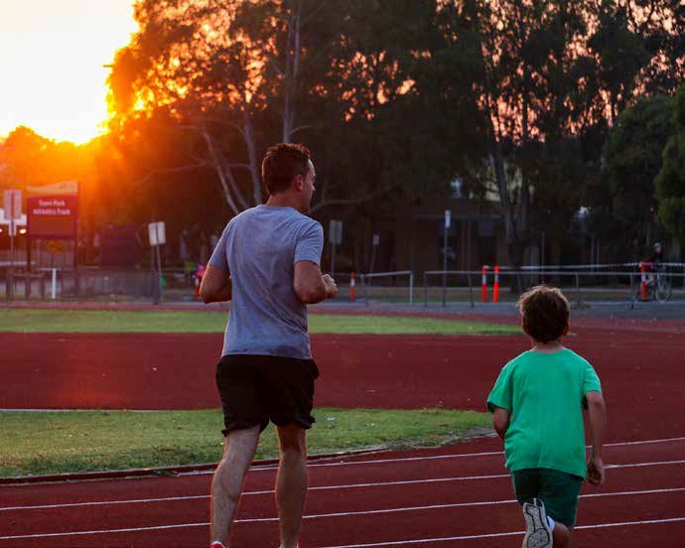

A number of other relevant Council plans and strategies were referenced in the development of this document and are linked below for reference:
- Maroondah Disability Action Plan 2022-2026 | Maroondah City Council
- Children and Families Strategy | Maroondah City Council
- Positive Ageing Framework and Action Plan 2021–2025 | Maroondah City Council
- Melbourne East Regional Sport and Recreation Strategy | Maroondah City Council
- Open Space Strategy | Maroondah City Council
- Youth Strategy | Maroondah City Council
- Equally Active Strategy | Maroondah City Council
- Maroondah Extreme Sports Strategy | Maroondah City Council

The strategy must ensure that the recommended future direction correlates and complements these linking documents and above all reflect Maroondah’s community vision, Maroondah 2040. (New 2050 Vision under development)
From the Maroondah 2040 community vision engagement process, eight preferred future outcomes here identified as community priorities looking ahead to the year 2040 and beyond. These future outcomes will drive the 2040 vision. The most relevant future outcome to this strategy is:
A safe, healthy and active community
In 2040, Maroondah will be a safe, healthy and active community with local opportunities provided
for people of all ages and abilities to have high levels of social, emotional and physical wellbeing.

9

Maroondah – A snapshot of active opportunities

Maroondah is located in Melbourne’s eastern suburbs, approximately 25km from Melbourne CBD with a population forecast of 155,043.4

Maroondah is home to approximately 135 active recreation organisations and 140 sporting clubs. There are 430 designated reserves including 61 sporting ovals; 121 playgrounds; 34km of walking tracks and shared pathways; three bowling clubs; three community gardens; three skate areas, two athletics tracks, a croquet club; 84 tennis courts and six multiuse indoor halls. Maroondah City Council owns and manages two golf courses, Ringwood Golf and Dorset Golf; a multiuse stadium, The Rings; an outdoor 50 metre pool, Croydon Memorial Pool; a combined aquatic and fitness centre, Aquahub a Regional diving, fitness and aquatic facility, Aquanation, an indoor/outdoor multisport complex, Maroondah Nets and a new Regional indoor cricket training centre, Maroondah Edge.

Maroondah is also home to five Neighbourhood Houses and boasts a comprehensive listing of community organisations offering varied physically active opportunities for differing interests, ages and abilities. Maroondah has a significant number of active organisations for retirees and in recent years has seen an increase in churches offering a range of social and leisure programs to extend their reach within the community. Schools play a large role in offering physical activity opportunities to children and young people through school curriculum, interschool sports and out of school hours programming. Maroondah also has a range of private recreation providers offering health and fitness programs, organised sports and other physically active pursuits.

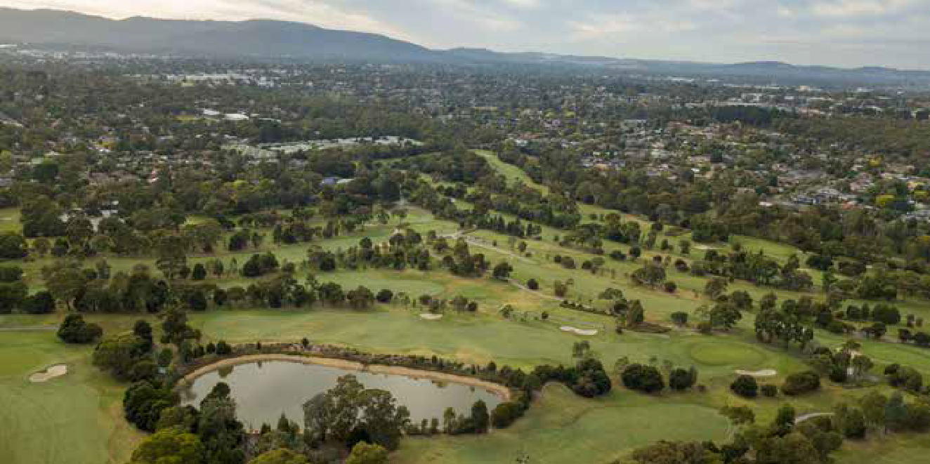
Dorset Golf

Council’s role in influencing physical activity levels
Council plays an integral role in the provision and facilitation of physical activity opportunities through both the provision of services and infrastructure and the strategic planning and development of environments that support active living.
There are eight Council service areas that have been identified as having a direct impact on Maroondah community’s ability to participate in physical activity. The internal key stakeholders and their role in relation to impacting physical activity levels are as follows:

Leisure and Major Facilities

The Rings, Maroondah Nets, Maroondah Edge, Aquahub, Aquanation, Croydon Memorial Pool, Ringwood Golf, Dorset Golf, Sportsfield management and Maintenance
Direct provision of fitness and lifestyle programs and management of spaces

Maroondah Sport and Recreation
Planning and provision of programs and events. Provision of funding, training and other support for community providers.

Projects and Asset Management

Asset Planning, Asset Management, Building Projects, Building Maintenance
Management of Council’s community assets, to facilitate safety, longevity, and continued provision of services for the community. Advice and management of Capital Works Projects and strategic planning relating to the ongoing lifecycle management of Council assets.

Communications and Citizen Experience
Assist in the promotion of infrastructure, programs and events and targeted health promotion campaign and support the engagement of residents in infrastructure planning and strategy design.

Community Services

Aged and Disability Services, Youth and Children’s Services, Maternal and Child Health
Provision of targeted support and initiatives; facilitation of health promotion initiatives and community partnerships to enhance the wellbeing of Maroondah residents aged 0 to 11 years, 12 to 25 years, 65+ years and persons with a disability.

City Futures

Strategic Planning and Sustainability, Community Wellbeing
Manage the Maroondah Planning Scheme that supports and encourages active living through urban design, landscapes, buildings and land uses.
Oversee the planning and advocacy for an integrated public and active transport network and the delivery of initiatives that encourage the utilisation of active transport.
Undertake Health and Wellbeing planning, advocacy and support for marginalised and disadvantaged communities, and strengthening and building the capacity of the community.

Engineering and Building Services

Engineering Services, Building Services
Provision of engineering technical expertise in areas of traffic and transportation planning, engineering development approvals, and project management for the development and/or enhancement of assets such as roads, footpaths, bicycle paths, and buildings.

Operations

Bushland Management, Built Environment, Tree Maintenance, Parks and Open Space
Responsible for the ongoing audits and maintenance of playgrounds, parks and bushland reserves as well as the footpath and trail network.

Community Safety

Community Health, Local Laws
Facilitate health promotion initiatives for residents and food premises.
Management of dog parks. Promote responsible pet ownership – dogs on leash, encourage regular dog walking.

State and Federal priorities

Federal Government – Sports 2030 – National Sports Plan
In June 2011 the Federal Government developed the National Sport and Active Recreation Framework which guided the development of policy and resource allocation across the sport and active recreation sector until 2021. This plan has since been replaced by the Sports 2030 – National Sports Plan which guides the Federal Government’s vision to ensure Australia as “the world’s most active and healthy nation, known for our integrity and sporting success”.
Sport 2030 has four key priority areas which
are sport-focussed, however priority one addresses increasing the physical activity levels of all Australians:
- Build a more active Australia –
More Australians, more active, more often;
- Achieving sporting excellence – National pride, inspiration through international sporting success;
- Safeguarding the integrity of sport – A fair, safe and strong sport sector free from corruption;
- Strengthening Australia’s sport industry – A thriving Australian sport and recreation industry.

State Government – Active Victoria 2022-2026
The Victorian Government strategic framework for sport and active recreation in Victoria outlines three objectives and 6 outcomes to guide activities and investment in sport and active recreation.
Connecting communities
Sustained participation  More Victorians participate equitably in sport and active recreation | Infrastructure  Victoria has inclusive, accessible, and respectful places for sport and active recreation
Building value
Sector capability  The sport and active recreation workforce is highly skilled and leads a strong, sustainable industry | Good governance  Sport and active recreation is a safe, inclusive, and resilient sector
Enduring legacy
High performance  Victorians can achieve success at the highest level | Events  Victoria maintains a strong pipeline of sporting events within the Victorian events calendar

As part of the Plan, the Australian Government has committed to reducing inactivity amongst Australians by 15 per cent by 2030.

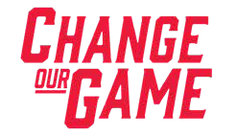
The office for Women in Sport and Recreation Change our Game initiative
In 2015, the Victorian Government released a report from the independent Inquiry into Women and Girls in Sport and Active Recreation. The report highlighted the degree of gender inequality in Victorian sports and recreation and outlined nine key recommendations to help change and improve sport and recreation for all involved.
The overwhelming finding was that women are under-represented in leadership roles in the sport and active recreation sector. As a mechanism to implement the report recommendations, the Office for Women in Sport and Recreation was formed.
The Office has been instrumental in leading initiatives to increase the number of women and girls participating in sport and active recreation.

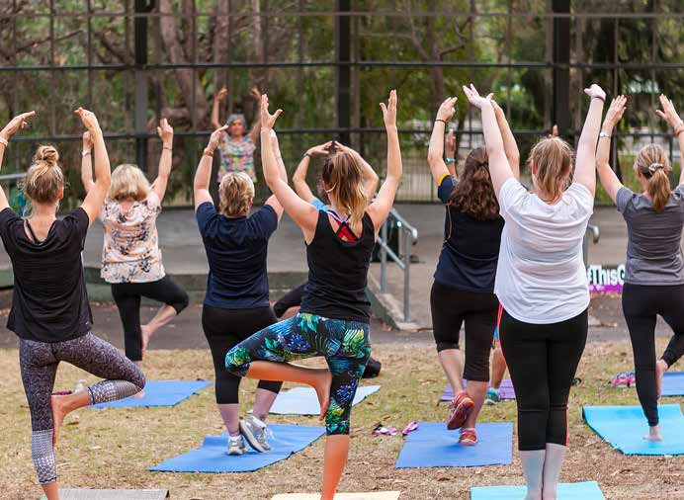

How much is enough activity?

It is widely accepted that regular physical activity is essential in improving health and wellbeing, but how much physical activity is enough to maintain a healthy lifestyle?

The Australian Government Department of Health and Ageing have developed an evidence based set of National Physical Activity Guidelines for children, adults and older Australians. The most recent update, released in 2014, added Sedentary Behaviour (sitting time) to the guidelines as well as muscle strengthening activities.

The intensity of the physical activity should represent a noticeable increase in a person’s breathing and heart rate. Moderate intensity physical activities include a brisk walk, golf, mowing the lawn or swimming. Vigorous intensity physical activities include jogging, aerobics, fast cycling, soccer or netball.

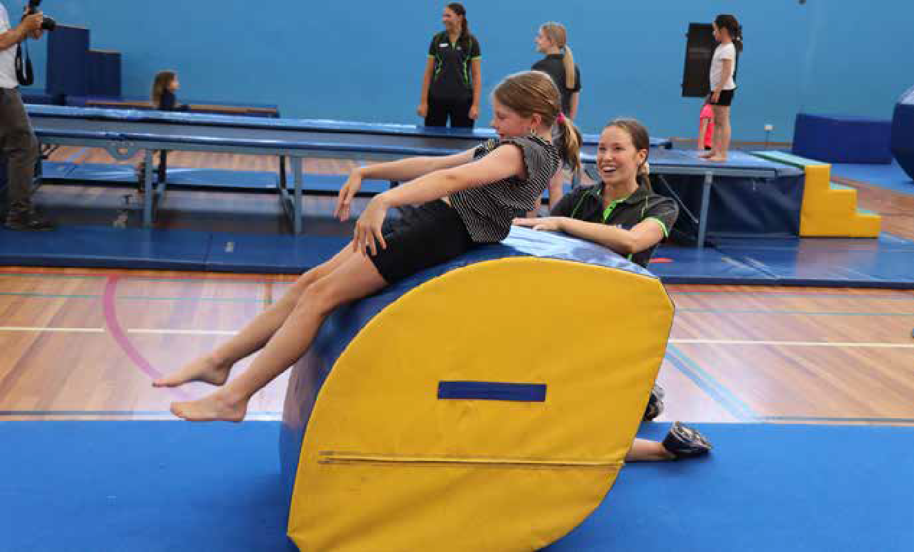

National Physical Activity and Sedentary Behaviour Guidelines5

0 to 5 years | - Babies should take part in physical activity from birth, particularly supervised floor-based play in safe environments.  - Toddlers and pre-schoolers should be physically active every day for at least three hours, spread throughout the day.  - Children three to five years should be active for at least three hours per day including  one hour of energetic play. Limit time sitting or lying except when sleeping.  - Less than two years – no screen time.  - Two to five years limit to less than one hour screen time per day.
5 to 17 years | - Children and young people aged five to 17 years should take part in a combination of moderate and vigorous activities for at least 60 minutes a day.  - Engage in activities that strengthen their muscles and bones on at least three days per week.  - Limit use of electronic media for entertainment to no more than two hours a day.  - Break up long periods of sitting as often as possible.  - Children aged five to 13 years get nine to 11 hours of uninterrupted sleep.  - Young people aged 14 to 17 years get eight to 10 hours of uninterrupted sleep.
18 to 64 years | - Each week adults 18 to 64 years of age should do either:  - 2.5 to five hours of moderate intensity physical activity or  - 1.25 to 2.5 hours of vigorous intensity physical activity or  - a combination of both  - Muscle strengthening activities should also occur on at least two days each week.  - Minimise the amount of time spent in prolonged sitting.  - Break up long periods of sitting as often as possible.
65+ | - Older adults should accumulate at least 30 minutes of moderate intensity physical activity on most, preferably all, days of the week.  - Activities should include activities to improve balance, flexibility and strength to improve overall benefit.  - Minimise the amount of time spent in prolonged sitting.  - Break up long periods of sitting as often as possible.

What has changed since the 2015 strategy?

Improved access to Maroondah facilities
Council’s 2017 Sport Demand Analysis paper reported that 78 per cent of existing facilities at Council’s sporting grounds do not adequately cater for female participation. Since this time, Council has been highly successful in partnering with the State and Federal governments to support a $77,685,000 investment to improve sporting infrastructure access and amenities. Improvements have included female-friendly amenities and pavilion design, additional change facilities, and upgrades to sportsfield surfaces and lighting to increase capacity. These improvements have reduced the deficit figure from 78 per cent to 20 per cent, with planning underway to address the remaining five facilities that do not adequately cater for women and girls. Furthermore, all upgrades have been undertaken according to universal design principles ensuring all abilities access and unisex amenities to accommodate gender diversity.
Since 2015, Council has supported increased walking throughout Maroondah by investing in 53,434 metres of new footpaths; 20,297 metres of shared paths; and 191 new public street lights and reserve floodlighting improving access, safety and active transport options.

COVID-19 pandemic impacts
During the COVID-19 pandemic and in the months post, reports indicated an increase in walking and cycling in some groups, however, there was a definitive decrease in overall mobility, physical fitness and health and mental health. Restrictions, health fears and illness had adverse effects on activity, social engagement and income. Compared to pre-pandemic, fewer Australians are relying solely on sporting clubs or organised venues for exercise. Families reported a greater awareness of time-poor lifestyles and have since become more selective in extracurricular activities and voluntary roles. This has affected both participation and the number of volunteers within the sport and recreation sector, with research by the Australian Sports Commission reporting around 61 per cent of volunteers had resumed their usual volunteering roles.7

New Sports and new ways of delivery
The previous Physical Activity Strategy and Sports Demand Analysis highlighted a need to deliver sport differently to increase participation.
Limitations of infrastructure capacity, time and a seven day work week was impacting the traditional weekend sport format. Significant investment in sportsfield lighting has supported meeting this need, with traditionally weekend sports all introducing or expanding their night offerings in Maroondah. Council has also supported the introduction of sports since 2015. Walking formats of cricket, netball and soccer have all been successfully established as has Volleyall, all abilities volleyball, footsal and pickleball, which has seen a dramatic growth in its short time in Maroondah.
The recent Maroondah Tennis Strategy has also highlighted the success of ‘Book a Court’, casual tennis play and an opportunity to further expand social tennis in Maroondah venues.

Greater diversity
Maroondah is becoming a much more diverse population. Latest Census data reports that 29,094 people who were living in City of Maroondah in 2021 were born overseas, and
15 per cent arrived in Australia within five years prior to 2021. In 2021, The highest proportion of recent overseas arrivals were from China, followed by people from Myanmar who represented 16.2 per cent of new arrivals to Maroondah in comparison to the newly arrived figure for Greater Melbourne which is 1 per cent.6
Additionally, Maroondah has experienced an increase in the identification and recognition of gender diversity. This is evidenced by the large increase in demand for services to support gender diverse people and their families.

Decline in mental health
Mental health is a key component of overall health and wellbeing (WHO 2021)8. The proportion of Victorian adults who experienced high or very high levels of psychological distress increased from 18.1 per cent in 2019 to 23.4 per cent in 2020. This was significantly higher in the younger age groups – 35.0 per cent of adults aged 18 to 24 years and
27.8 per cent of adults aged 25 to 34 years.8
The National Study of Mental Health and Wellbeing conducted in 2021 found that an estimated one in five (21 per cent) Australians aged 16 to 85 experienced a mental disorder in the previous 12 months (ABS 2022a)9 This rise may well be attributed to the global pandemic, however in the absence of updated data, anecdotally these rates have not subsided post COVID-19.

Greater opportunities for women and girls
Data collated to inform the 2022 Melbourne East Regional Sports and Recreation Strategy highlighted that Maroondah has 38 per cent female sports participation across 16 key sports. Growth has been spurred on by the successful introduction and promotion of the AFLW and Football Victoria’s W League, WBBL and Australia’s success in the 2020 Women’s T20 Cricket World Cup, and 2023 Women’s Football World Cup.
In Maroondah, Women and girls’ AFL participation was 5 per cent in 2016 and has increased to 23 per cent in 2023. Additionally increased funding and support for the inclusion of netball as part of senior AFL clubs has led to the EFL rebranding to become the Eastern Football Netball League with 80 per cent of league clubs now fielding netball teams. Cricket Victoria has also seen female participation gains of 12.8 per cent in the year to 2022 and Football Victoria (soccer) has pledged a target of 50:50 gender split by 2027.

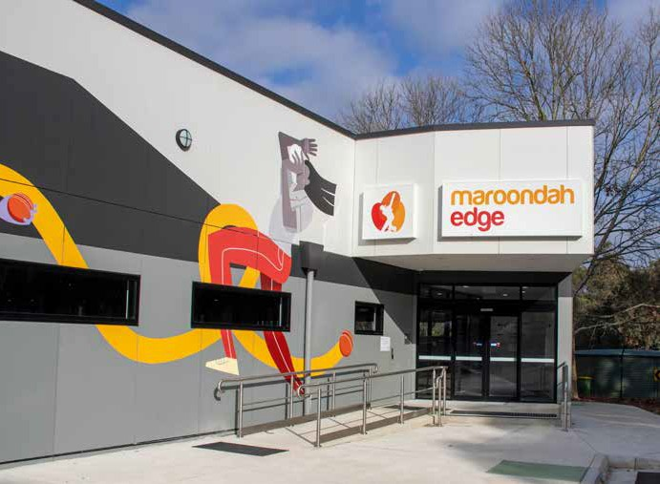

What has not changed since 2015?

Lower participation rates amongst marginalised groups
Research highlights that people from Culturally and Linguistically Diverse backgrounds; Aboriginal and Torres Strait Islander people; people with disabilities and their carers; and people who identify as LGBTQIA+ are often impeded by physical, systemic, environmental barriers and personal circumstance and may experience further disadvantage due to diversity within their diversity (Intersectionality).10 These barriers lead to fewer opportunities to access safe, affordable and appropriate programmes and places in which to be physically active.

The prevalence and impacts of devices
Prevalent device and screen use is continuing to foster sedentary behaviours. Studies have found that the average Australian adult spends 5.67 hours a day on their phone11 and an average of seven hours watching paid TV/movie streaming services per week.12
Most Australian children spend more time on screens than is recommended. Estimates from research suggest only 17 to 23 per cent of preschoolers and 15 per cent of five to 12 year olds meet screen-time guidelines.13 Guidelines state no screen time for children under two years, up to one hour – aged two to five years and no more than two hours of sedentary recreational screen time per day for children and young people aged five to 17 years (not including schoolwork).

Environmental impacts
The impacts of climate change are continuing to increase, placing pressure on infrastructure and escalating the need to utilise renewable resources. Pressure on open space is growing with increasing population and multi-storey dwellings.
Opportunities for new open space in Maroondah is continuing to diminish.
Additionally, there has been a marked rise in the instances of extreme weather events. Flash flooding, extreme wind and periods of extreme heat are impacting participation, infrastructure integrity and tree health within Maroondah’s open space.
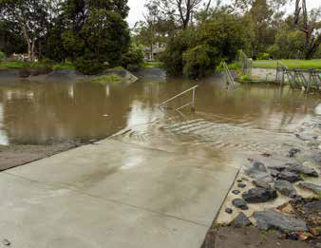

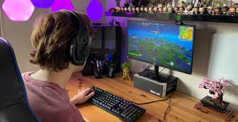

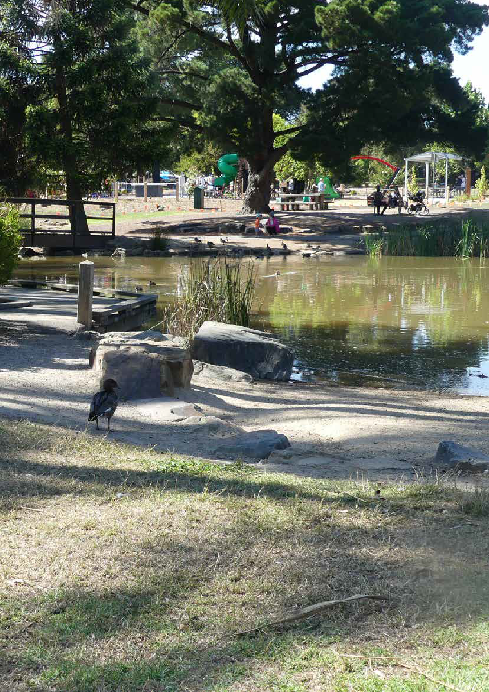

Community engagement summary

Methodology | Dates | Engagements
Walking Sports Expo participant survey | May 2022 and 2023 | 49 contributors
Maroondah Festival Café Consult activity | November 2022 | 589 contributors
Maroondah Sports Club online survey | January 2023 | 28 contributors
Australia Day Citizenship participants surveys | January 2023 | 34 CALD participants
Your Say platform via Council’s website | July/August 2023 | 149 contributors
Library pop ups  - Croydon  - Ringwood | July 2023 | 12 contributors  21 contributors
Council Community Advisory Groups  - MYWA  - Liveability  - Disability  - Inclusion | July/August 2023 | 10 contributors  12 contributors  6 contributors  16 contributors
Migrant Information Centre – Community Leaders Network | December 2023 | 10 contributors

Maroondah Liveability Wellbeing and Resilience Strategy 2021–2031

Community feedback
Engagement with the community, post the COVID-19 pandemic, has highlighted that our community values exercise, healthy eating, access to health services and good mental wellbeing. The community has an understanding that healthy lifestyles lead to improved wellbeing and reduced illness. Our community highlighted the relationship between physical and mental health and the opportunities to facilitate and support social connection.
Opportunities to connect with nature were highly valued and seen to provide benefits to mental wellbeing, physical health and social connection.

The community would also appreciate more affordable facilities, free outdoor recreation options as well as active and passive activities that promote health and wellbeing for all. Health and wellbeing facilities, spaces, services, programs and events provided by Council, and its partners, are highly regarded. It was highlighted that Council has an opportunity to further raise awareness of what is on offer within the Maroondah community to enhance resident health and wellbeing.14

Maroondah sporting clubs

The impacts of reduced volunteerism in sports will need to be regularly monitored. Ongoing communication and collaboration with leagues and peak sporting bodies will be required to ensure that sports continue to review the effectiveness of promotions, scheduling, and program design, to adapt to the diverse and changing needs of our community. Council will also continue to plan for the enhancement of the quality and accessibility of our community sports and recreation infrastructure.
In February 2023, in preparation for the update of Council’s Physical Activity Strategy, Maroondah sports clubs were given the opportunity to provide feedback to Council highlighting their current greatest challenges. Twenty-seven clubs representing a range of sports highlighted volunteer and committee recruitment and retention as a key challenge to local sporting clubs, as depicted below:

Retaining volunteers
Attracting volunteers
Financial viability

Retaining participants
Fundraising
Greatest challenges fixed by Maroondah clubs in 2023
Facility Standards
Regulations
Attracting participants
Recruiting/retaining committee members
Maintaining facilities

How active are we?

35%
of Australian adults were completely physically inactive (that is, undertook no days of physical activity in the past week (Census) – this was similar for both men (36%) and women (35%)

More than one in three –

35.7%
people aged 15 years and over undertook moderate exercise, while 17.7% engaged in vigorous exercise.

One in three –

32.5%
people 15 years and over reported completing strength or toning exercises and 46.0% reported walking for transport.13

Nearly half –

49.4%
of employed people aged 18 to 64 years described their day at work as mostly sitting.14

General physical activity
Based on the latest available data, it is estimated that 75 per cent of Australian adults aged 18–64 did not meet both the physical activity component and the muscle-strengthening component of the National Physical Activity Guidelines. This proportion was higher in women (78 per cent) than men (73 per cent) (ABS 2022b).15

Organised sport
2021 research highlights organised sport participation rates (across all ages) are higher for males (17 per cent) than females (9 per cent) in Victoria.16 These figures demonstrate a gender disparity in sport participation which requires further localised exploration and targeted initiatives to address contributing factors.

Children and Young People
The National Physical Activity Guidelines recommend that young people aged 15 to 17 years complete at least 60 minutes of moderate to vigorous intensity physical activity every day. The guidelines also recommend that young people include strength or toning activities on at least three days per week. Furthermore, young people should not sit or lie for long periods of recreational time. Recommendations for children and young people suggest no more than two hours of sedentary recreational time per day.
Under 18s spend their time across a range of activities including education and training, paid work, socialising, playing sport, learning how to drive and other pastimes outside school including volunteering.
Less than one in 10 (8.9 per cent) young people met the physical activity guidelines17. Walking for transport plays a significant role in young people’s physical activity. For 18 to 24 year olds, walking for transport alone (excluding walking for fitness) comprises about half of the total time spent on physical activity (ABS, 2021)18.
The Student Resilience Survey was developed in collaboration with the University of South Australia and have surveyed 1000’s of primary and secondary school children across Australia. The recent Resilient

Youth Australia Student Resilience Survey19 in which Maroondah school students participated, highlighted the following finding for the Maroondah Wellbeing Cluster: On the topic of Healthy Bodies, 87 per cent of students from Grade 6, self-reported being physically active for one hour per day.

Children Youth and Families consultation 2022-2023 – Community Engagement Report
During 2022/23, Council undertook an extensive community consultation with children, young people, families, and stakeholders, via online surveys, consultation groups, events and a Maroondah Student Voice Forum to inform the development of the next two-year Action Plans for Council’s Children and Families Strategy and the Youth Strategy. The Community Engagement Report gives emphasis to the provision of more local places for children, young people and families to be physically active.
Key findings of the engagement with Maroondah children, young people, parent/carers and community organisations included:

What’s going well – Top five

Children 0 to 12 years
- Parks/playgrounds/outdoors
- Schools/education
- Events
- Friendship/socialisation

Young People 10 to 25 years
- Schools/education
- Sports
- Events
- Friendship/socialisation
- Youth facilities/programs/services

Key issues and challenges
- Financial constraints, cost of living and affordability
- Mental Health – Key challenge High prevalence of disorders: anxiety, depression, and disordered eating. Covid – still impacting ability to connect back into community, social anxiety.

What could be improved?
- Walkability – more quality footpaths and bike paths and greater connectivity
- Improved Parks, playgrounds and outdoor social spaces
- Communications and Engagement – Promote the value of “outdoors”, physical activities/play to the community Consultation with disadvantaged young people to really hear their voice.

Adults 15+
In 2020-2021, half (50.9 per cent) of Australians aged 15 years and over went walking for exercise, recreation or sport (excluding workplace activity) in the week prior to the survey. Females were more likely than males to walk for exercise (52.7 per cent and 49.0 per cent respectively).20
Council’s online Your Say Maroondah Survey of 149 residents reflected similar results however with the addition of Yoga/pilates within the top five and swimming at six.

The latest AUSPLAY data (2022 calendar year) for Maroondah LGA listed the top 10 activities to be:

Walking (Recreational)
42.5%
33.2%
18.4%
16.2%
12.3%
8.5%
6.5%
4.6%
4.6%
4.1%
Fitness/Gym Running/Athletics
Swimming Cycling Basketball Bushwalking
Golf Netball Tennis

What motivates us to be active?

Physical health and fitness is the strongest motivator for Australians 15+ to participate in sport and physical activity.
However, participating in sport and physical activity for social, psychological, and mental health reasons has increased over the past 5 years21.
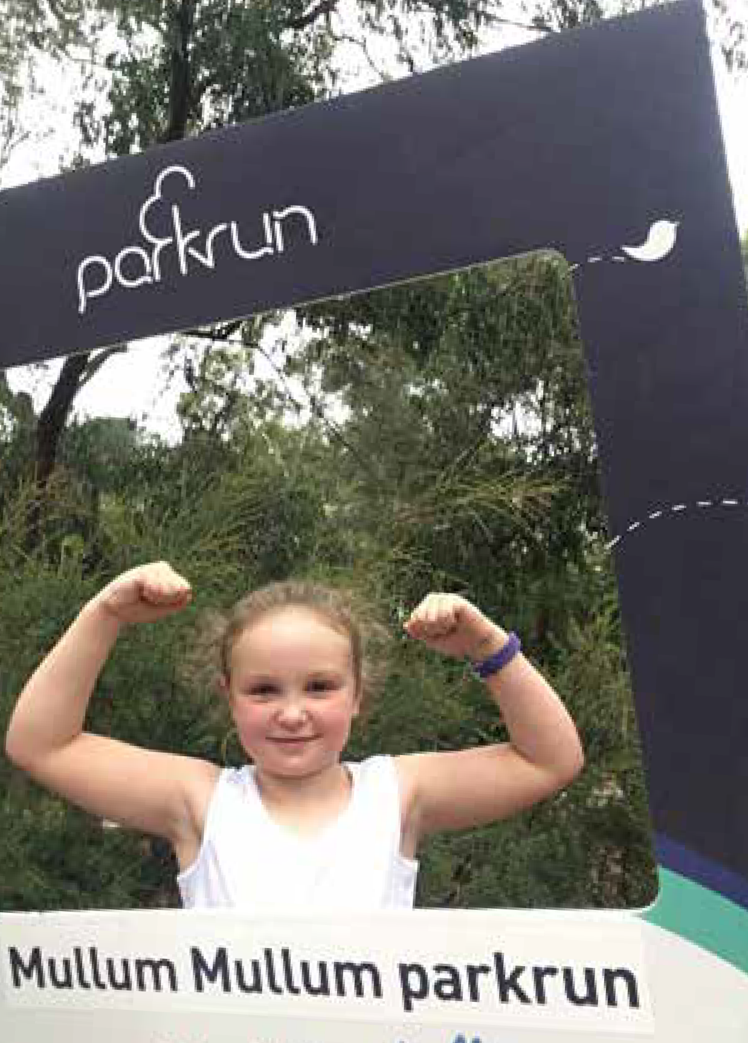
Understanding the reasons people undertake regular physical activity can assist with the design of programs and infrastructure.
In 2019, the top motivators for participating in physical activity among young people aged 15 to 17 and 18 to 24 differed:
- Among 15 to 17 year olds, the top motivator was fun/enjoyment (71 per cent), followed by physical health or fitness (64 per cent). The third motivator was social reasons (38 per cent) followed by performance or competition (14 per cent)
- Among 18 to 24 year olds, the top motivator was Physical health or fitness (75 per cent) followed by fun/enjoyment (53 per cent). The third motivator was social reasons (35 per cent) followed by psychological/mental health therapy (21 per cent) (ASC 2020)22.

Recent (2023) Your Say Maroondah online engagement with Maroondah residents has revealed that health and fitness is the primary motivator for undertaking regular physical activity.

What are the three main reasons you participate in physical activity for exercise or recreation?

120
104
5
5
44
59
31
18
17
29

Health and fitness Fun/enjoyment

100

80

60

40

20

0

Exercising pets Relaxation/stress relief Being out in nature
Socialising/meeting new people

To lose or maintain weight

To play sport

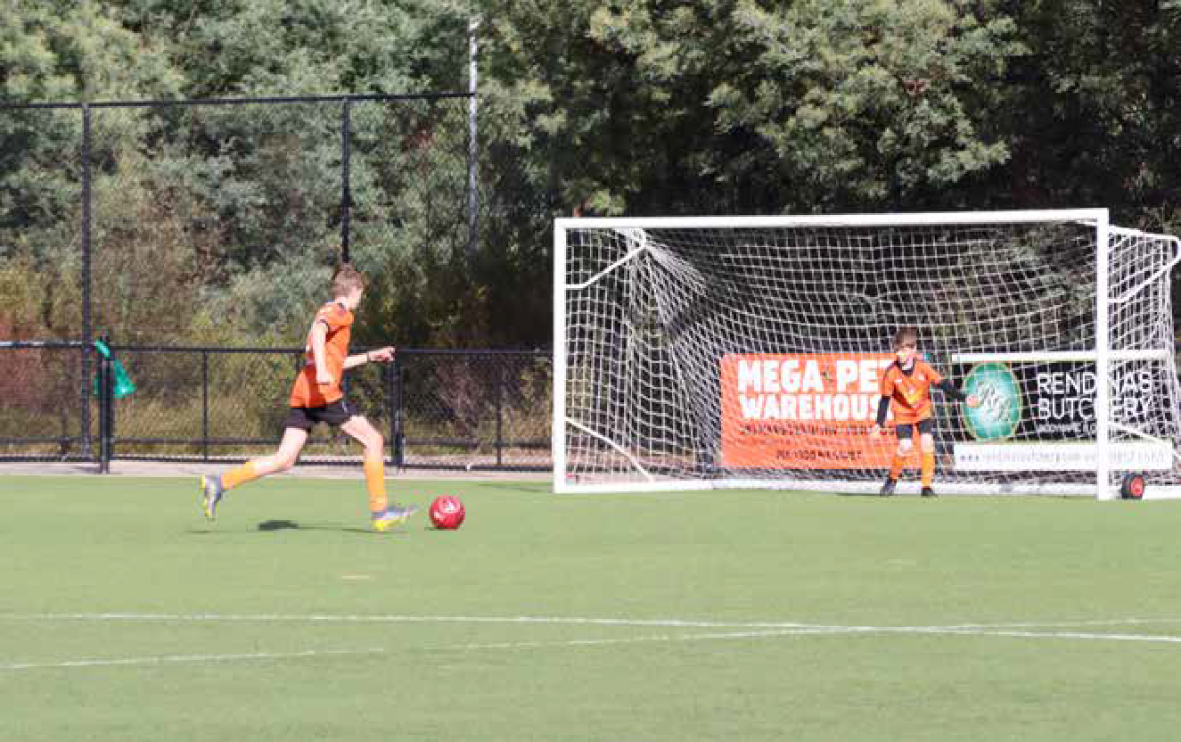

Challenges affecting physical activity levels.

To plan strategies to encourage active living and increase the physical activity levels of Maroondah residents we need to understand the inhibitors.

There are different factors that affect the physical activity levels of specific populations and therefore different strategies required to overcome these.
This document highlights the challenges and opportunities for the general community and then focuses on seven (7) different specific population groups in order to target specific actions which will have a positive impact on participation. These specific populations were identified through the results of community engagement and through the Maroondah Liveability Wellbeing and Resilience Strategy.

General community

Common challenges
A key challenge for engaging the general Maroondah community is the perception of, or a real issue of not enough time. While many people are indeed time poor, with work, home, caring and community commitments, time constraints are not the whole explanation. For many it is a vicious cycle of a lack of motivation fuelled by poor diet, sedentary behaviour, and possibly poor sleeping habits which leads to feeling low on energy.
The continued increase in dwelling density is reducing residential green spaces, placing another constraint on the activity levels of Maroondah residents.
Guilt and self-blame are also expressed factors impacting individuals’ exercise levels. Feelings of guilt stem from differing circumstances; insufficient or no exercise, not meeting perceived expectations of how to look or how to exercise, or viewing exercise as sacrificing family time or work commitments.

Opportunity for Council to increase Maroondah’s level of physical activity
It is important to convey the message that physical activity can be accumulative and need not be undertaken in one block of time. Building opportunities for physical activity into everyday routines can be achievable but requires a change in mindset to recognise that being physically active does not require a gym or sports membership or even activewear. Conveying positive messaging to empower individuals to feel good about small segments of active movement will motivate progression to a more active every day. The provision of safe, easy to access, active travel opportunities and inclusive play and gathering places will also assist more residents to incorporate daily physical activity.

Culturally and linguistically diverse (CALD) communities
Physical activity opportunities and communications should be planned and developed in ways that are responsive to our Culturally and Linguistically Diverse communities.

Common challenges23
- Language barriers and/or complex registration processes
- Lack of time
- Education and work priorities
- Family and traditional community commitments
- Scheduling conflicts with religious responsibilities
- Settlement constraints
- Financial constraints especially for newly arrived residents
- Lack of transport
- Inflexible dress codes
Opportunities for Council to increase levels of physical activity
- Ensure messages use simple words and pictures
- Messages to convey how activity can help them achieve other priorities e.g. enhance studies
- Seek to understand and demonstrate respect for cultural differences and beliefs24
- Utilise community leaders and health professionals to support information dissemination
- Low cost opportunities and support for clubs to source grants to offset costs
- Encourage clubs to provide social,
non-competitive opportunities for participation
- Promote public open space areas where informal sport can be played
- Support the provision of activities which families can undertake together
- Involve culturally diverse communities in the planning of new facilities and activities.
In the previous strategy, it was highlighted that Council should develop strategies to address the concerns of the Myanmar (Burmese) community specifically relating to their desire to play soccer in Maroondah.
Since this time, Council has developed three multipurpose facilities at Hughes Park, East Ringwood Reserve and Dorset Recreation Reserve to support the Chin and Karen communities, with dedicated active recreation and community meeting spaces.
Council will continue to support these communities to maximise use of these facilities for all ages and genders and foster partnerships and integration with other local sporting organisations.

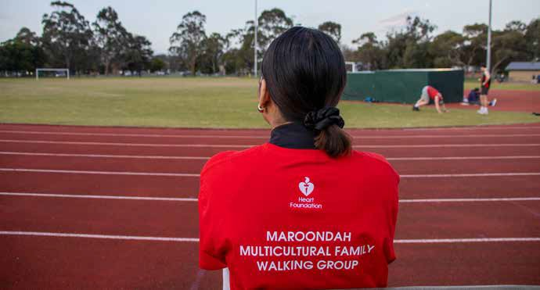

First Peoples
Opportunities for Council to increase levels of physical activity
- Consider culturally specific programs that take into account the unique historical context and health experiences of Indigenous Australians in future approaches to targeting inactivity27
- A 2018 research paper into the perceptions of physical activity among Indigenous Australians highlighted that “The Western concept of individual exercise programs would appear not to be the best approach when promoting physical activities in this population. Group, community, or family activities are all approved forms of physical activity. High importance is attached to the type of environment in which exercise is undertaken, with the natural land remaining influential in Indigenous culture”28
- Utilise Council’s Wurundjeri Community Consultative Workshops to understand local issues and gauge effectiveness of current communications
- Ensure Council planning and programming is in alignment with Council’s Reconciliation Plan.
To decrease the gap in health inequalities experienced by Aboriginal and Torres Strait Islander Peoples, targeted promotion and/or programs should be considered to increase regular physical activity rates. Research states that 12 per cent of Aboriginal and Torres Strait Islander adults in non-remote areas met the physical activity guidelines in 2018-2019. The rates of sufficient activity were slightly higher for Indigenous males than for Indigenous females (13 per cent compared with 10 per cent), around one in five (20 per cent).25
A 2012 study also found that family was identified to be at the forefront of Indigenous youth’s motivation in the type of sport they decide to play and how they connect with family members. In Indigenous culture, the females have a large responsibility to family.26

Common challenges26
  - Safety
  - Affordability
  - Social environment
  - Lack of transport and logistical difficulty
  - Competing work, family or cultural commitments
  - Lack of time
  - Lack of self-motivation
  - Lack of confidence to try something new
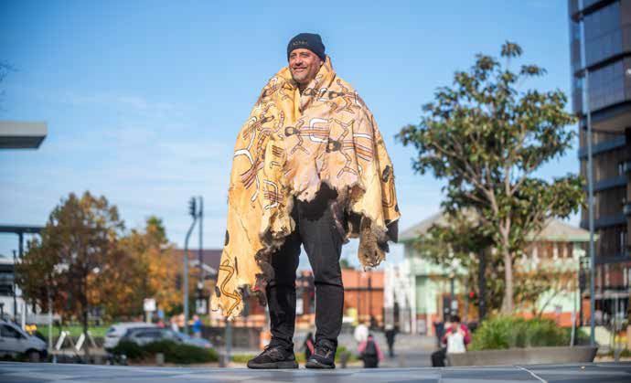

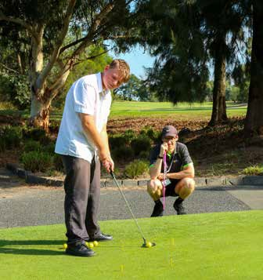
Young people
This group is defined as young people aged between 12 to 26 years, who make up approximately 17 per cent of the Maroondah population.29 Common challenges highlighted in the previous strategy were reviewed and amended by Maroondah’s 2023 Youth Wellbeing Advisory Group during a workshop session in July 2023.

Common challenges
- Cost of activities, high casual usage fees or long term commitment
- Lack of motivation
- Lack of confidence or self-esteem
- No companion or other people to participate with
- Circle of friends who are not active
- Inability to access childcare
- Not having the correct knowledge about health and fitness
- Body image perceptions
Opportunities for Council to increase youth levels of physical activity
- The social opportunities presented by sport should be as important as the competitive aspect
- Rethinking how organised sport is promoted and delivered, including more flexible options for involvement
- Health promotion initiatives aimed at both young people and/or parents to dispel misconceptions and promote the healthy mind and body benefits of physical activity
- Improved infrastructure to support Active Travel to school and places of work or play
- Provision of low cost, casual commitment opportunities
- Provide different FUN, feel good, social options – “with great music”
- Provide online, tours, basic gym etiquette and usage information to lessen anxiety for new participants
- Simply providing information to youth about benefits, frequency, and duration of physical activity is not sufficient for enhancing physical activity behaviour. Subtle changes in framing physical activities can have a dramatic influence on youths’ physical activity motivation and behaviours. Adults should encourage youth to participate in activities they find enjoyable, feel competent doing, have chosen to do, and that include positive social support—these conditions optimize their motivation for sustaining physical activity and thus the physical, social, and psychological health benefits afforded from such participation.30
- Not having found something that interests them, don’t know what they enjoy or what’s out there.
- Timing of activities – early morning activities often not conducive to the biorhythm of young people
- Lack of healthy role models (parents) – healthy versus skinny misconception
- Not having the rest/restorative sleep they need to meet the demands of daily life
- Mental health issues
- Identity stereotyping e.g. ‘I’m not a sporty person’, ‘Exercise isn’t my thing’
- Safety concerns – young person’s and/or parents, including injury, general safety in public, peer-to- peer violence, gender-based violence and harassment, sexual violence and harassment, and child abuse and grooming
- Lack of time due to homework and/or part-time work, issues of work/life balance
- Perception – Is exercise self-care or a chore?
- Fear of running into acquaintances/peers who may judge
- Environment – quality of paths, lighting
- Public transport easier than active travel, lack of motivation to prepare for and undertake cycling
- Competition focus of sport deters continued involvement beyond childhood. “What’s the point?
- Perception that physical activity must be sport or gym.

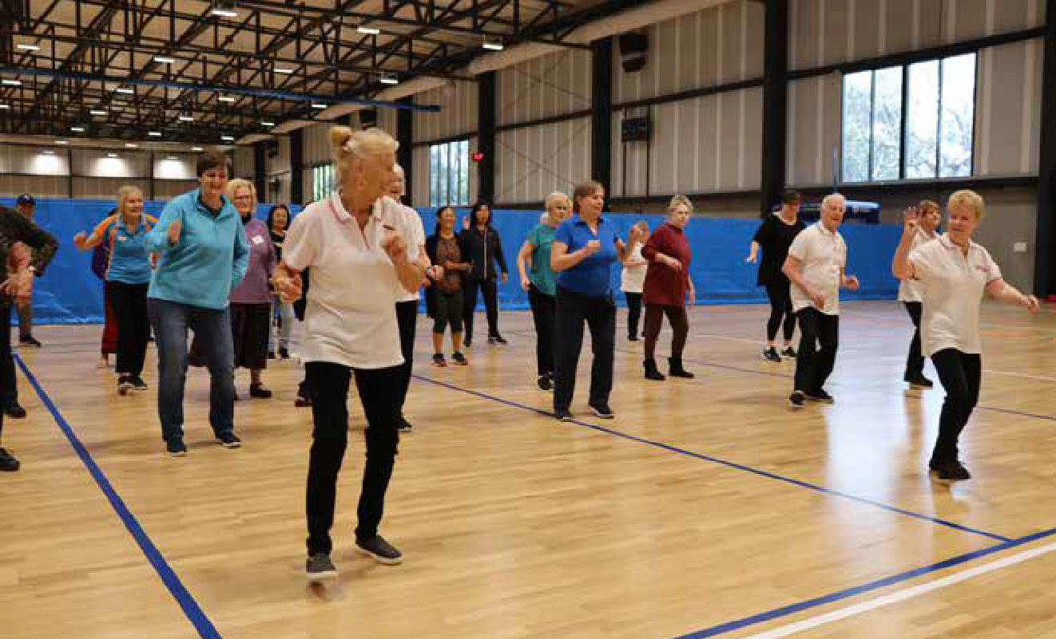

Older people
Latest Census data highlights that approximately 27.6 per cent of the Maroondah population is aged over 55 years.31 To support the needs of our older residents, Maroondah City Council is a member of the World Health Organisation’s Global Network of Age–friendly Cities and Communities Network. This network focuses on taking action at the local level to promote active and healthy ageing.
Council has also made a further commitment through the endorsement of a Positive Ageing Framework and Action Plan 2021-2025. The Plan addresses the current challenges faced by an ageing population and plans ways to optimize opportunities for health, participation and security in order to maintain independence and enhance quality of life as people age.

Common challenges
- Physical constraints: discomfort and pain are common barriers to exercise as well as illness, chronic health conditions and obesity
- Fear of injury: injury is a very legitimate concern for older people however a lack of exercise can amplify general functional decline and balance issues
- Fixed income: gym, swimming and personal training can be expensive for older persons on a fixed income
- Cognitive decline: those who are experiencing memory loss or cognitive decline may face barriers to engaging in physical activity
- Isolation: lack of connection may limit knowledge of activities opportunities and limit motivation. Lack of transport may also contribute to isolation
- Financial insecurity: older people face a unique set of potential financial stresses as they enter retirement, which can impact on their ability to access to healthy food, physical activity and recreation, and services.32
Opportunities for Council to increase levels of physical activity
- Provision of green spaces, adequate seating and safe, pedestrian friendly, walkways.
- Well-designed roads to assist the egress of pedestrians and their mobility aids.
- Safe and accessible public buildings and toilets.
- Events and activities, that are planned and promoted with consideration of the needs of older adults.
- Fostering community integration through encouraging multigenerational spaces and activities.
- Promotion imagery includes older people, depicting them positively and without stereotypes.
- Regular and reliable distribution of information through accessible community platforms and media.

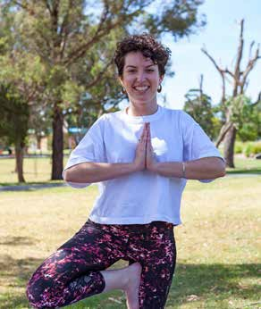

Women and girls

Equally Active Strategy 2019 An active participation strategy for women and girls
Safe, healthy and acti
According to the 2021 Census, 51.6 per cent or 56,351 of Maroondah residents identified as female.
Maroondah has an increasing proportion of carers providing regular unpaid care with 8,066 women aged 15+ providing assistance to a person with a disability, long term illness or old age. Furthermore, 15,876 women aged 15+ reported that they undertake unpaid childcare as their primary role and of this 4,448 indicated that this included care for children other than their own.
Evidence highlights that there is no one approach to addressing the gender disparity in physical activity participation among Maroondah residents. Different female population cohorts within Maroondah experience different challenges to being as active as they should be, or would like to be, to maintain optimal health and wellbeing.33 To understand the needs of women and girls, in 2019 Council developed the Equally Active, active participation strategy to develop targeted strategies to address low participation in specific population cohorts and to increase and sustain women and girls’ participation in traditionally male dominated sports.
Opportunities for Council to increase levels of physical activity
- Engagement with women and girls to ensure suitably scheduled, accessible activities
- Availability of activities popular with women
- Women only teams/program options
- Family friendly policies/ places
- Design sensitive to perceptions of security
- Provide and promote relatable active role models
- Representation of women in community sport, coaching and decision making roles
- Actively targeting and marketing participation to women and girls and those most vulnerable
- Incorporate specific design features to support women’s participation
- Support equitable access to facilities and resources through education and policy
- Support the provision of safe, non-judgemental spaces for independent exercise
- Support the provision of fun, social and non-competitive options
- Assist traditionally male-dominated sports clubs to undertake change initiatives to create and sustain inclusive, welcoming environments.

Common challenges
- Time poor
- Caregiving responsibilities leading to time and scheduling constraints, guilt and lack of energy
- Sensitivity to body image
- Girls are more likely to report barriers such as embarrassment, sweating, fear of injury, and weight criticism by peers and family members compared with boys34
- A systemic fear of judgment of appearance, ability and/or priorities
- Gender inequality in recreation and sporting settings
- Safety concerns, including gender-based harassment and violence
- Cultural differences
- Financial priorities
- Newly arrived young women can experience additional settlement challenges including increased family responsibilities and duties, negotiation of different cultural expectations about gender roles, economic disadvantage, social isolation, lack of experience and knowledge about services and lack of confidence to engage with services.

LGBTIQA+
The LGBTIQA+ (Lesbian, Gay, Bisexual, Transgender, Intersex and Queer/Questioning, Asexual) community make up an estimated 10 per cent of Maroondah’s population. Research shows LGBTIQA+ people have some of the lowest rates of participation in sport, recreation and physical activity out of any community in society.
Avoidance of participation in sport is often linked to poor experiences due to discrimination or harassment. An international study by Australian researchers35 found that:
  - Over 80 per cent of people have either witnessed or experienced homophobia in sport
  - Sport is considered hostile and unwelcoming to young people with diverse sexualities and genders

Common challenges
  - Lack of understanding the difference between gender and sex.
  - Lack of understanding of what is transgender.
  - Transphobia or homophobia or perceived transphobia or homophobia.
  - Verbal abuse and/or inappropriate sledging from players, officials, coaches, spectators.
  - Strict sport rules on gender and sex (leaving transgender people without a competition to play in).

  - Some medically prescribed drugs transgender people require are on banned substance lists.
  - Mental health issues.
  - Physical abuse (from team-mates and rougher play on field).
  - Lack of role models.
  - Change rooms can create feelings of angst and discomfort.
  - Negative past experiences.
  - Perception that physical activity must be sport or going to the gym.
Opportunities for Council to increase levels of physical activity
- Education within sport and recreation clubs and promotion of support resources
- Facilitate discussions with sport leagues about updating gender and sex rules and uniform requirements
- Private spaces (cubicles) within change rooms and non-gendered options
- Encourage and support the development of policy for players, officials and spectators
- Support initiatives to celebrate and demonstrate support for LGBTIQA+ inclusion
- Messaging that physical activity may be accumulative segments of short activity including active travel.

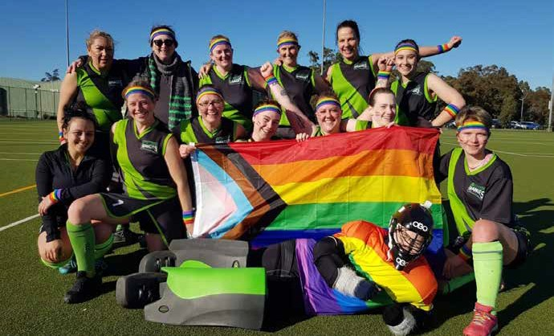

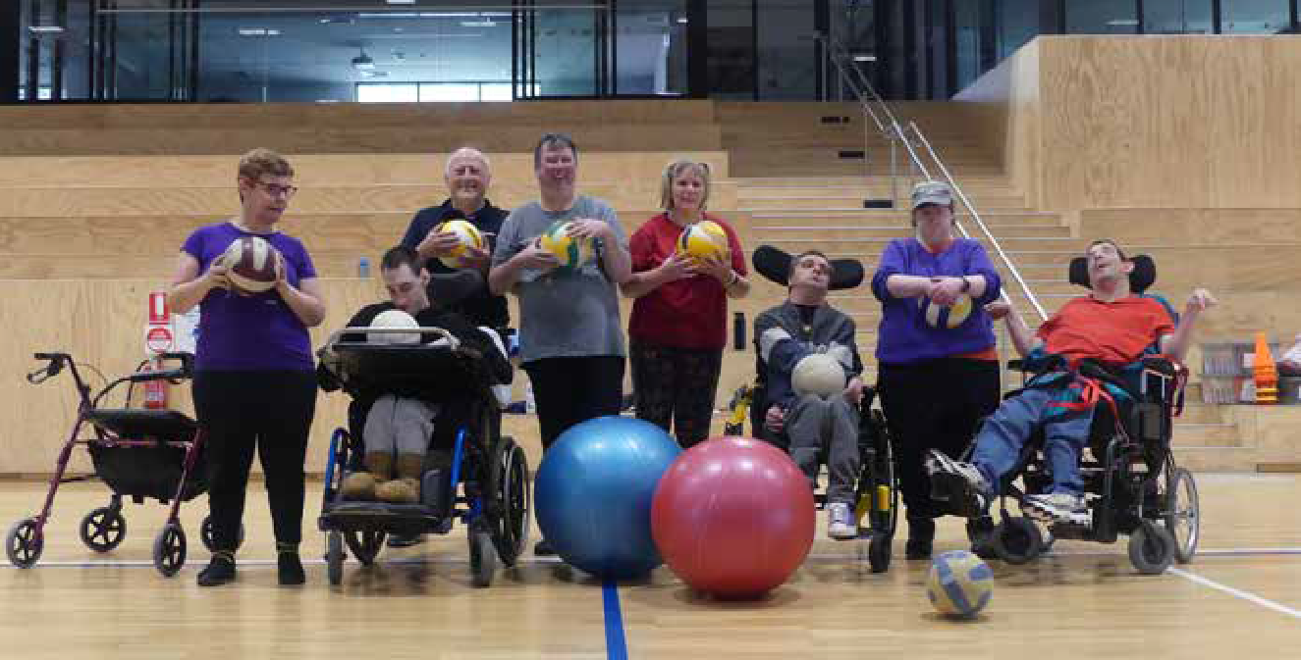

People with disabilities
Participation rates for people with disability are significantly lower than the general population. In 2021, 6,847 people (or 6.0 per cent of the population) in the City of Maroondah reported needing help in their day-to-day lives due to disability.36 Furthermore over 30,000 people live with some form of disability in Maroondah which is an estimated 29 per cent of the population.
Disability is defined as “an umbrella term, covering impairments, activity limitations and participation restrictions”.37
The latest ABS release on Physical Activity (2020/21 financial year) highlighted that Australians aged 18 years and over with disability were twice as likely as those without disability to have completed zero minutes of physical activity in the last week (20.5 per cent compared with 9.9 per cent).

Common challenges38
- Cost was identified as a major factor due to limited disposable income. Costs included transport, equipment, registration fees, support to participate and other additional costs associated with disability.
- Attitudinal barriers are those that discriminate against people with disabilities or are perceived as unwelcoming.
- Physical barriers are features of buildings, play space or open spaces that impede access or participation by people with disabilities.
- Information or communications barriers happen when a person cannot easily access or understand information.
- Access to opportunities There are a limited number of activities for children with disability. Sometimes available activities run at inconvenient times, or have long waiting lists.
A person with a disability is more likely to face several challenges and barriers which require understanding as part of investigating practical solutions. For example:
- A person with a disability may have a particular medical condition that affects the body’s metabolism.
- Reduced mobility and lack of regular exercise
- Reduced muscle tone.
- Medication that may increase appetite.
- Eating habits that may be affected by depression, anxiety, boredom or frustration.
- Dependence on family members of carers to provide nutrition, transport and activity support.
Opportunities for Council to increase levels of physical activity
- Raise awareness within the community of access and inclusion barriers, rights and inclusive practices.
- Promote participation in Council recreation, arts, leisure and cultural activities and events ensuring all communication tools are accessible and DDA compliant.
- Ensure access for people with disabilities is considered in the planning and design of play spaces and open spaces.
- Continue to deliver disability awareness training to Council employees particularly those involved program development, infrastructure planning and direct service delivery.

A strategy for a more active future
There are different factors that affect the physical activity levels of specific populations and therefore different strategies are required to overcome these. In the previous section the strategy has highlighted many of the common challenges inhibiting activity levels and opportunities which may have a positive impact on participation. To address the highlighted challenges and to make physical activity an easier option, the strategy focuses on four (4) key priority areas which highlight opportunities for Council action.

Increasing active travel
Despite the many benefits of active transport, physical and attitudinal barriers prevent people from extensively using active travel modes.
There are a range of improvement opportunities that Council can undertake to enhance the pedestrian and cycle network. These will include completion of the gaps, to facilitate greater continuity and
connectivity, remove physical barriers, more pedestrian crossings
, expansion of long and short stay
Spaces and places that encourage physical activity
Public Open Space is of high importance
to Maroondah residents. This level of regard may be a key factor in promoting active living and providing opportunities for people to be more active.
The creation of vibrant, activated parks and reserves will generate greater volumes of
users, assisting people to feel safer and be motivated to exercise, by the energy of others.

bicycle parking and installing wayfinding signage.
Maroondah moving more often

Supporting diversity in sport
The demographic of Maroondah is becoming increasingly diverse. Our culturally, linguistically and gender diverse communities, women and girls and people with disabilities are looking for sporting options that are welcoming and inclusive.
It is Council’s intention to support inclusive sporting settings to achieve participation that reflects our diverse community.

Connecting with our least active residents
Council has invested significant resources to improving the quality, access and safety of Maroondah’s open spaces, sports facilities, footpaths and trails.
This information needs to be widely disseminated using multiple targeted avenues along with reframed positive messaging to increase daily activity levels.

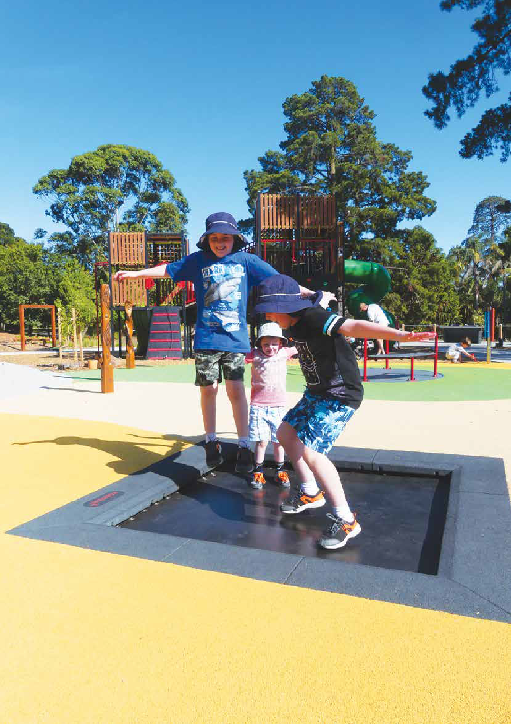

McAlpin Reserve Play Space

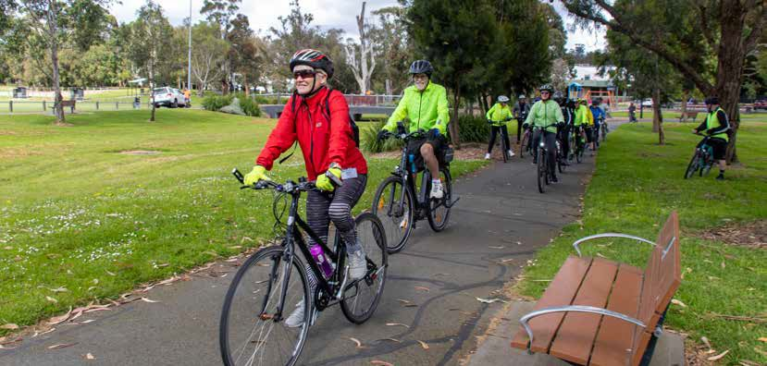
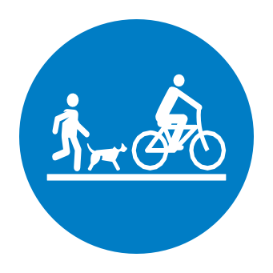
Outcome description
Safe, healthy and active
Outcome area Increasing active travel
Council will continue to work with other partners to improve our streets, trails and spaces to be great places for people to walk, run, ride and play and choose active travel as a regular part of their daily life.

What the evidence tells us
People that walk, run, ride, scoot or skate as part of their everyday activities, participate in active modes of travel. Inherent in active travel modes is some level of physical activity. Active travel can be an important source of physical activity and contribute to reaching the necessary daily physical activity levels to stay fit and healthy. For example, public transport users in Melbourne achieve over 40 minutes of exercise a day, compared with less than 10 minutes for a car user.39
The health and wellbeing benefits of physical activity that stems from active travel are well established and understood. Public health research shows that people that regularly walk, ride or wheel tend to be healthier, fitter, have better mental wellbeing and are a connected community.40
The co-benefits from greater physical activity are associated with reduced obesity, increased aerobic fitness, cognitive function and social inclusion.
Importantly, the health benefits of walking or riding a bicycle outweigh the health risk associated with potential injury.
The active travel modes are low cost, low impact and zero emission transportation that in certain circumstances, over short distances, can be quicker than motorised travel. Due to the low cost and time flexibility, certain community groups that are less likely to participate in organised active pursuits, will walk for leisure and active travel.
Therefore, active travel contributes to a reduction in health, mobility and society inequalities.
The active travel modes enable equity, connection and inclusion in our society and at places. It allows people of any age or ability the means to be independent and choose where they want to go. Active travel, aided through assisted mobility, is fundamental to preserve the mobility and independence of an aging community, people with disability and people that don’t drive. Likewise, active travel is also important to children and young people to take steps towards independent lives. In Outer Melbourne about a third (33.68 per cent) of all journeys to education use active transport for at least part of the way (VISTA)41.
Active travel is done on its own or in combination with public transport. When done on its own, nearly all trips are walked over a short distance to reach local places for social, recreation, personal business, work and shopping purposes (VISTA). The average walking distance is 1.1 km and average time spent walking is 15 minutes. People will walk for longer distance and time for purposes of education, recreation, personal business reasons.
Participation in cycling is extremely low, constituting less than 1 per cent of proportion of active travel trips. On average distance covered by

a bike ride is 6.8 km and an takes 27.5 minutes. Cycling is most undertaken for social, recreation and work purposes.
Nearly every trip involving public transport made in Maroondah will include some active travel at either, the origin, transition between modes or destination. For 88.4 per cent of Maroondah households buses are the closest public transport42. In Melbourne, 94 per cent of trips to the bus stop are walked43. The median walk to a bus stop is 390 meters. PTV station access data shows that walking is also important for accessing stations. In 2014, 63 per cent of passenger’s walk to Heathmont Station, 46.1 per cent to Ringwood East, 32.3 per cent to Croydon and 25.8 per cent to Ringwood44 Cycling to stations across all stations is lower than 1.6 per cent of passengers.
Overall, in 2020, more trips originating in the municipality were made by active transport (11.9 per cent) than public transport (6.7 per cent) (VISTA). A significant majority of active transport trips are walked (11.46 per cent).
The online Strava Heat Map reveals the locations with the extensive walking and cycling volumes are along the trails, pathways and major roads. It highlights the importance of trails, pathways and footpaths to influences and facilitate participation in active modes of transport.
Many people living in Maroondah struggle to choose active travel modes for short trips to reach local destinations, services and activities. Known barriers that influence the likelihood and amount of participation in active travel are, where people live, their level of income, job and education access, the fabric of neighbourhoods, the street environment, personal safety concerns and the quality of public transport.
There is considerable potential to boost population levels of physical activity thought the encouragement of active travel. For the potential to be realised the conditions of our streets and neighbourhoods must be walkable, bicycle friendly and safe for everyone. Enhancement of community connections and access to local shops, education, medical and community services so active travel can be a mode of choice and the delivery of education to develop people’s skills to safely walk or ride a bike, scooter or skateboard.

What the community has told us
Communities across Maroondah have expressed views, expectations and attitudes towards active travel across several community engagements undertaken for a range of projects.
Strong community support for walkability neighbourhoods and better active travel options was a prominent and collective view. Requests included more footpaths, better connectivity and separation of bike and walking paths and public open space to be made safer after dark to support active travel and recreation. In particular, the community highlighted the need to provide opportunities to build active travel confidence, promote free public facilities and active transport networks which will support greater participation in all types of walking and bike riding.
These calls encapsulate the community expectation for Council to provide more and quality active transport infrastructure, events and programs.
Good transport services and facilities were identified as the highest priority for current and future housing by the Housing Strategy Engagement Report. Most respondents would like a shared pathway, trails, footpath and bus stops to be within five minutes of their home. Over half of respondents were willing to travel either 10 or 20 minutes to a train station. The feedback is an acknowledgement of the high importance the community places on good access to sustainable transport in choosing a home.
The My Neighbourhood Café consultation highlighted the community’s varied experience of walking and bike riding across the 12 local centres. Respondents were asked to rate the quality of safe walking and cycling networks. The centres identified as having a low or medium quality active travel networks were Burnt Bridge, McAdam Square, Ringwood North and Ringwood East. The community gave 59 suggested enhancements to improve the network. The improvements can be categorised into four types: lighting, footpaths, bicycle paths and safe streets/ spaces. The community values such facilities and wants the implementation to occur quicker than at the current rate. The consultation findings also called for more pedestrian and bike facilities which is consistent with the request letters received by Council. In 2022, Council receives 60 requests for new footpaths and 50 requests for lighting.
While there is strong support for active and public transport in the community it is by no means a consensus. It is acknowledged that the community contains diverse views, expectations and attitudes and some compete with active travel outcomes at the local level. The competition for space and accommodating community expectations is complex and will have to be balanced to be acceptable.

Safe, healthy and active

Priority actions

Key Direction | Priority Actions | Lead Responsibility | Timeframe
1.1 Deliver behaviour change programs to increase confidence to walk and ride for short trips. | 1.1.1 Link Council’s walking routes information to the Victoria Walks web platform and create a communication plan. | City Futures Maroondah Leisure | 2024/2025
 | 1.1.2 Partner with schools to organise cycling and pedestrian safety education programs and events. | City Futures | 2023/  Onward
 | 1.1.3 Partner with community organisations including Victoria Police to offer a bike education initiative focusing on bike etiquette and safety. | City Futures Maroondah Leisure | 2024/2025
1.2 Advocacy to other tiers of government for arterial road improvements for pedestrian access and safety. | 1.2.1 Review the Principal Pedestrian Network to reprioritise the provision of walking pathway and footpaths to improve access within activity centres. | City Futures | 2024/2025
 | 1.2.2 Review the Maroondah Bicycle Network Plan to guide cycling infrastructure investment within five priority local neighbourhoods. | City Futures | 2023/2024
1.3 Deliver safer, direct and connected on road and off-road cycling ways. | 1.3.1 Lobby the Victorian Government for funding to facilitate the delivery of the Greenwood Avenue shared user pathway. | City Futures | 2023/  Onward
 | 1.3.2 Develop and implement a real-time pedestrian and cyclist counter network to supply continuous and robust data. | City Futures | 2025/25  Onwards
 | 1.3.3 Continue the implementation of Council’s capital works footpath  construction and street light enhancement programs. | Engineering & Building Services | Ongoing
 | 1.3.4 Continue the implementation of Council’s capital works program for accessibility improvements for all abilities. | Engineering & Building Services | Ongoing
1.4 Prioritise the provision of safe pedestrian and cycling facilities within 800 metres of stations and bus interchanges to realise the greatest outcomes from active transport. | 1.4.1 Complement the principal pedestrian network with well-placed crossings, street furniture, tree planting and optimise wayfinding signage. | Engineering & Building Services | Ongoing

Indicators of progress

Outcome | Indicators | Data Source | Base Metric | Frequency Reported
Increase in the percentage of trips made by people walking and riding a bike. | Mode share by number of trips (%). | Victorian Integrated Survey of Travel and Activity. | 11.95%  (2020) | Biennial
Increase in community’s perception that streets are walkable. | The community score for level of satisfaction with  streets and footpaths. | Community Satisfaction Survey. | 65 | Annual
Increase in the percentage of trips made by students walking or riding a bike to school. | Mode share by trip purpose split by number of trips (%). | Victorian Integrated Survey of Travel and Activity. | 12.51%  (2020) | Biennial
Increase in the number of trips per a day that are walked for social and recreational walks and the average distance and time taken. | Number of trips per a day. | Victorian Integrated Survey of Travel and Activity. | 14,778  (2020) | Biennial
 | Weighted average (km). |  | 1.1km (2020)
 | Weighted average (mins). |  | 16.4 mins  (2020)

Safe, healthy and active

Outcome area
Spaces and places that encourage physical activity

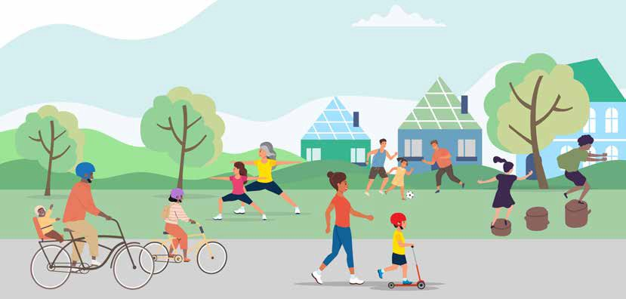

Outcome description
Maroondah will have a network of high quality inclusive play and gathering places that cater for all cohorts within our community and are designed and maintained to maximise participation and to support good mental and physical health.

What the evidence tells us
Physical activity levels can be strongly influenced by the places and spaces within the community. Open spaces include green space, parks, playgrounds, walking/bicycle trails, reserves, golf courses and public sporting/recreation areas.
Vegetation and nature are important for wellbeing. Visual and physical contact with nature helps reduce stress, anxiety, blood pressure and muscle tension, improves self-esteem, encourages positive feelings, and helps us recover from mental illness. A network of safe walking and cycling routes that provide access to green spaces in an urban environment also encourages physical activity.
Residents living in neighbourhoods with good access to public open space are more likely to use such spaces and gain the associated physical activity, and mental and physical health benefits. There is considerable evidence that living within walking distance of parks and in neighbourhoods
with more green public open space is linked to greater use of these areas and positive health outcomes.45
72 per cent of Maroondah dwellings are estimated to be within 400 metres of public open space, which is higher than both Knox (69 per cent) and Yarra Ranges (53 per cent).46

What the community has told us
Within the Maroondah Liveability, Wellbeing and Resilience Strategy, our community highlighted the relationship between physical and mental health and the opportunities to facilitate and support social connection. Opportunities to connect with nature were highly valued and seen to provide benefits to mental wellbeing, physical health and social connection. The community would also appreciate more affordable facilities, free outdoor recreation options as well as active and passive activities that promote health and wellbeing for all.47 A quote from a female Ringwood resident stated “We should all feel safe to go about our business, regardless of the hour of the day or day of the week. We should be able to walk the streets at night or early morning without fear or trepidation”.

Play and Gathering Places Strategy engagement
In 2023, to help inform the inaugural Play and Gathering Places Strategy, Council undertook extensive community consultation. The community were asked to provide feedback on where, why, and how they play and gather in Maroondah. The “Connection Matters” campaign ran for 10 weeks from January to April 2023. During the campaign, 1500 people visited Council’s Your Say Maroondah page with 719 people completing the online survey.
A summary of key findings included:
- Our community are invested in and want to connect to these places more

Priority actions
35 per cent respondents used places daily, 53 per cent weekly

Our community want to be stewards of these places
66 per cent respondents seeking community connections and 27 per cent seeking stewardship

Maroondah’s Open Spaces are vital to the wellbeing of our communities
53 per cent of respondents rated these extremely important

Our community value as a priority, a well-connected, planned and serviced Open Space network
87 per cent respondents walk to these places

Key Direction | Priority Actions | Lead Responsibility | Timeframe
2.1 Provide activated, highly utilised spaces that are multiuse to maximise natural surveillance and community safety. | 2.1.1 In accordance with Council’s public lighting policy, support the installation, or upgrade to the quality of, sustainable lighting for improved safety and to support increased evening activity. | Projects & Asset Management. | Ongoing
2.2 Design spaces which consider the feedback and lived experience of a wide range of ages, backgrounds and abilities to ensure equitable access with a priority being to reduce inequalities. | 2.2.1 Develop targeted engagement activations that will gain feedback representing the widest range of community perspectives. | Service Areas. | Ongoing
 | 2.2.2 Undertake internal training to understand intersectionality and how to utilise this lens to guide future planning. | Equal Opportunity Committee. | 2025/2026
2.3 Advocate for improved Maroondah sporting facility construction to cater for people of all abilities to provide a welcoming/inclusive environment. | 2.3.1 Continue to advocate for improved community facilities, that have flexible spaces to accommodate the diverse needs of the community. | Sport & Recreation Community Services. | 2024-2029

Indicators of progress
Victorian Child Health and Wellbeing Survey (VCHWS) – Proportion of young people and proportion of children living in neighbourhoods with good parks, playgrounds and play spaces.
- Development of and/or increased usage of open space feedback mechanisms.
- Collation and interpretation of usage data.
- Incorporate cultural and/or heritage aspects in all new Council facility developments or enhancements.
- Where applicable, Gender Impact Assessments are undertaken, and findings actioned.

Outcome area Supporting diversity in sport

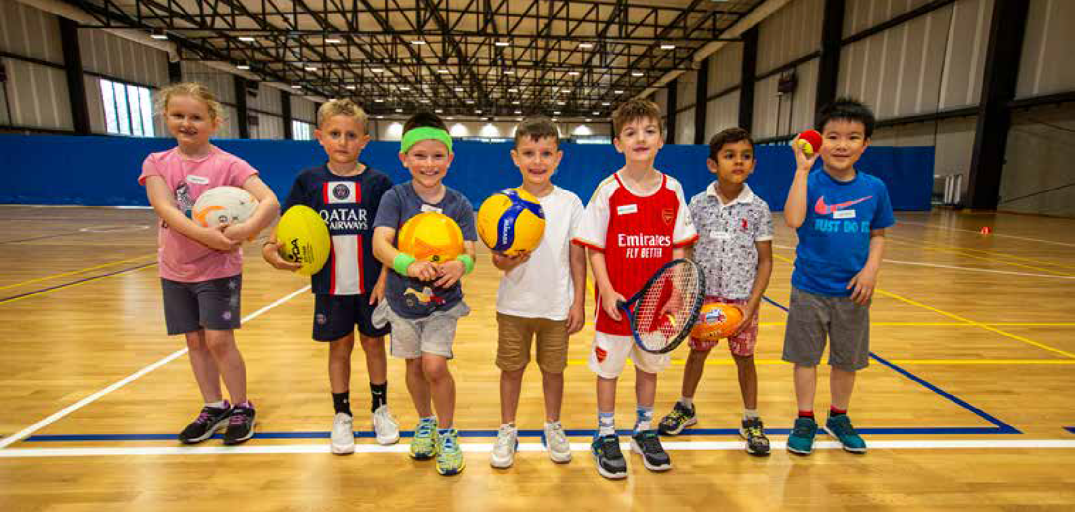

Outcome description
Safe, healthy and active
Sports settings will be welcoming and inclusive of all genders, cultures and abilities by providing accessible facilities, safe, inclusive club environments and participation opportunities, to ensure that no one is excluded or fearful of discrimination.

What the evidence tells us
While Victoria’s current physical activity profile highlights that the majority of Maroondah residents, roughly 70 per cent, do not currently participate in organised sport and may not hold a desire to do so, sport still plays an important role in the community, for health and fitness, social interaction and social cohesion. Sport teaches important values and involvement can provide a rewarding opportunity to interact with others as a participant, volunteer, leader, or supporter.
Sports organisations need however, to consider that they may not be accessible to all and that there is a need to embrace new ways of delivering sport to a diverse range of cultures, genders and abilities who want to be involved. Council in partnership with sporting leagues and associations, and industry experts, need to provide education and resources to
support club committees, existing participants, officials and coaches to foster cultural change.
Maroondah is home to a diverse range of communities including, but not limited to, people with disability, cultural and linguistic diverse (CALD) communities, Aboriginal and Torres Strait Islanders, people from a range of faiths, and community members with different gender and sexual identities.47 These communities may experience barriers to their participation in physically active endeavours. When different parts of a person’s identity or circumstances – such as age, race, culture, disability, gender, socioeconomic status or religion intersect it can further impede a person’s ability to access or feel welcome in activities such as community sport. Sporting organisations need to be aware of this concept of intersectionality and understand that while addressing one barrier, there still maybe other factors impeding an individual’s participation. Programs should be co-designed with people with lived experience of a range of different aspects of diversity to ensure intersectionality is considered. Co-design is different to consultation as it is a process whereby relevant stakeholder views contribute not only to the thinking but also the making of decisions.48
With a growing preference for active pursuits without the commitment of training and competition, supporting the expansion of social or informal sport options into a wider variety of sport

settings will support increased participation. Social sport can provide a non-gendered, non-competitive or less competitive environment, where participants can enjoy exercise and social interaction with less structure, or no structure and less administration and officiating resources required.

What the community has told us
In the recent 2022/2023 Change Our Game – State of Play49 survey of 670 Victorian respondents, 29 per cent of respondents identified Racism in sport and 32 per cent identified Fair and Equal participation opportunities for women and men as key current issues. 90 per cent of women versus 66 per cent of men said gender inequality is still an issue in sport that needs to be fixed.
Youth Sense, Year 13 and Visa Inc. conducted a nationwide survey in April 2023 with 1250, 13 to 23 year olds. Overall, 43 per cent of teenage girls and young women were found to not play sport. Of the top 10 reasons they gave for not playing, I’m not good enough (34 per cent), body insecurities (31 per cent), I don’t like the competitive side of sport (30 per cent), I feel inadequate compared to the top players and athletes (29 per cent), my physical fitness wasn’t adequate (28 per cent), and too much pressure (26 per cent)50 all were key factors. These factors aligned with feedback from a workshop held with the Maroondah Youth Wellbeing Advocates Group.
Proud to Play, inclusivity in sport advocacy organisation states that “Many LGBTQI+ people are disengaged from sport and recreation, as these environments have not kept up with societal change”.

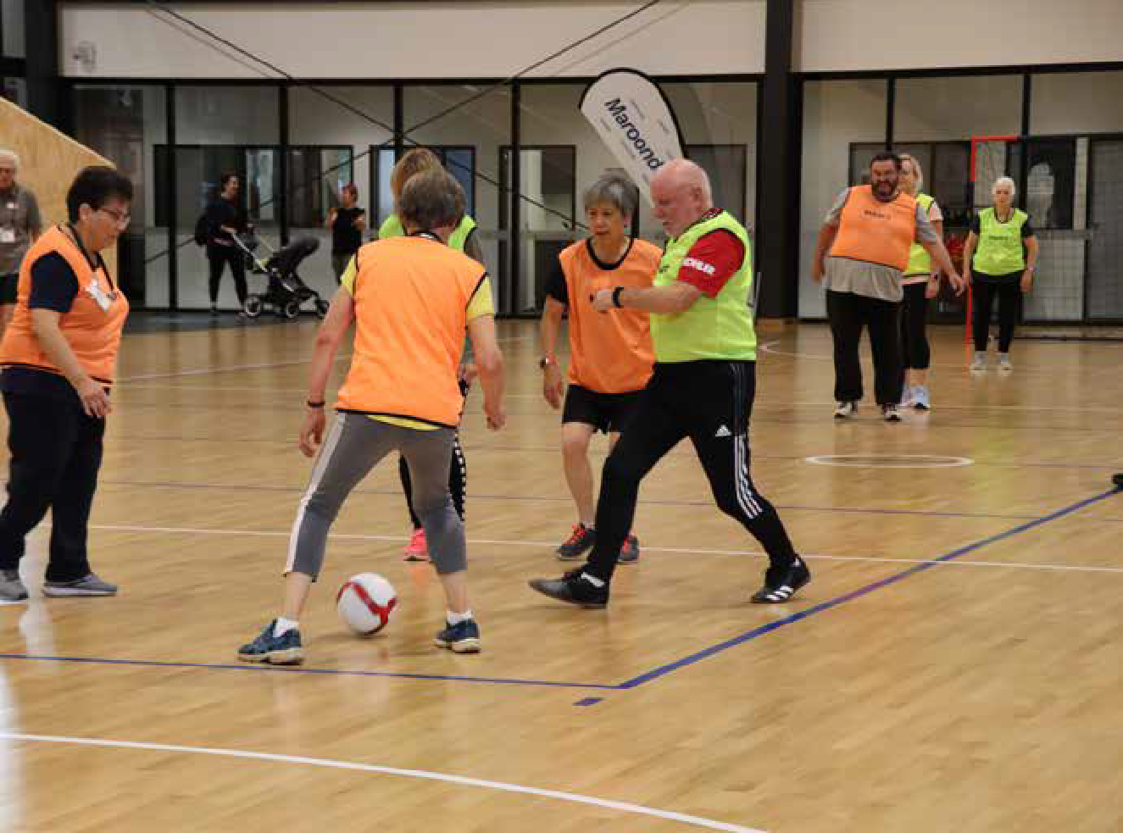

Safe, healthy and active

Priority actions

Key Direction | Priority Actions | Lead Responsibility | Timeframe
3.1 Support the expansion of social sport opportunities. | 3.1.1 Encourage and support local clubs to apply for funding to pilot social sport initiatives. | Sport & Recreation | Ongoing
 | 3.1.2 Promote open space areas available for informal sport. | Sport & Recreation | Ongoing
3.2 Provision of safe, accessible and welcoming spaces and community facilities. | 3.2.1 Incorporate best practice access and inclusion design principles in the upgrade and enhancement of community facilities, to ensure safe, accessible, and welcoming spaces. | Projects and Asset  Management | Ongoing
 | 3.2.2 Partner with inclusion advocacy organisations to provide awareness training on inclusion and provision of culturally safe spaces. | Maroondah Leisure City Futures | June 2025
 | 3.2.3 Partner with Tennis Victoria to develop an Access & Inclusion strategy for Tennis in Maroondah. | Sport & Recreation | July 2025
3.3 Fair allocation of sporting facilities for all genders. | 3.3.1 In partnership with the Melbourne East Regional Sport & Recreation network of Local Government organisations, develop a Fair Access Policy to guide and measure the gender equitable allocation of sporting infrastructure. | Melbourne East Region Sport and Recreation Strategy Network (MERSRS) | June 2024
 | 3.3.2 Utilise Council’s Community Facilities booking and reporting processes to capture usage data by gender. | Sport & Recreation | Ongoing
3.4 LGBQTIA+ inclusion education and advocacy for gender diverse and transgender sports participation. | 3.4.1 Work with local leagues and associations to support local clubs to understand the needs of gender diverse and transgender participants and promote initiatives to improve/grow inclusion. | Sport & Recreation | 2025/2026
3.5 Support promotional opportunities that encourage people of all abilities to be active. | 3.5.1 Support community awareness of existing accessible sporting and recreational programs and accessible infrastructure. | Maroondah Leisure Community Services, Communications & Citizen Experience | Ongoing

Indicators of progress
- Increased demographic information collection for Maroondah Leisure memberships.
- Peak sporting body participation data.
- Comparison to Sports Demand analysis 2017 gender baseline data.
- Creating a Place for Women in Sport – Post Completion Survey data.
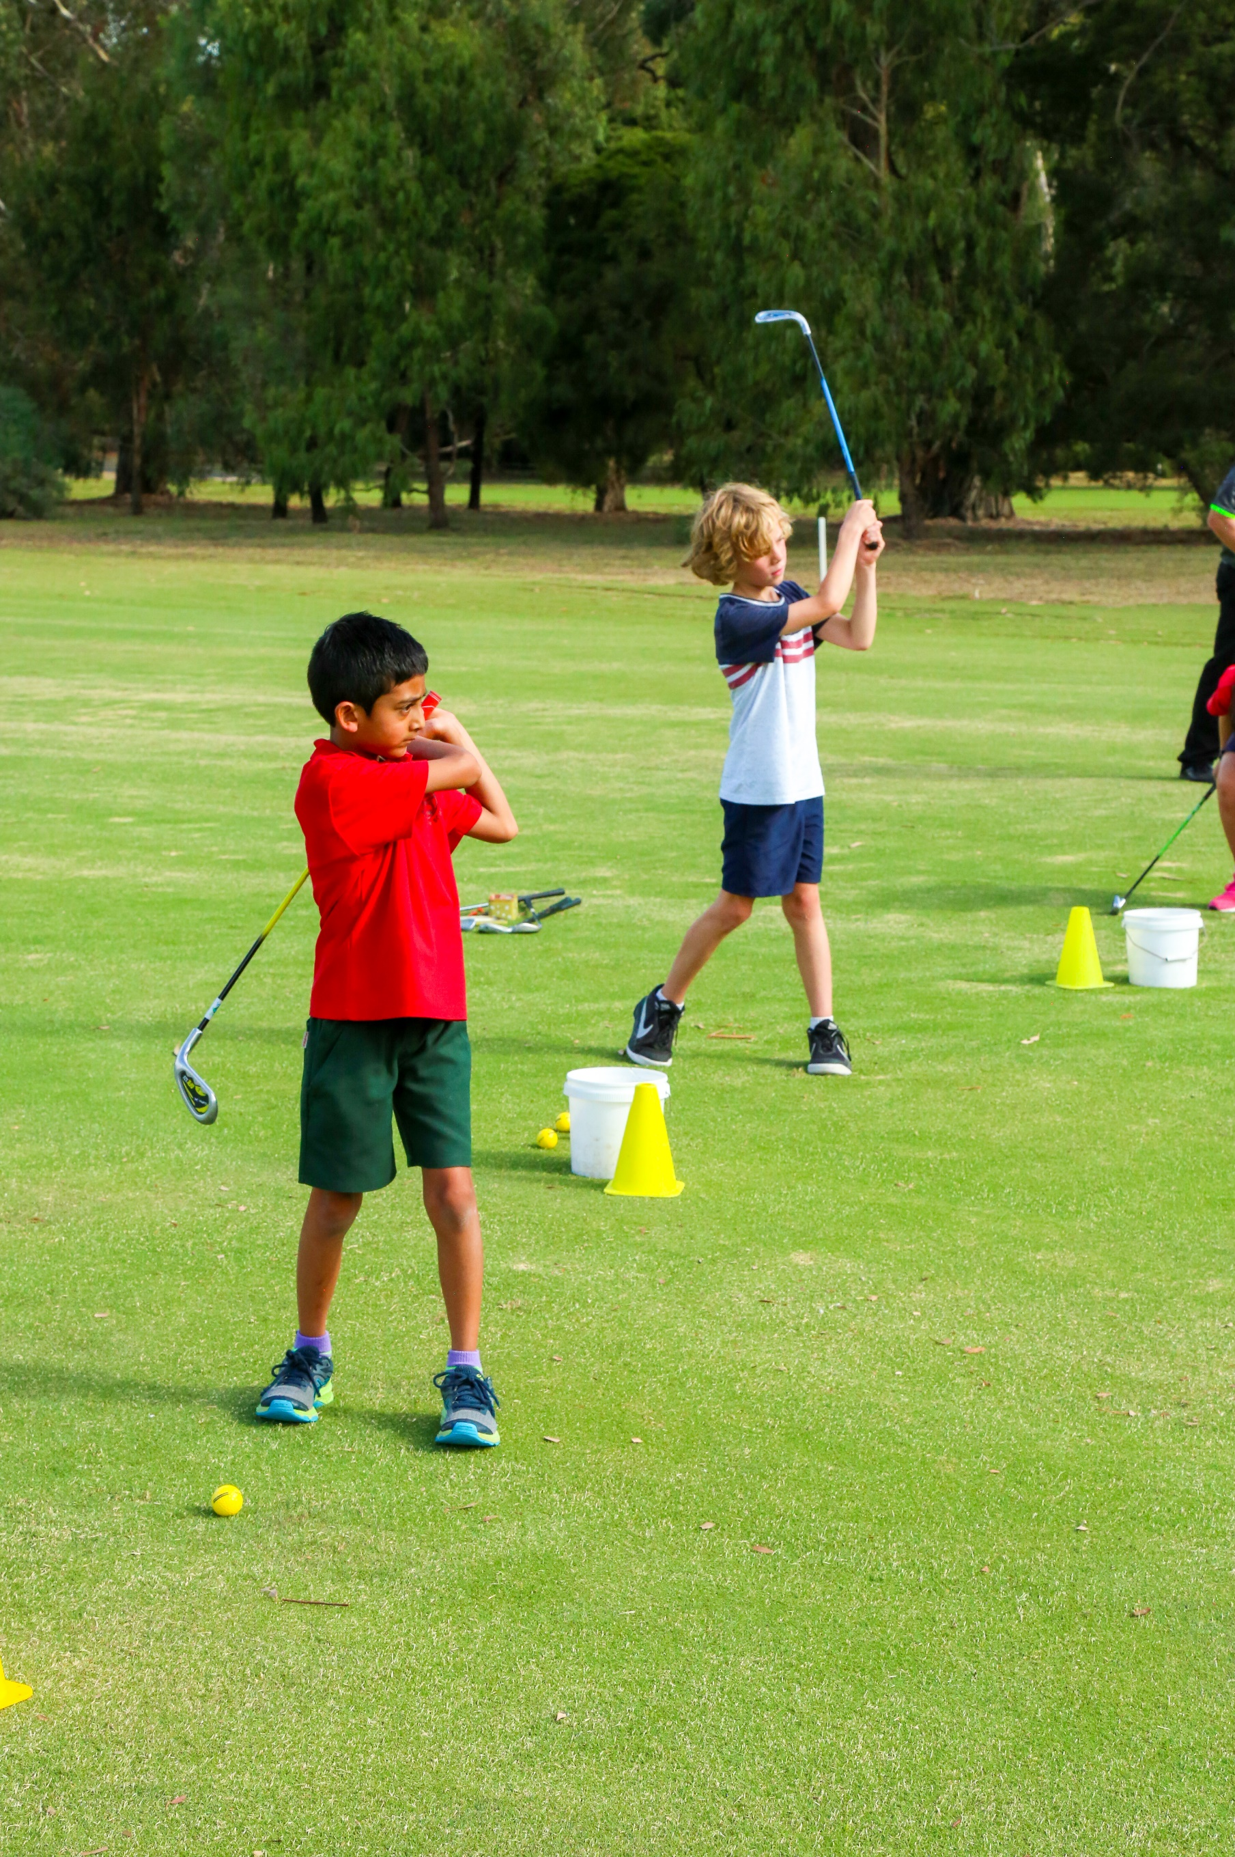

Outcome area Connecting with our least active residents

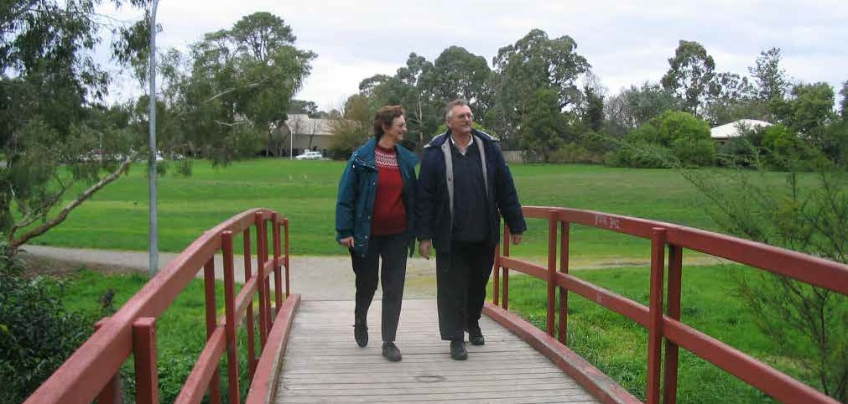

Outcome description
Safe, healthy and active
Council will disseminate information highlighting the value of incremental movement and the range of local active opportunities, using a range of accessible formats. Council will seek to, and support others to, engage with low participatory cohorts when designing programs and/or communications.

What the evidence tells us
Communities are not homogenous, and to reach as many individuals as possible, it is important to consider how different cohorts of the community will receive and process messaging.
The diverse range of needs in our community must be considered when planning, and activating public spaces and places, including accessible communications and wayfinding. When developing communication for events, programs or facilities thought should be given to who will want to use the space or place and take into consideration all needs; people with vision, hearing, mobility, cognitive and psychosocial disability as well as carers, parents with prams and people for whom English is a second language.52 Where possible utilise local networks and multiple formats of communication to disseminate information.
Council will not rely on public notices or general advertisements to reach the whole community, given that there is different messaging required to reach
Maroondah’s most inactive residents. Positive messaging supporting the benefits of small incremental segments of activity has the ability to empower people leading sedentary lifestyles to move more often.

What the community has told us
Community feedback during the COVID 19 restrictions highlighted that many residents had previously never realised the breadth of open space opportunities within walking distance of their homes. The 5km restrictions coerced families to explore their local neighbourhoods many noting that they had no idea of the extent of walking tracks, parks and other facilities within their neighbourhood. While it is hopeful that we will never again face lockdown travel restrictions, the situation has highlighted that greater promotion and effective wayfinding is required for residents to realise the local opportunities available to them.
Furthermore, in undertaking consultation with the community, conversations and feedback often reverted to barriers to attending the gym or sports with little recognition that physical activity can be simply moving more and sitting less in everyday lives. The guilt from not prioritising formalised activity often led to people doing nothing at all, feeling a hopelessness due to lack of time and/or motivation.
This feedback highlights the need for Council to invest in awareness promotions on the value in moving more often, even in short bursts, and reducing time sitting.

Priority actions

Key Direction | Priority Actions | Lead Responsibility | Timeframe
4.1 Collaborate with Community networks and Council Advisory Group Committees that represent or are connected to the people that we are trying to reach. | 4.1.1 Regularly attend the Eastern Volunteers Network Community of Practice, Migrant Information Centre’s Community Leaders Meeting, Maroondah Emergency Relief Network, Maroondah Reconciliation Partnership Group, Disability Advisory Committee, and other networks and Advisory Committees to understand needs, share opportunities and determine effective avenues for promoting campaigns. | City Futures  Sport & Recreation | Ongoing
 | Capitalise on existing State and Federal Campaigns such as the Get Active Platform and Heart Foundation Walking Platform to benefit our community. | Sport & Recreation | Min 1 per calendar year
 | 4.2.2 Develop a targeted MOVING campaign to assist residents to understand movement options and the benefits of increased daily activity and decreased sitting. | Sport & Recreation | October 2025
 | 4.2.3 Develop a process for the design and testing of targeted campaigns and promotions to ensure that it is reaching and resonating with the intended market. | Sport & Recreation Communications & Citizens Experience City Futures Community Services | March 2025
 | 4.2.4 Develop and evaluate Communication and Engagement Plans for infrastructure upgrade completions and programs including the development of accessible social scripts and other important access information. | Communications & Citizens Experience | Ongoing
4.3 Support sports, recreation and social groups to increase their connection and profile within the community. | 4.3.1 Provide a series of club development training opportunities to understand the needs of, and ways to reach marginalised groups. | Sport & Recreation | Min 1 per year
4.4 Utilise responsible pet ownership campaigns as a mechanism to promote increased physical activity. | 4.4.1 Link social media messaging of ‘Why being active with your dog is beneficial’, to the Ok my dog’s friendly campaign.  Include messaging in the Responsible Pet owner packs and web information. | Local Laws | April 2025

Indicators of progress
- Review analytics of specific Council ‘Active’ webpages and social scripts.
- Utilise data and technology tracking measures to obtain and review baseline data on open space utilisation.
- Number of Maroondah walkers registered on the Heart Foundation Walk initiative.

Tracking our progress

The specific priority actions and projects outlined in this Strategy will be monitored as they are implemented and reported to Council on a bi-annual basis with Strategy review commencing in the fourth year. Council will continue to work with the State and Federal Governments, key

Glossary
Physical Activity: World Health Organisation defines physical activity as any bodily movement produced by skeletal muscles that requires energy expenditure – including activities undertaken while working, playing, carrying out household chores, travelling, and engaging in recreational pursuits.
Active Living: A way of life that integrates physical activity into daily routines
Sport: The Australian Sports Commission defines sport as: ‘A human activity capable of achieving a result requiring physical exertion and/or physical skill which, by its nature and organisation, is competitive and is generally accepted as being a sport’.
Incidental Physical Activity: Physical activities performed that are undertaken as part of carrying out normal daily chores.
stakeholders including peak sporting bodies and health agencies, local sports and recreation providers and other community networks to make Maroondah’s places, spaces and opportunities as welcoming and suitable as possible to the least active members of our community.

Sedentary Behaviour: The Department of Heath describes ‘Sedentary behaviour’ as a term used to describe time spent doing physically inactive tasks that do not require a lot of energy.
Pedestrian: A person who travels by foot.
Intersectionality: Describes how different parts of a person’s identity or circumstances – such as age, race, culture, disability, gender, socioeconomic status or religion – intersect and combine to shape people’s life experiences, including unequal outcomes, privilege and discrimination.
COVID 19 Pandemic: The COVID-19 pandemic was a global outbreak of coronavirus, an infectious disease caused by the severe acute respiratory syndrome coronavirus.

References

- VICHEALTH www.vichealth.vic.gov.au/our- work/encouraging-regular-physical-activity accessed 27/3/2023
- Maroondah City Council (2014) Physical Activity Strategy Household survey
- Inside Edge MESRS Melbourne East Region Participation Data – Top 18 Sports
- Atlas.id.com.au/maroondah
- Department of Health and Aged Care (2014) Australia’s Physical Activity and Sedentary Behaviour Guidelines Accessed 16/03/23
- www.profile.id.com.au/maroondah/overseas- arrivals accessed 15/5/23
- Australian Sports Commission and Volunteering Australia (2021) Partnership to bring the sector together.
- World Health Organization, ‘Mental disorders fact sheet, accessed October 2023
- Victorian Government –Department of Health (2020) Victorian Population Health Survey
- Australian Institute of Health and Welfare Mental health services in Australia: Mental health: prevalence and impact – (aihw.gov.au) Access 11.05.2023
- www.reviews.org/au/mobile/2022-mobile-
phone-usage-statistics accessed 18.05.2023
- Deloitte (2021) Media Consumer Survey
- Maroondah City Council (2021) Maroondah Liveability Wellbeing and Resilience Strategy 2021-2031 pg39
- Australian Institute of Health and Welfare Physical activity snapshot – (aihw.gov.au) release 19/5/2023
- www.aifs.gov.au/resources/short-articles/too-much-time-screens Accessed 18/5/23
- VicHealth (2021) Sport participation in Victoria 2015–2021 The impact of COVID-19 and the recovery of participation in sport
- Australian Bureau of Statistics (2023) Physical activity, 2020-2021 financial year (abs.gov.au)
- Garrard J, (2017). Young people and walking. Victoria Walks, Melbourne
- Resilient Youth Australia (2023) STUDENT RESILIENCE SURVEY Snapshot Report Maroondah Wellbeing Cluster
- Australian Bureau of Statistics (2022) ABS National Health Survey 2020/2021 release 21/3/22
- www.clearinghouseforsport.gov.au/participation-in-sport accessed Aug 2023
- Australian Sports Commission 2020. AusPlay Survey national results 2019 Canberra
- Football Australia Factsheet Culturally and Liguistically Diverse Communities
- BERII MEK City Council How to reach CALD population Fact Sheet http//Active.merri-bek.vic.gov.au
- ABS, 4715.0 2018–19 National Aboriginal and Torres Strait Islander Health Survey 2019
- Nelson A.L., Macdonald D., Abbott R.A. A risky business? Health and physical activity from the perspectives of urban Australian Indigenous young people. Health Risk Soc. 2012
- Macniven R, Elwell M, Ride K, Bauman A and Richards J 2017. A snapshot of physical activity programs targeting Aboriginal and Torres Strait Islander people in Australia. Health Promotion Journal of Australia 28:185-206.
- Dahlberg E, Hamilton S, Hamid F, and Thompson S,*Indigenous Australians Perceptions’ of Physical Activity: A Qualitative Systematic Review 2018
- Australian Bureau of Statistics, Census of Population and Housing 2016 and 2021. Compiled and presented by .id (informed decisions).
- The Convergence Partnership Fund of the Tides Foundation, (2010) Fostering Physical Activity for Children and Youth
- Australian Bureau of Statistics, Census of Population and Housing 2016 and 2021. Compiled and presented by .id (informed decisions).
- Arnott, C and Porteous, S. (2017). Health and wellbeing needs of older people living in the Eastern region of Melbourne, Inner East Primary Care Partnership, Melbourne.
- Maroondah City Council (2019) Equally Active Strategy
- Australian Bureau of Statistics (2022)ABS National Health Survey 2020/2021 release 21/3/22
- Outonthefields.com accessed 26.05.2023
- www.profile.id.com.au/maroondah Accessed 17/3/2023
- Australian Government Disability Discrimination Act 1992

- Australian Sports Commission (2010). Getting Involved in Sport. Participation and Non Participation of people with a disability in sport and active recreation Dr Nora Shields and Ms Anneliese Synnot La Trobe University (2010) Barriers and facilitators to physical activity and community sports for children with disability
- Bus Association of Victoria. Public transport use – a ticket to health. Briefing paper. Port Melbourne, VIC; 2010.
- Burke M., Stanley J., Duncan M., et al. Action area 4: Active transport. In: Blueprint for an Active Australia. 3rd ed. Melbourne: National Heart Foundation of Australia, 2019.
- Department of Transport and Planning 2023, Victorian Integrated Survey of Travel and Activity (VISTA), accessed 15 September 2023
- Department of Transport (2010), Metropolitan Bus Service Review: Knox/Maroondah/Yarra Ranges, BoozandCo, Melbourne
- Eady, J and Burtt, D (2019). Walking and transport in Melbourne suburbs. Victoria Walks, Melbourne, Nov.2019
- PTV 2015, Passenger Activity by Metropolitan Stations 2008-2009 to 2013-2014.
- Healthyactivebydesign.com.au/design- features/public-open-spaces/evidence
- Maroondah City Council,(2021) Maroondah Liveability Wellbeing and Resilience Strategy 2021-2031 pg19
- Maroondah City Council, (2021) Maroondah Liveability Wellbeing and Resilience Strategy 2021-2031 pg39
- Purple Orange. (2021) Guide to Co-Design with people living with disability.
- Victorian Government. Change Our Game State of Play Survey 2022-2023
- www.youthsense.com.au/parents/whats- driving-teenage-girls-away-from-playing-sport accessed 26/05/2023
- Inclusive SA Accessible Wayfing and Signage Toolkit, https://inclusive.sa.gov.au/resources accessed 6.6.23

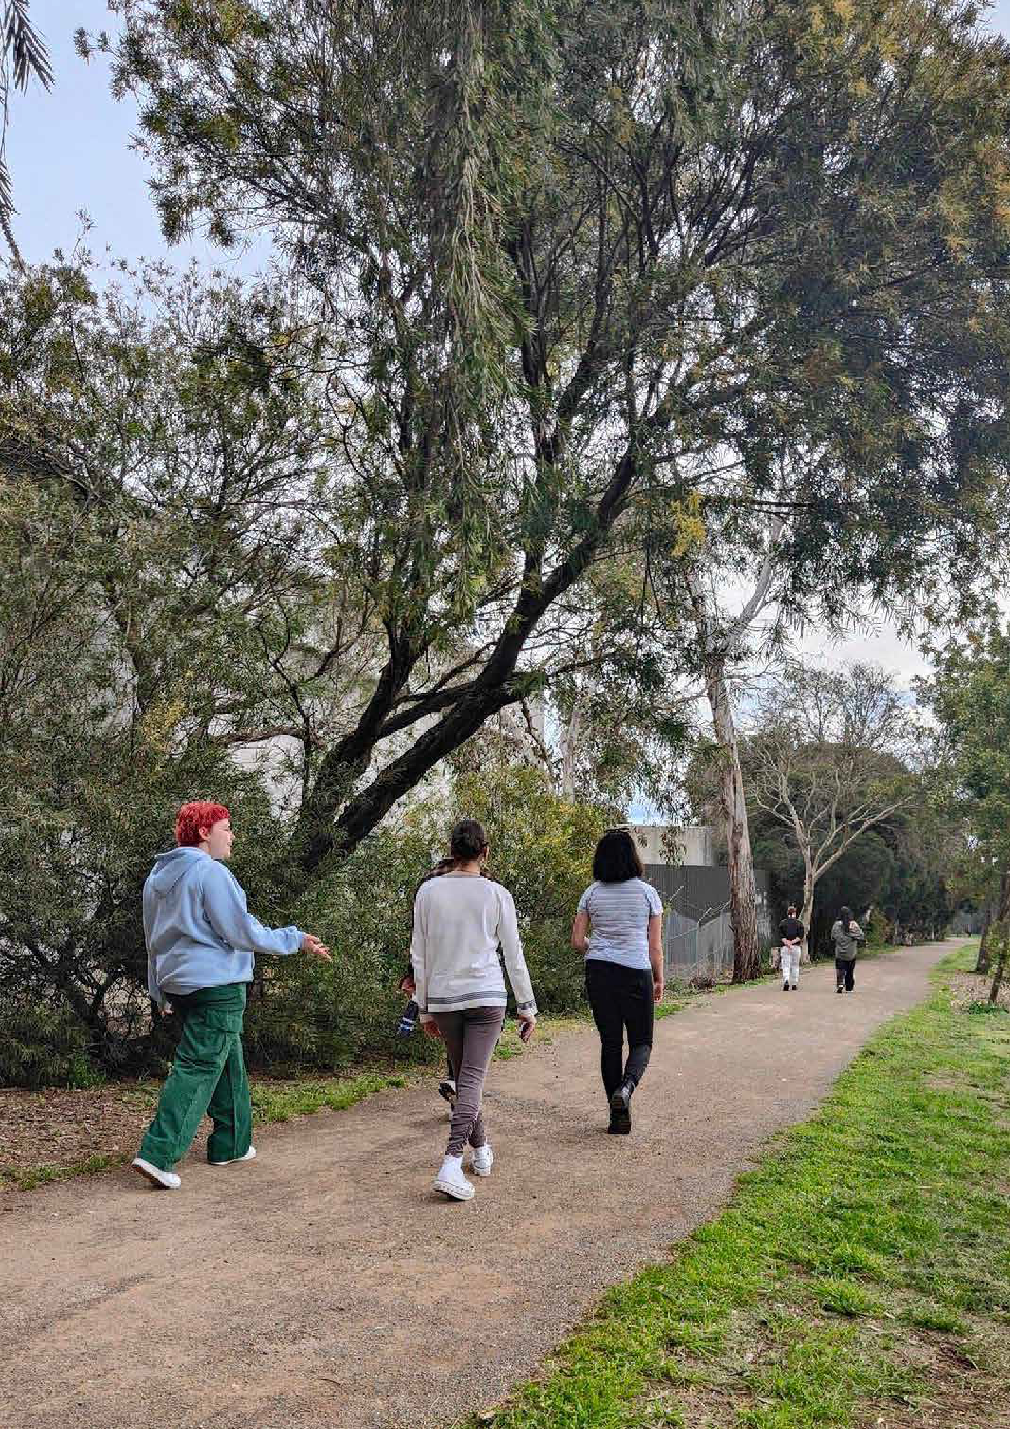

MAROONDAH CITY COUNCIL PHYSICAL ACTIVITY STRATEGY 2024-2029 51

To contact Council
  - phone 1300 88 22 33 or (03) 9298 4598
  - SMS 0480 020 200
  - visit our website at www.maroondah.vic.gov.au
  - email maroondah@maroondah.vic.gov.au
Translating and Interpreter Service
13 14 50
National Relay Service (NRS)
13 36 77
MaroondahCityCouncil
maroondahcitycouncil
Maroondah City Council
CityofMaroondah
Maroondah City Council




mcc1162-Jun24

