
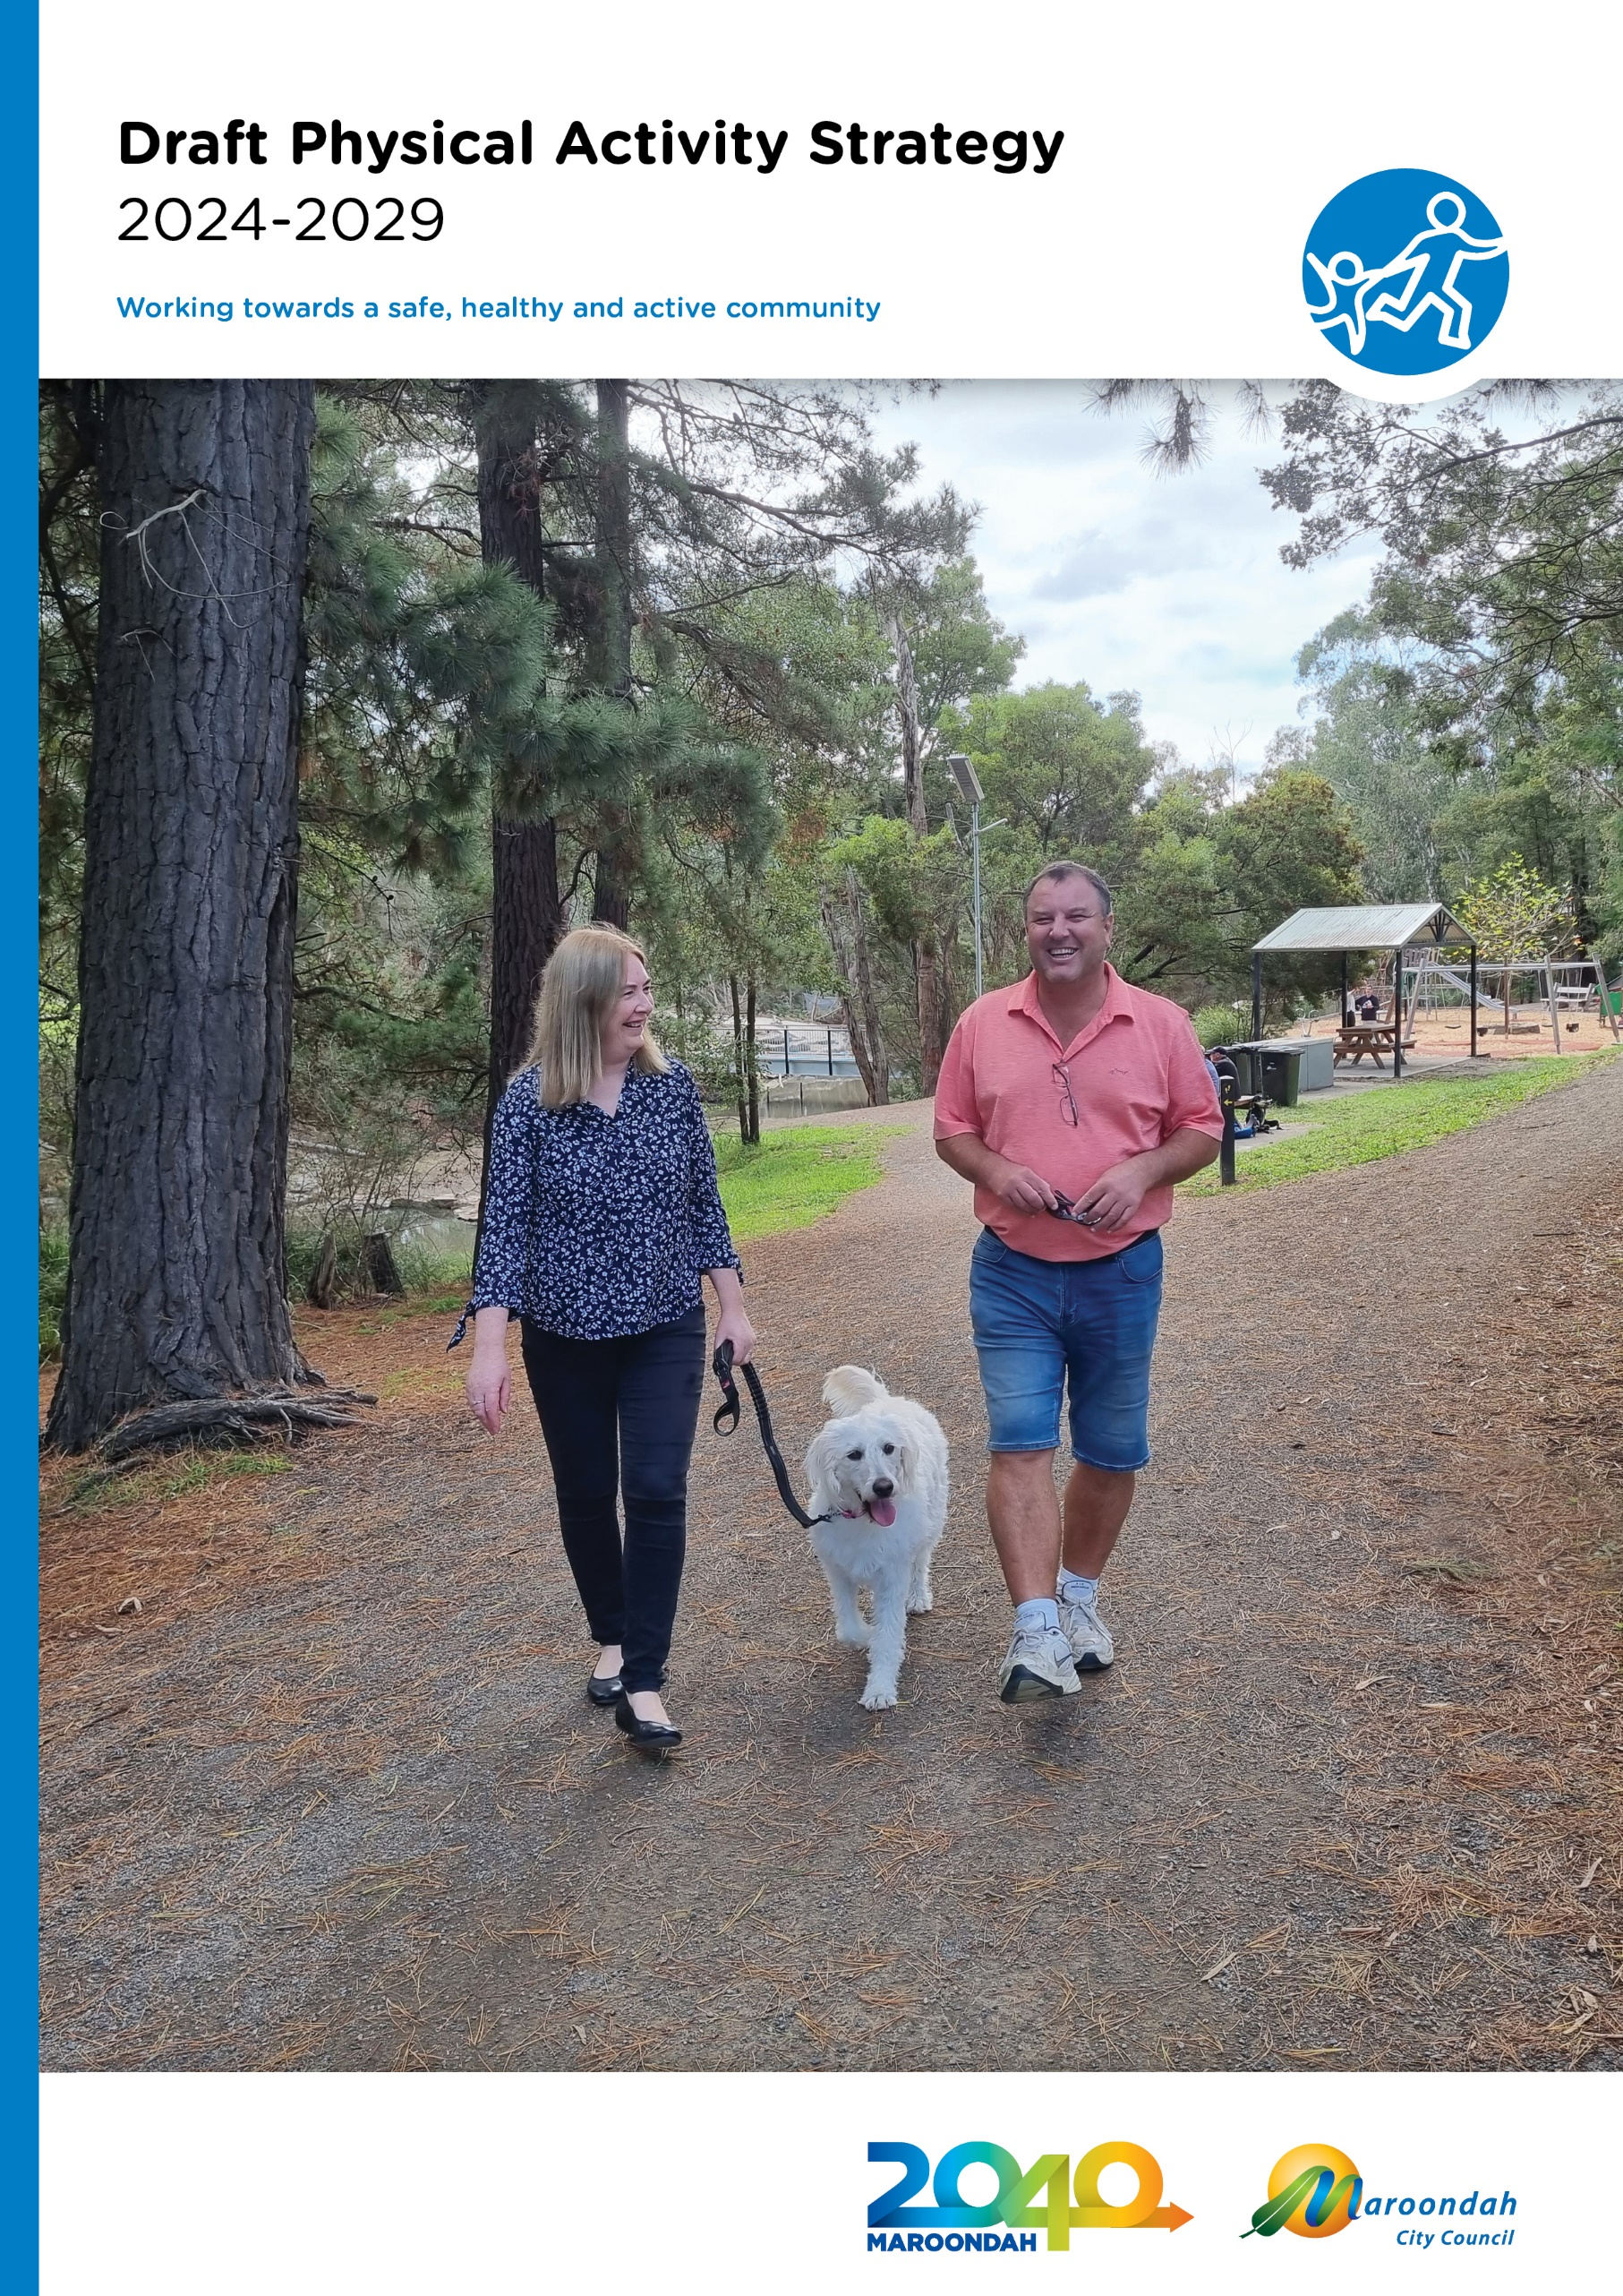

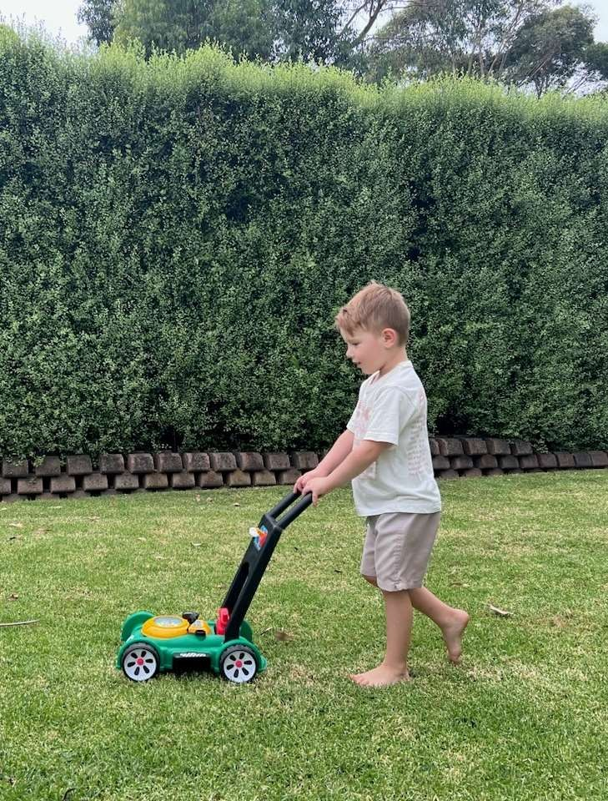

Acknowledgment of Country
We, in the spirit of Reconciliation, acknowledge the Wurundjeri People of the Kulin Nation as Traditional Custodians of the land now known as the City of Maroondah, where Indigenous Australians have performed age old ceremonies. We acknowledge and respect their unique ability to care for Country and their deep spiritual connection to it. We pay our respects to their Elders, past and present.

Contents
EXECUTIVE SUMMARY 3
Why is increasing physical activity levels important? 4
Notable achievements of the 2015 - 2020 Physical Activity Strategy 6
Strategic Context 7
Maroondah- A Snapshot of active Opportunities 8
State and Federal Priorities 10
State Government - Active Victoria 2022-2026 10
The Office for Women in Sport & Recreation Change our Game Initiative 10
Community Engagement Summary 14
How active are we? 16
What motivates us to be active? 18
Challenges affecting Physical Activity levels 18
GENERAL COMMUNITY 19
CULTURALLY & LINGUISTICALLY DIVERSE (CALD) COMMUNITIES 20
FIRST PEOPLES 21
YOUNG PEOPLE 22
OLDER PEOPLE 23
WOMEN AND GIRLS 24
LGBTIQA+ 25
PEOPLE WITH DISABILITIES 26
Increasing Active Travel 27
A strategy for a more active future 27
Increasing Active Travel 28
Spaces and places that encourage physical activity 31
Supporting Diversity in Sport 33
Outcome description 35
Tracking our progress 37
Glossary and References 38
Glossary 38
References 39

EXECUTIVE SUMMARY

The majority of Maroondah residents do not undertake enough physical activity.
Based on the latest available ABS data, 35% adults aged 18–64 are insufficiently physically active. More women (39%) than men (32%) did not do the recommended amount of physical activity (ABS 2022b). Increasing the level of physical activity in the Maroondah Community is likely to have a major impact on public health and therefore Maroondah City Council will prioritise the development and/or improvement of environments to support physical activity and Active Lifestyles.

The Physical Activity Strategy 2024 - 2029 builds on the recommendations of Maroondah’s Maroondah Liveability Wellbeing and Resilience Strategy and input from the Maroondah 2050 Vision, setting actions for the next five years to address levels of inactivity.

A perceived lack of time is reported as a primary reason Maroondah residents do not undertake enough regular physical activity. This reasoning indicates the need to ensure that there is an extensive range of accessible spaces, places and opportunities to make it easier to move, more often. Furthermore, information and education are essential to reframing the message that achieving the daily 30 minutes can be incremental movement and may be of greater health benefit, regardless of intensity, when used to break up long periods of inactivity. The top five activities undertaken by Maroondah residents were reported as walking, fitness class/gym, running/jogging, cycling and yoga/pilates, acknowledging the preference for physical activity pursuits that are non-competitive, informal or unstructured, and/or can be undertaken in one’s own time.

There are different factors that affect the physical activity levels of specific populations and therefore different strategies are required to overcome these. The Physical Activity Strategy highlights the challenges and opportunities being experienced by the general community and identifies seven (7) low participatory cohorts to target, with actions that will have a positive impact on participation. To address the highlighted challenges, and make physical activity an easier option, the strategy focuses on four (4) key outcome areas which highlight opportunities for Council action.


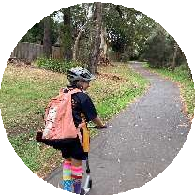

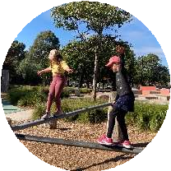

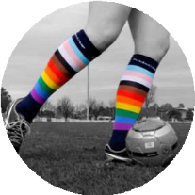
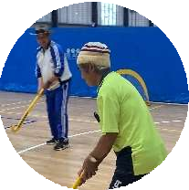
Increasing Active Travel

Encourage & support walking, cycling & use of public transport

Spaces & places that encourage physical activity
Create vibrant, active public open spaces, where people feel safe, welcomed & motivated

Supporting Diversity in Sport

Support inclusive sporting settings to achieve participation that reflects our increasingly diverse community.

Connecting with our least active residents

Design & promotion of accessible opportunities, infrastructure & positive messaging

Consultation
In preparation for the development of Council’s Physical Activity Strategy, a range of consultation methods were undertaken to establish a clear picture of Maroondah’s current participation levels, reasons for non- participation and community needs. There was also a wide range of recent data and extensive community feedback obtained for the Maroondah Liveability Wellbeing and Resilience Strategy and in preparation for the Maroondah Play and Gathering Places Strategy and the Maroondah 2050 visioning project.

Action
In order to address levels of inactivity, Council must consider the barriers and opportunities outlined in this strategy and undertake measurable actions over the next 5 years.

The key directions and priority actions will guide the development of new policies, infrastructure improvements, programs and collaborative initiatives which will improve practices, respond to demonstrated need, increase access and encourage residents to prioritise physical activity in their daily routine.

Priority actions will be led by a wide range of Council service areas. The implementation will be the responsibility of each lead area with support from relevant service areas detailed in the plan. Reporting will be undertaken annually under the facilitation of Council’s Sport and Recreation Team.

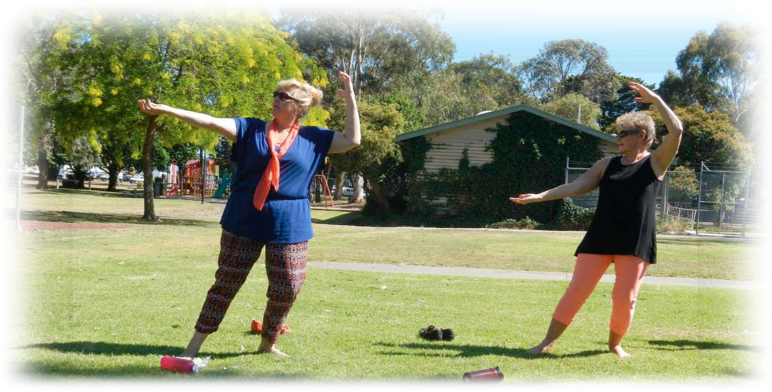
Why is increasing physical activity levels important?

Physical activity is important at any age for good physical and mental health and wellbeing. All forms of physical activity can provide health benefits if undertaken regularly. Physical inactivity and sedentary behaviours are a risk factor for a variety of mental illnesses including depression, anxiety, and age- related cognitive decline.³

As well as the health gains by regular movement in preventing chronic disease and promoting mental wellbeing, other benefits include making social connections, increasing productivity, and positive changes to the environments, such as reduced traffic congestion and safer neighbourhoods^{i}.

Active living is incorporating regular physical activity into daily routine. It includes active travel, play, gardening, incidental exercise as well as participating in sport or an active pursuit for pleasure and fitness. Prioritising physical activity as an individual, an organisation and as a community has multiple benefits to overall health, social, economic and environmental benefits.
Increasing the level of physical activity in the Maroondah Community is likely to have a major impact on public health and therefore Council will prioritise the provision of supportive environments for physical activity to assist residents to adopt an active living lifestyle.

Maroondah residents self-report that the key reason that their level of regular physical activity is impeded, is ‘lack of time’.^{ii} This reasoning indicates the need to shift the mindset in those that are least active to view increasing activity levels as moving more often, even if in small increments.

Research has highlighted that any increased movement is beneficial and that incorporating greater movement throughout the day, which breaks up periods of sitting, may in fact be more valuable than extended periods of sitting followed by a large block of moderate to intensive activity.
Council must continue to provide and enhance environments for physical activity in public open space and recognise that while sport and organised recreation is a key component, informal recreation and incidental exercise is of primary importance to increasing overall activity levels as only 17.39% of Maroondah residents engage in organised sport^{iii}. Council should support the provision of a wide range of accessible opportunities to make moving more often, easier to achieve. Furthermore, accessible information and education are essential to ensure that residents understand what options are available and to support inclusion within these environments.

Background

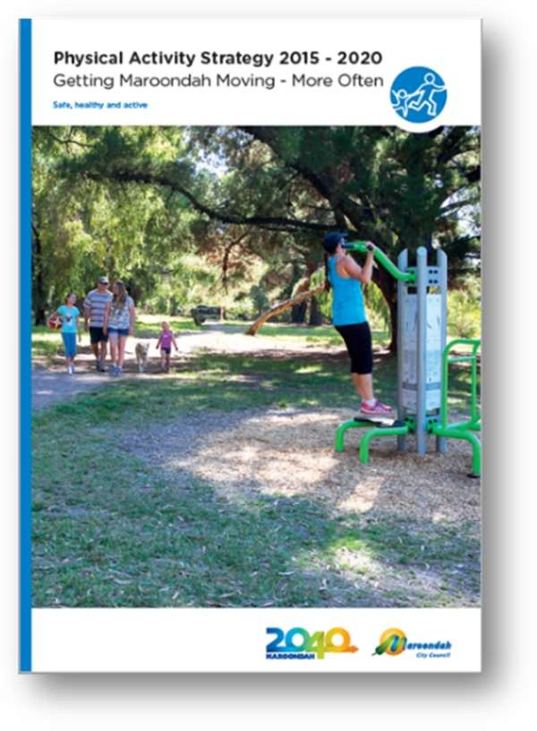
The 2015 -2020 Physical Activity Strategy has been of great benefit for Council, both in terms of a strong rationale for investment in sports and recreation infrastructure and for creating greater opportunities for physical activity. The strategy has been an integral component to the success of many State and Federal grant submissions providing evidence to support requests for investment in sport & recreation.
Within the 5 year timeframe of the strategy, all three levels of government have placed greater importance on supporting increased physical activity levels for social, physical and mental benefit. There has been a significant increase in policy and financial investment to support new initiatives which has been prompted by the greater awareness of the impacts of physical activity on health & wellbeing and the relationship between women and girls’ inclusion in traditionally male dominated sport as a primary intervention in the prevention of violence against women.
Changing places amenities

Notable achievements of the 2015 - 2020 Physical Activity Strategy

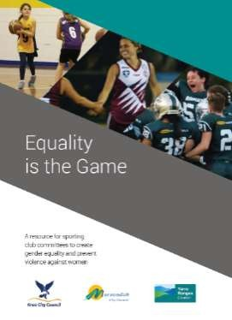
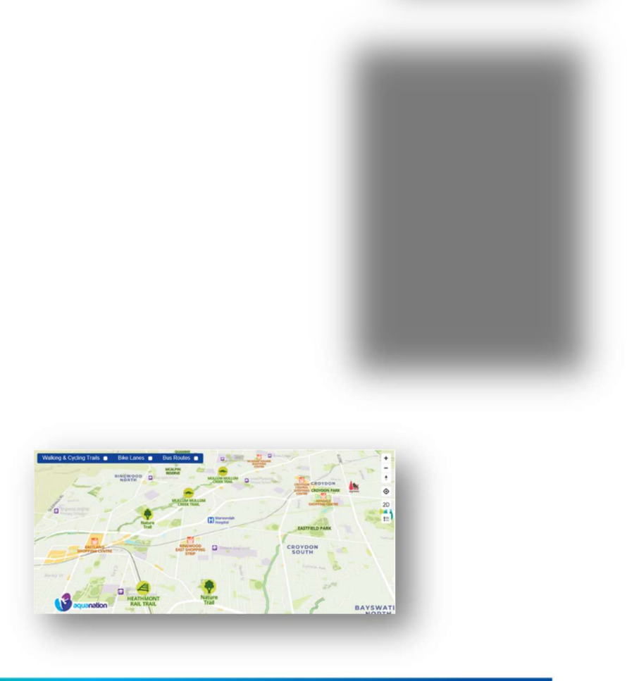
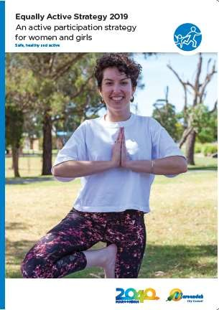

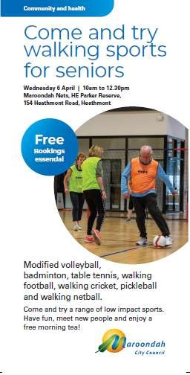
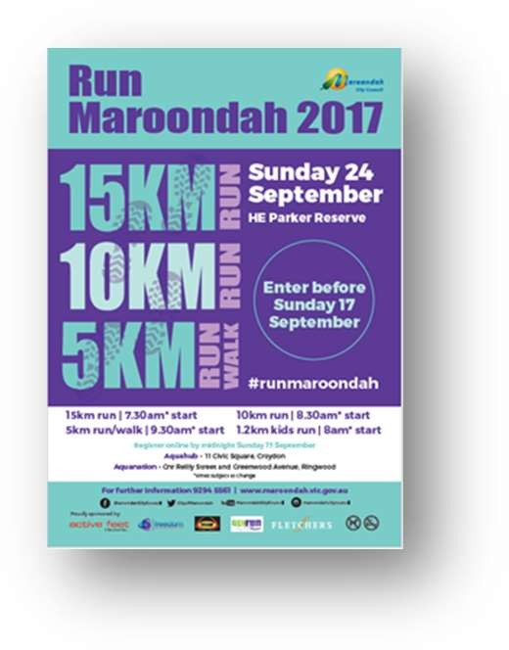
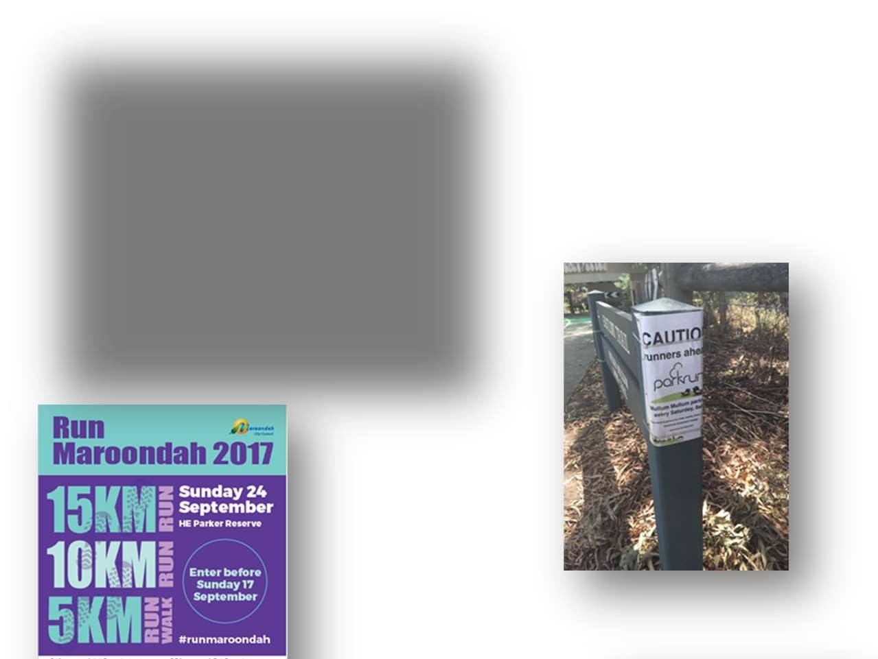
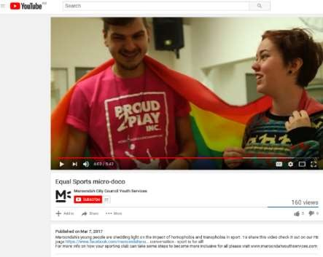
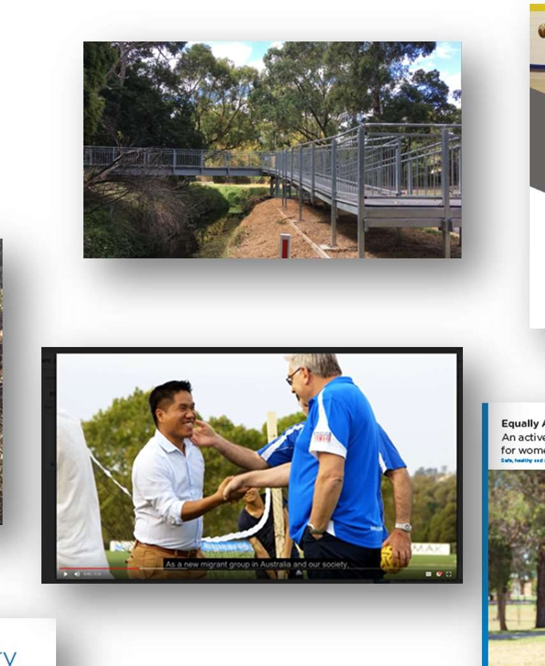
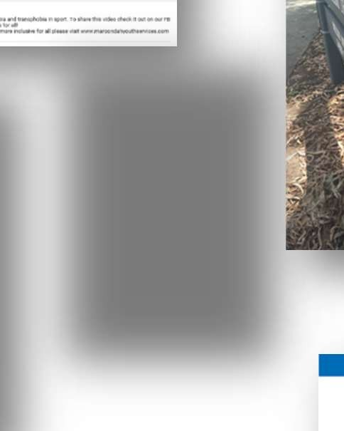
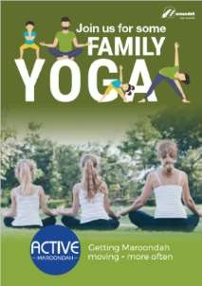
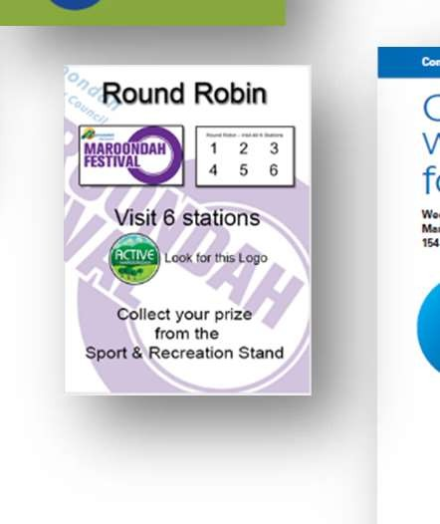

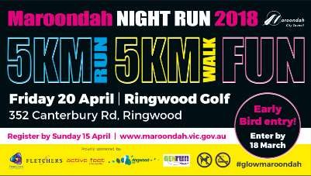
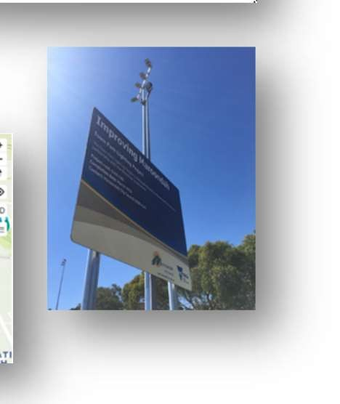
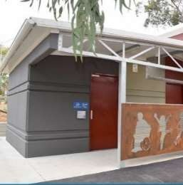
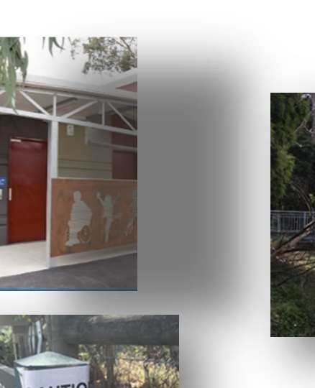
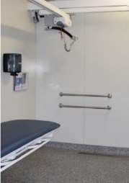

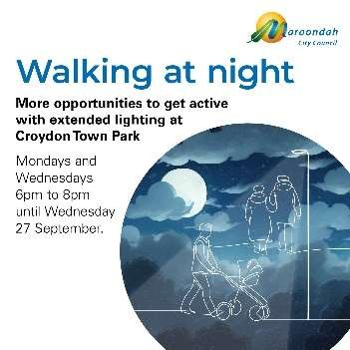

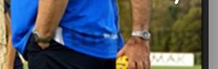

Community partnerships
Inclusive initiatives

Online interactive map

Strategic Context
To fully understand the context for the strategy as it relates to Maroondah City Council, the document must highlight the relevant links between current Council policies and the provision of planning, design, infrastructure, programs & services and information that support active living.
Fundamental to the implementation of Council’s roles and responsibilities, is Maroondah’s Integrated Planning Framework. The framework sets out the relationship and priority order of Council’s strategic documents that will guide the development and implementation of the Physical Activity Strategy. The primary documents include:

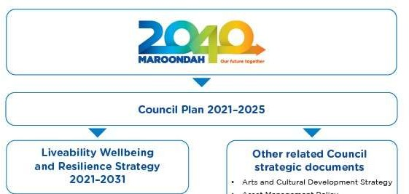
Maroondah’s Community Vision To be updated in 2024 to 2050

A number of other relevant Council plans and strategies were referenced in the development of this document and are linked below for reference:
- Maroondah Disability Action Plan 2022-2026 | Maroondah City Council
- Children and Families Strategy | Maroondah City Council
- Positive Ageing Framework and Action Plan 2021–2025 | Maroondah City Council
- Melbourne East Regional Sport and Recreation Strategy | Maroondah City Council
- Open Space Strategy | Maroondah City Council
- Youth Strategy | Maroondah City Council
- Equally Active Strategy | Maroondah City Council
- Maroondah Extreme Sports Strategy | Maroondah City Council

The Strategy must ensure that the recommended future direction correlates and complements these linking documents and above all reflects Maroondah’s vision, Maroondah 2040. (New 2050 Vision under development)
From the Maroondah 2040 community vision engagement process, 8 preferred future outcomes have been identified as community priorities looking ahead to the year 2040 and beyond. These future outcomes will drive the 2040 vision. The most relevant future outcome to this strategy is:

A safe, healthy and active community
In 2040, Maroondah will be a safe, healthy and active community with local opportunities provided for people of all ages and abilities to have high levels of social, emotional and physical wellbeing.

Maroondah- A Snapshot of active Opportunities

Maroondah is located in Melbourne’s eastern suburbs, approximately 25km from Melbourne CBD with a population forecast of 155,043.⁴.

Maroondah is home to approximately 135 active recreation organisations and 140 sporting clubs.There are 430 designated reserves including 61 sporting ovals; 121 playgrounds; 34km of walking tracks & shared pathways; 3 bowling clubs; 3 community gardens; 3 skate areas, 2 athletics tracks, a croquet club; 84 tennis courts and 6 multiuse indoor halls. Maroondah City Council owns and manages 2 golf courses, Ringwood Golf and Dorset Golf; a multiuse stadium, The Rings; an outdoor 50 metre pool, Croydon Memorial Pool; a combined aquatic and fitness centre, Aquahub a Regional diving, fitness and aquatic facility, Aquanation, an indoor/outdoor multisport complex, Marondah Nets and a new Regional indoor cricket training centre, Maroondah Edge.

Maroondah is also home to five (5) Neighbourhood Houses and boasts a comprehensive listing of community organisations offering varied physically active opportunities for differing interests, ages and abilities. Maroondah has a significant number of active organisations for retirees and in recent years has seen an increase in churches offering a range of social and leisure programs to extend their reach within the community. Schools play a large role in offering physical activity opportunities to children and young people through school curriculum, interschool sports and out of school hours programming. Maroondah also has a range of private recreation providers offering health and fitness programs, organised sports and other physically active pursuits.

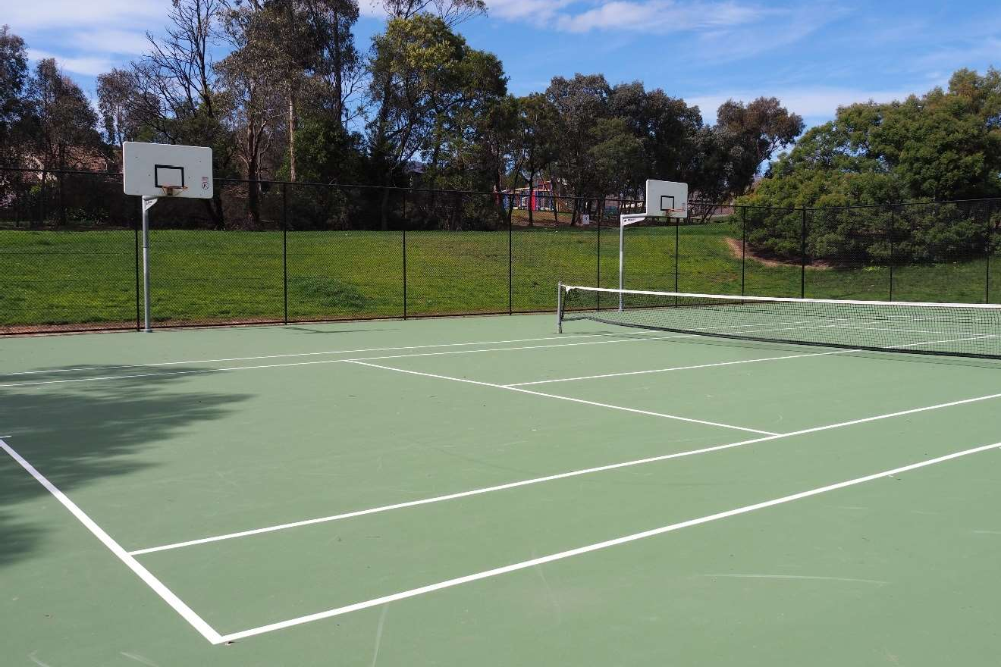

Council’s role in influencing physical activity levels
Maroondah City Council plays an integral role in the provision and facilitation of physical activity opportunities through both the provision of services and infrastructure and the strategic planning and development of environments that support Active Living.

There are eight (8) Council Departments which have been identified as having a direct impact on Maroondah Community's ability to participate in physical activity. The internal key stakeholders and their role in relation to impacting physical activity levels are as follows:

Leisure and Major Facilities | City Futures
The Rings, Maroondah Nets, Maroondah Edge, Aquahub, Aquanation,Croydon Memorial Pool, Ringwood Golf, Dorset Golf, Sportsfield management and Maintenance | Strategic Planning and Sustainability, Community Wellbeing  Manage the Maroondah Planning Scheme that supports and encourages active living through urban design, landscapes,  buildings and land uses.
Direct provision of fitness and lifestyle programs and  management of spaces  Maroondah Sport and Recreation  Planning and provision of programs and events. Provision of funding, training and other support for community providers. | Oversee the planning and advocacy for an integrated public and active transport network and the delivery of initiatives that encourage the utilisation of active transport.  Undertake Health and Wellbeing planning, advocacy and support for marginalised and disadvantaged communities, and strengthening and building the capacity of the community.
Projects and Asset Management  Asset Planning, Asset Management, Building Projects, Building Maintenance  Management of Council’s community assets, to facilitate safety, longevity, and continued provision of services for the community. Advice & management of Capital Works Projects and strategic planning relating to the ongoing lifecycle management of Council assets. | Engineering & Building Services  Engineering Services, Building Services  Provision of engineering technical expertise in areas of traffic and transportation planning, engineering development approvals, and project management for the development and  / or enhancement of assets such as roads, footpaths, bicycle paths, and buildings.
Communications & Citizen Experience  Assist in the promotion of infrastructure, programs and events and targeted health promotion campaign and support the engagement of residents in infrastructure planning and strategy design. | Operations  Bushland Management, Built Environment, Tree Maintenance, Parks and Open Space  Responsible for the ongoing audits and maintenance of playgrounds, parks and bushland reserves as well as the footpath and trail network.
Community Services | Community Safety
Aged & Disability Services, Youth & Children’s Services, Maternal & Child Health  Provision of targeted support and initiatives; facilitation of health promotion initiatives and community partnerships to enhance the wellbeing of Maroondah residents aged 0- 11 years, 12- 25 years, 65+ years and persons with a disability. | Community Health, Local Laws  Facilitate health promotion initiatives for residents and food premises.  Promote responsible pet ownership - dogs on leash, encourage regular dog walking.


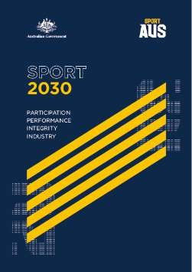
State and Federal Priorities

Federal Government - Sports 2030 - National Sports Plan

In June 2011 the Federal Government developed the National Sport and Active Recreation Framework which guided the development of policy and resource allocation across the sport and active recreation sector until 2021. This plan has since been replaced by the Sports 2030 - National Sports Plan which guides the Federal Government’s vision to ensure Australia as “the world’s most active and healthy nation, known for our integrity and sporting success”. Sport 2030 has four key priority areas which are indeed sport focussed however priority one addresses increasing the physical activity levels of all Australians:

- Build a more active Australia — More Australians, more active, more often;
- Achieving sporting excellence — National pride, inspiration through international sporting success;
- Safeguarding the integrity of sport — A fair, safe and strong sport sector free from corruption;
- Strengthening Australia’s sport industry — A thriving Australian sport and recreation industry.
As part of the Plan, the Australian Government has committed to reducing inactivity amongst Australians by 15 per cent by 2030.

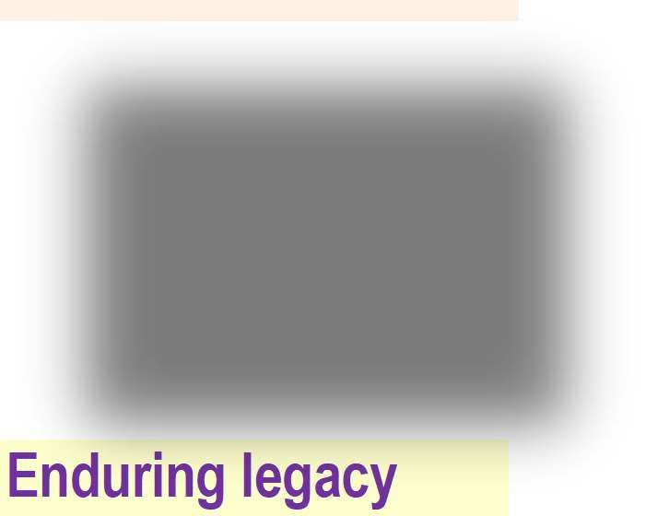
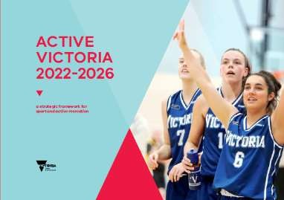
State Government - Active Victoria 2022-2026

The Victorian Government strategic framework for sport and active recreation in Victoria outlines three objectives and 12 key directions to guide activities and investment in sport and active recreation
Enduring legacy
High Events
performance Victoria maintains a
Victorians can strong pipeline of achieve success at sporting events the highest level within the Victorian
events calendar
Building value
Sector capability Good governance The sport and active Sport and active recreation workforce is recreation is a safe, highly skilled and leads inclusive, and
a resilient sector
strong, sustainable industry
Connecting communities
Sustained Infrastructure
participation Victoria has inclusive,
More Victorians accessible, and participate equitably in respectful places and sport and active spaces for sport and
recreation active recreation

The Office for Women in Sport & Recreation Change our Game Initiative

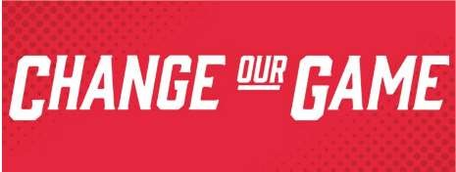
In 2015, the Victorian Government released a report from the independent Inquiry into Women and Girls in Sport and Active Recreation. The report highlighted the degree of gender inequality in Victorian sports and recreation and outlined nine key recommendations to help change and improve sport and recreation for all involved.

The overwhelming finding was that women are under-represented in leadership roles in the sport and active recreation sector. As a mechanism to implement the report recommendations, the Office for Women in Sport & Recreation was formed. The Office has been instrumental in leading initiatives to increase the number of women and girls participating in sport and active recreation.

How Much Is Enough Activity?
It is widely accepted that regular physical activity is essential in improving health and wellbeing, but how much physical activity is enough to maintain a healthy lifestyle?

The Australian Government Department of Health and Ageing have developed an evidence based set of National Physical Activity Guidelines for children, adults and older Australians. The most recent update, released in 2014, added Sedentary Behaviour (sitting time) to the guidelines as well as muscle strengthening activities.







National Physical Activity & Sedentary Behaviour Guidelines5
0-5 years
- Babies should to take part in physical activity from birth, particularly supervised floor- based play in safe environments.

- Toddlers and pre-schoolers should be physically active every day for at least three hours, spread throughout the day.

- Children 3-5 yrs should be active for at least 3 hours per day including 1 hour of energetic play. Limit time sitting or lying except when sleeping.

- Less than 2 years -no screen time,

- 2-5 years limit to less than one hour screen time per day
5-17 years
- Children and young people aged 5 - 17 years should take part in a combination of moderate and vigorous activities for at least 60 minutes a day.

- Engage in activities that strengthen their muscles and bones on at least three days per week.

- Limit use of electronic media for entertainment to no more than two hours a day

- Break up long periods of sitting as often as possible

- Children aged 5 to 13 years get 9 -11 hrs of uninterrupted sleep

- Young people aged 14 to 17 years get 8 - 10 hrs of uninterrupted sleep.
18-64 years
- Each week adults 18-64 years of age should do either:
2.5 to 5 hours of moderate intensity physical activity
or
1.25 to 2.5 hours of vigorous intensity physical activity
or
a combination of both

- Muscle strengthening activities should also occur on at least two days each week.

- Minimise the amount of time spent in prolonged sitting.

- Break up long periods of sitting as often as possible
65+
- Older adults should accumulate at least 30 minutes of moderate intensity physical activity on most, preferably all, days of the week.

- Activities should include activities to improve balance, flexibility and strength to improve overall benefit

- Minimise the amount of time spent in prolonged sitting.

- Break up long periods of sitting as often as possible

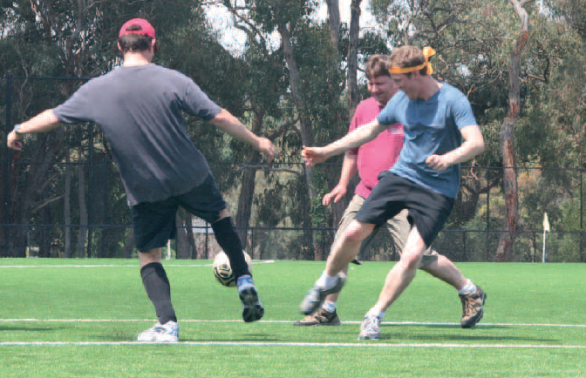

The intensity of the physical activity should represent a noticeable increase in a person’s breathing and heart rate. Moderate intensity physical activities include a brisk walk, golf, mowing the lawn or swimming. Vigorous intensity physical activities include jogging, aerobics, fast cycling, soccer or netball.

What has changed since the Strategy?


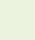



Improved Access to Maroondah Facilities
Council’s 2017 Sport Demand Analysis paper reported that 78% of existing facilities at Council’s sporting grounds do not adequately cater for female participation. Since this time, Council has been highly successful in partnering with the State and Federal governments to support a $77,685,000 investment to improve sporting infrastructure access and amenities. Improvements have included female friendly amenities and pavilion design, additional change facilities, and upgrades to sportsfield surfaces and lighting to increase capacity. These improvements have reduced the deficit figure from 78% to 20%, with planning underway to address the remaining five facilities that do not adequately cater for women and girls. Furthermore, all upgrades have been undertaken according to universal design principles ensuring all abilities access and unisex amenities to accommodate gender diversity.

Since 2015, Council has supported increased walking throughout Maroondah by investing in 53,434 metres of new footpaths, 20,297 metres of shared paths and 191 new public street lights and reserve floodlighting improving access, safety and active transport options.

COVID Pandemic Impacts
During the Covid pandemic and in the months post covid, reports indicated an increase in walking and cycling in some groups, however, there was a definitive decrease in overall mobility, physical fitness and health and mental health. Restrictions, health fears and illness had adverse effects on activity, social engagement and income. Compared to pre-pandemic, fewer Australians are relying solely on sporting clubs or organised venues for exercise. Families reported a greater awareness of time-poor lifestyles and have since become more selective in extracurricular activities and voluntary roles. This has affected both participation and the number of volunteers within the sport and recreation sector, with research by the Australian Sports Commission reporting around 61% of volunteers had resumed their usual volunteering roles7.

New Sports and new ways of delivery
The previous Physical Activity Strategy and Sports Demand Analysis highlighted a need to deliver sport differently to increase participation. Limitations of infrastructure capacity, time and a 7 day work week was impacting the traditional weekend sport format. Significant investment in sportsfield lighting has supported meeting this need, with traditionally weekend sports all introducing or expanding their night offerings in Maroondah. Council has also supported the introduction of sports since 2015. Walking formats of cricket, netball and soccer have all been successfully established as has Volleyall, all abilities volleyball, footsal and pickleball, which has seen a dramatic growth in its short time in Maroondah. The recent Maroondah Tennis Strategy has also highlighted the success of Book a Court, casual tennis play and an opportunity to further expand social tennis in Maroondah venues.

Greater Diversity
Maroondah is becoming a much more diverse population. Latest Census data reports that 29,094 people who were living in City of Maroondah in 2021 were born overseas, and 15% arrived in Australia within 5 years prior to 2021. In 2021, China had the highest proportion of recent overseas arrivals, followed by people from Myanmar who represented 16.2% of new arrivals to Maroondah in comparison to the newly arrived figure for Greater Melbourne which is 1%.6

Additionally, Maroondah has experienced an increase in the identification and recognition of gender diversity. This is evidenced by the large increase in demand for services to support gender diverse people and their families.

Decline in mental health
Mental health is a key component of overall health and wellbeing (WHO 2021). The proportion of Victorian adults who experienced high or very high levels of psychological distress increased from 18.1% in 2019 to 23.4% in 2020. This was significantly higher in the younger age groups—35.0% of adults aged 18-24 years and 27.8% of adults aged 25-34 years. 8 The National Study of Mental Health and Wellbeing conducted in 2021 found that an estimated 1 in 5 (21%) Australians aged 16–85 experienced a mental disorder in the previous 12 months (ABS 2022a)9 This rise may well be attributed to the global pandemic however in the absence of updated data, anecdotally these rates have not subsided post covid.

Greater opportunities for women & girls
Data collated to inform the 2022 Melbourne East Regional Sports & Recreation Strategy highlighted that Maroondah has 38% female sports participation across 16 key sports. Growth has been spurred on by the successful introduction and promotion of the AFLW and Football Victoria’s W League, WBBL and Australia’s success in the 2020 Women’s T20 Cricket World Cup, and 2023 Women’s Football World Cup.
In Maroondah, Women and girls’ AFL participation was 5% in 2016 and has increased to 23% in 2023. Additionally increased funding and support for the inclusion of netball as part of senior AFL clubs has led to the EFL rebranding to become the Eastern Football Netball League with 80% of league clubs now fielding netball teams. Cricket Victoria has also seen female participation gains of 12.8% in the year to 2022 and Football Victoria (soccer) has pledged a target of 50:50 gender split by 2027.

What has not changed since 2015?
Lower participation rates amongst marginalised groups
Research highlights that people from Culturally and Linguistically Diverse backgrounds, Aboriginal and
Torres Strait Islander people, people with disabilities and their carers, and people who identify as LGBTQIA+ are often impeded by physical, systemic, environmental barriers and personal circumstance and may experience further disadvantage due to diversity within their diversity (Intersectionality).¹⁰ These barriers lead to fewer opportunities to access safe, affordable and appropriate programmes and places in which to be physically active.

The prevalence and impacts of devices
Prevalent device and screen use is continuing to foster
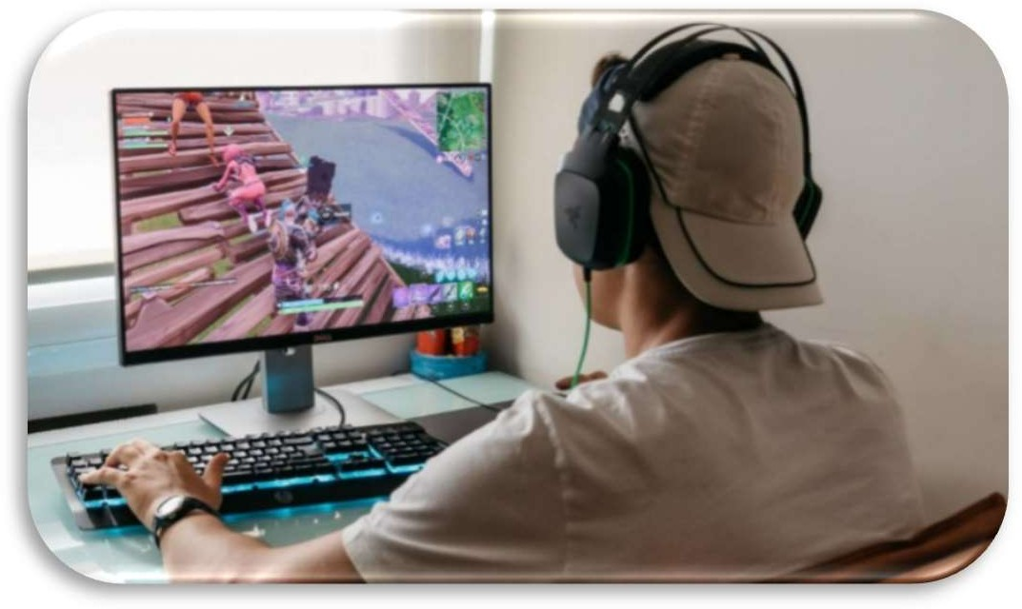
sedentary behaviours. Studies have found that the average Australian adult spends 5.67 hours a day on their phone¹¹ and an average of 7 hours watching paid TV/ movie streaming services per week¹²
Most Australian children spend more time on screens than is recommended. Estimates from research suggest only 17–23% of preschoolers and 15% of 5– 12 year olds meet screen-time guidelines.¹³ Guidelines state no screen time for children under two years, up to one hour - aged 2–5 years and no more than two hours of sedentary recreational screen time per day for
children and young people aged 5–17 years (not including schoolwork).

Environmental Impacts
The Impacts of climate change are continuing to increase, placing pressure on infrastructure and escalating the need to utilise renewable resources. Pressure on open space is growing with increasing population and multi storey dwellings. Opportunities for new open space in Maroondah is continuing to diminish.
Additionally, there has been a marked rise in the instances of extreme weather events. Flash flooding, extreme wind and periods of extreme heat are impacting participation, infrastructure integrity and tree health within Maroondah’s open space.
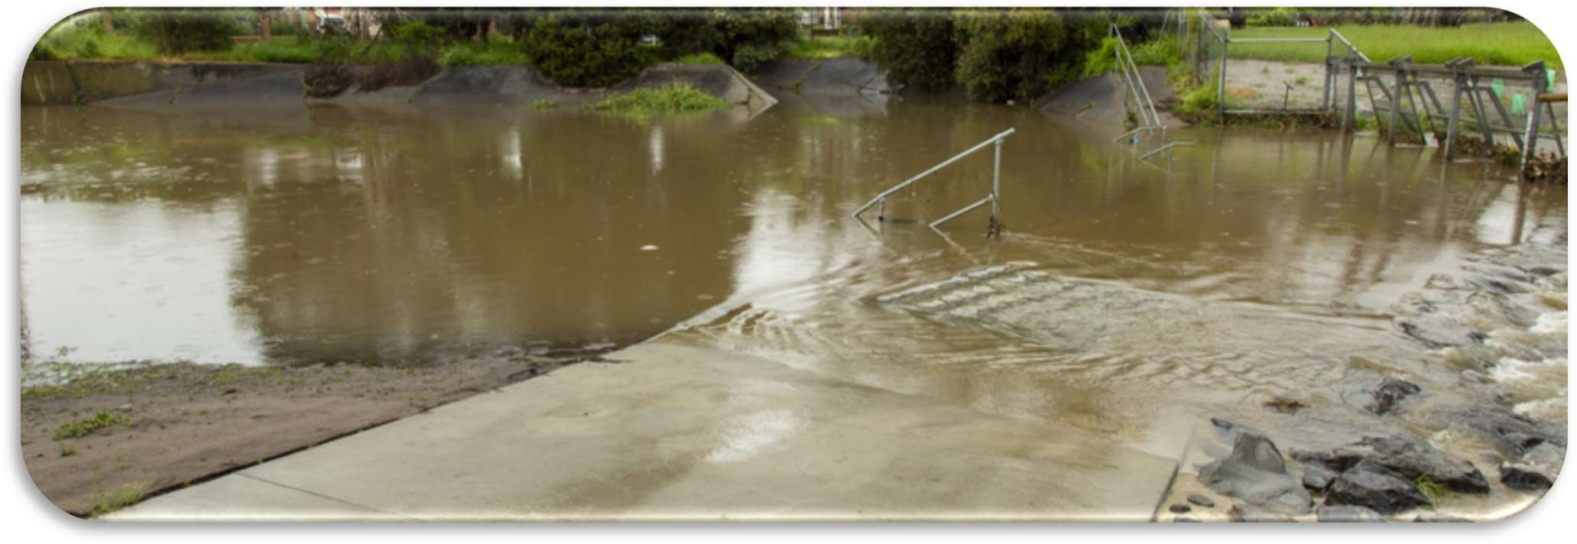

Community Engagement Summary

Methodology Dates Engagements
Walking Sports Expo Participant Survey | May 2022 & 2023 | 49 Contributors
Maroondah Festival Café Consult Activity | Nov 2022 | 589 Contributors
Maroondah Sports Club Online Survey | January 2023 | 28 Contributors
Australia Day Citizenship Participants Surveys | January 2023 | 34 CALD Participants
Your Say Platform via Council’s Website | July/Aug 2023 | 149 Contributors
Library Pop Ups | July 2023 | Croydon 12 Ringwood 21
Council Community Advisory Groups x 4 | July /Aug 2023 | MYWA 10, Liveability 12,  Disability 6, Inclusion 16
Migrant Information Centre - Community Leaders  Network | December 2023 | 10 Contributors

MAROONDAH LIVEABILITY WELLBEING AND RESILIENCE STRATEGY 2021 - 2031
Community Feedback

Engagement with the community, post the Covid pandemic, has highlighted that our community values exercise, healthy eating, access to health services and good mental wellbeing. The community has an understanding that healthy lifestyles lead to improved wellbeing and reduced illness. Our community highlighted the relationship between physical and mental health and the opportunities to facilitate and support social connection. Opportunities to connect with nature were highly valued and seen to provide benefits to mental wellbeing, physical health and social connection. The community would also appreciate more affordable facilities, free outdoor recreation options as well as active and passive activities that promote health and wellbeing for all. Health and wellbeing facilities, spaces, services, programs and events provided by Council, and its partners, are highly regarded. It was highlighted that Council has an opportunity to further raise awareness of what is on offer within the Maroondah community to enhance resident health and wellbeing.¹⁴

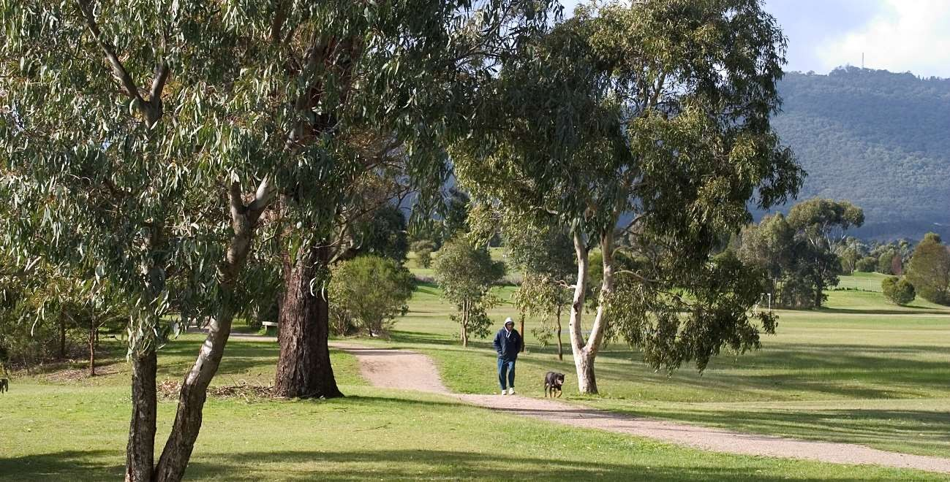

Maroondah Sporting Clubs

In February 2023, in preparation for the update of Council’s Physical Activity Strategy, Maroondah Sports Clubs were provided with the opportunity to provide feedback to Council highlighting their current greatest challenges. 27 clubs representing a wide range of sports highlighted volunteer and committee recruitment and retention as a key challenge to local sporting clubs, as depicted below:


GREATEST ISSUE FOR MAROONDAH
CLUBS IN 2023
Retaining
Retaining
Participants
Financial Viability Volunteers
Fundraising
Attracting
Volunteers
Regulations
Facility Standards
Attracting
Participants
Maintaining
Facilities
Recruiting/Retaining
Committee Members

The impacts of reduced volunteerism in sports will need to be regularly monitored. Ongoing communication and collaboration with leagues and peak sporting bodies will be required to ensure that sports continue to review the effectiveness of promotions, scheduling, and program design, to adapt to the diverse and changing needs of our community. Council will also continue to plan for the enhancement of the quality and accessibility of our community sports and recreation infrastructure.

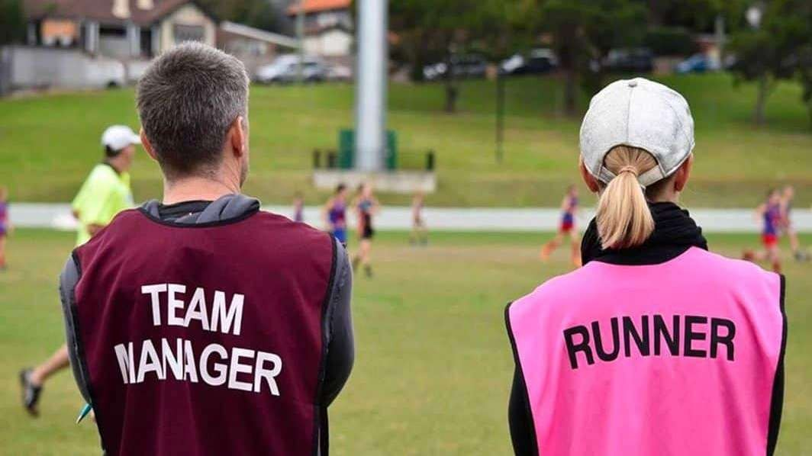

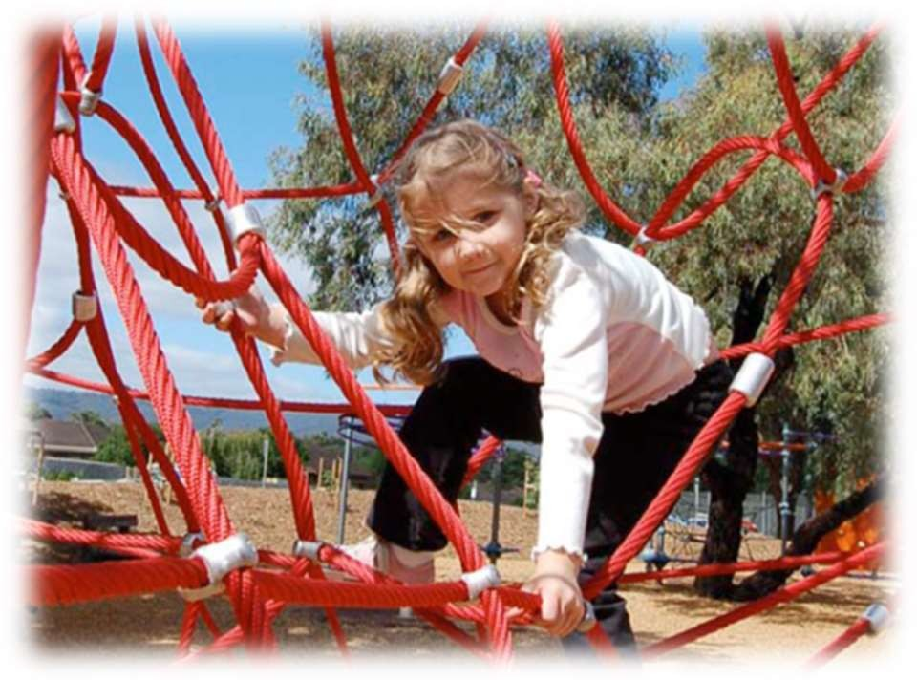
How active are we?

General Physical Activity

Based on the latest available data, it is estimated that 75% of Australian adults aged 18–64 did not meet both the physical activity component and the muscle-strengthening component of the National Physical Activity Guidelines. This proportion was higher in women (78%) than men (73%) (ABS 2022b).¹⁵

More than one in three (35.7%) people aged 15 years and over undertook moderate exercise, while 17.7% engaged in vigorous exercise.
35% of Australian adults were completely physically inactive (that is, undertook 0 days of physical activity in the last week (census) – this was similar for both men (36%) and women (35%)

One in three (32.5%) people 15 years and over reported completing strength or toning exercises and 46.0% reported walking for transport.16

Organised Sport
Nearly half (49.4%) of employed people aged 18-64 years described their day at work as mostly sitting17

2021 research highlights organised sport participation rates (across all ages) are higher for males (17%) than females (9%) in Victoria.¹⁸ These figures demonstrate a gender disparity in sport participation which requires further localised exploration and targeted initiatives to address contributing factors.

Children & Young People

The National Physical Activity Guidelines recommend that young people aged 15-17 years complete at least 60 minutes of moderate to vigorous intensity physical activity every day. The guidelines also recommend that young people include strength or toning activities on at least three days per
week. Furthermore, young people should not sit or lie for long periods of recreational time. Recommendations for children and young people suggest no more than 2 hours of sedentary recreational time per day.

Under 18s spend their time across a range of activities including education and training, paid work, socialising, playing sport, learning how to drive and other pastimes outside school including volunteering.

Less than one in ten (8.9%) young people met the physical activity guidelines. Walking for transport plays a significant role in young people’s physical activity. For 18-24 year-olds, walking for transport alone (excluding walking for fitness) comprises about half of the total time spent on physical activity (ABS, 2021).

The Student Resilience Survey was developed in collaboration with the University of South Australia and have surveyed 1000’s of primary and secondary school children across Australia. The recent Resilient Youth Australia Student Resilience Survey¹⁹ in which Maroondah school students participated, highlighted the following finding for the Maroondah Wellbeing Cluster: On the topic of Healthy Bodies, 87% of students from Grades 6, self-reported being physically active for one hour per day.

Children Youth & Families Consultation 2022-2023 - Community Engagement Report

During 2022/23, Council undertook an extensive community consultation with children, young people, families, and stakeholders, via online surveys, consultation groups, events and a Maroondah Student Voice Forum to inform the development of the next two-year Action Plans for Council’s Children and Families Strategy and the Youth Strategy. The Community Engagement Report gives emphasis to the provision of more local places for children, young people and families to be physically active.

Key findings of the engagement with Maroondah children, young people, parent/carers and community organisations included:

WHAT’S GOING WELL - TOP 5

Children 0 - 12yrs | Young People 10 - 25yrs
Parks / playgrounds / outdoors | Schools / education
Schools / education | Sports
Events | Events
Friendship / socialisation | Friendship / socialisation
 | Youth facilities / programs / services

KEY ISSUES AND CHALLENGES
- Financial constraints, cost of living and affordability
- Mental Health - Key challenge High prevalence of disorders: anxiety, depression, and disordered eating. Covid - still impacting ability to connect back into community, social anxiety

WHAT COULD BE IMPROVED?
- Walkability - more quality footpaths & bike paths and greater connectivity.
- Improved Parks, playgrounds and outdoor social spaces.
- Communications and Engagement - Promote the value of "outdoors", physical activities/play to the community Consultation with disadvantaged young people to really hear their voice.

Adults 15+
In 2020-21, half (50.9%) of Australians aged 15 years and over went walking for exercise, recreation or sport (excluding workplace activity) in the week prior to the survey. Females were more likely than males to walk for exercise (52.7% and 49.0% respectively).²⁰

The latest AUSPLAY data (2022 calendar year) for Maroondah LGA listed the top 10 activities to be:
AUSPLAY Top activities for Maroondah postcodes

Walking (Recreational) 42.50%
Fitness/Gym 33.20%
Running/Athletics 18.40%
Swimming 16.20%
Cycling 12.30%
Basketball 8.50%
Bushwalking 6.50%
Golf 4.60%
Netball 4.60%
Tennis 4.10%

Maroondah’s online Your Say Survey of 149 residents reflected similar results however with the addition of Yoga / pilates within the top 5 and swimming at #6.

What motivates us to be active?
Physical health and fitness is the strongest motivator for Australians 15+ to participate in sport and physical activity however participating in sport and physical activity for social, psychological, and mental health reasons has increased over the past 5 years²¹.

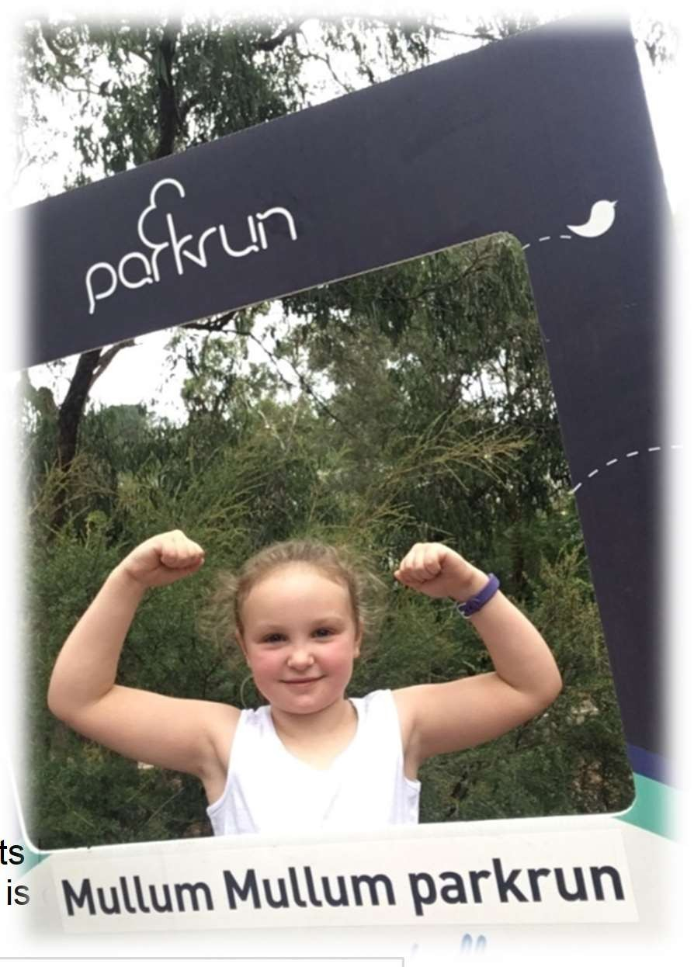
Understanding the reasons people undertake regular physical activity can assist with the design of programs and infrastructure.

In 2019, the top motivators for participating in physical activity among young people aged 15–17 and 18–24 differed:

  - Among 15–17 year olds, the top motivator was fun/enjoyment (71%), followed by physical health or fitness (64%). The third motivator was social reasons (38%) followed by performance or competition (14%).
  - Among 18–24 year olds, the top motivator was Physical health or fitness (75%) followed by fun/enjoyment (53%). The third motivator was social reasons (35%) followed by psychological/mental health therapy (21%) (ASC 2020).

Recent (2023) Your Say online engagement with Maroondah residents has revealed that health & fitness
is the primary motivator for undertaking regular physical activity. This is depicted below.
What are the three main reasons you participate in physical
activity for exercise or recreation?
120
104
100
Health & Fitness
Fun/Enjoyment

Exercising Pets
80
Relaxation/stress relief
59
60
55
Being out in Nature
44
40
29
31
Socialising /meeting new
people
To lose or maintain weight
20
18
17
To play sport
0

Challenges affecting Physical Activity levels.

To plan strategies to encourage active living and increase the physical activity levels of Maroondah residents we need to understand the inhibitors.
There are different factors that affect the physical activity levels of specific populations and therefore different strategies required to overcome these. This document highlights the challenges and opportunities for the general community and then focuses on seven (7) different specific population groups in order to target specific actions which will have a positive impact on participation. These specific populations were identified through the results of community engagement and through the Maroondah Liveability Wellbeing and Resilience Strategy.

GENERAL COMMUNITY

Common Challenges

A key challenge for engaging the general Maroondah community is the perception of, or a real issue of not enough time. While many people are indeed time poor, with work, home, caring and community commitments, time constraints are not the whole explanation. For many it is a vicious cycle of a lack of motivation fuelled by poor diet, sedentary behaviour, and possibly poor sleeping habits which leads to feeling low on energy.

The continued increase in dwelling density is reducing residential green spaces, placing another constraint on the activity levels of Maroondah residents.

Guilt and self-blame are also expressed factors impacting individuals’ exercise levels. Feelings of guilt stem from differing circumstances; insufficient or no exercise, not meeting perceived expectations of how to look or how to exercise, or viewing exercise as sacrificing family time or work commitments.

Opportunity for Council to increase Maroondah’s level of physical activity
It is important to convey the message that physical activity can be accumulative and need not be undertaken in one block of time. Building opportunities for physical activity into everyday routines can be achievable but requires a change in mindset to recognise that being physically active does not require a gym or sports membership or even activewear. Conveying positive messaging to empower individuals to feel good about small segments of active movement will motivate progression to a more active every day. The provision of safe, easy to access, active travel opportunities and inclusive play and gathering places will also assist more residents to incorporate daily physical activity.

CULTURALLY & LINGUISTICALLY DIVERSE (CALD) COMMUNITIES

Physical activity opportunities and communications should be planned and developed in ways that are responsive to our Culturally and Linguistically Diverse communities.

Common Challenges22
    - Language barriers and / or complex registration processes
    - Lack of time
    - Education and work priorities
    - Family & traditional community commitments
    - Scheduling conflicts with religious responsibilities
    - Settlement constraints
    - Financial constraints especially for newly arrived residents
    - Lack of transport
    - Inflexible dress codes

Opportunities for Council to increase levels of physical activity
    - Ensure messages use simple words and pictures
    - Messages to convey how activity can help them achieve other priorities e.g. enhance studies
    - Seek to understand and demonstrate respect for cultural differences and beliefs²³
    - Utilise community leaders and health professionals to support information dissemination
    - Low cost opportunities and support for clubs to source grants to offset costs
    - Encourage clubs to provide social, non-competitive opportunities for participation
    - Promote public open space areas where informal sport can be played
    - Support the provision of activities which families can undertake together
    - Involve culturally diverse communities in the planning of new facilities and activities.

In the previous strategy, it was highlighted that Council should develop strategies to address the concerns of the Myanmar (Burmese) community specifically relating to their desire to play soccer in Maroondah.
Since this time, Council has developed three (3) multipurpose facilities at Hughes Park, East Ringwood Reserve and Dorset Recreation Reserve to support the Chin and Karen communities, with dedicated active recreation and community meeting spaces. Council will continue to support these communities to maximise use of these facilities for all ages and genders and foster partnerships and integration with other local sporting organisations.
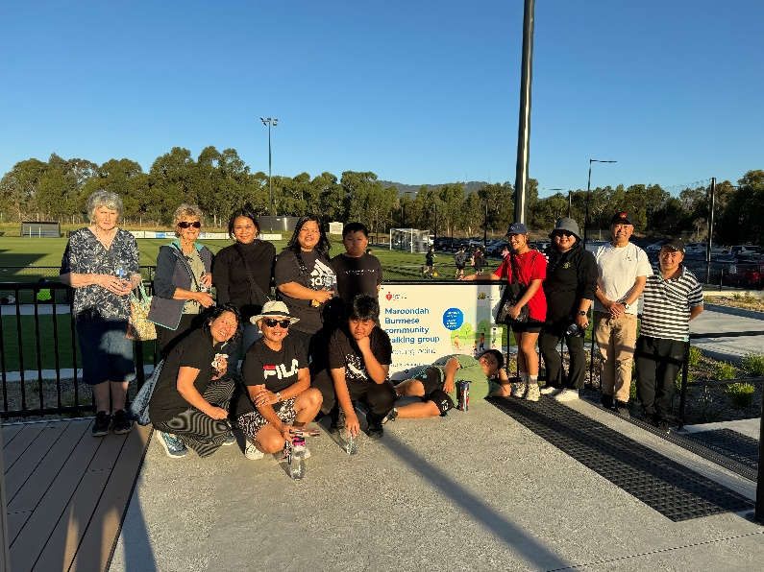

FIRST PEOPLES
To decrease the gap in health inequalities experienced by Aboriginal and Torres Strait Islander Peoples, targeted promotion and/or programs should be considered to increase regular physical activity rates. Research states that 12% of Aboriginal and Torres Strait Islander adults in non-remote areas met the physical activity guidelines in 2018-2019. The rates of sufficient activity were slightly higher for Indigenous males than for Indigenous females (13% compared with 10%). Around one in five (20%) ²⁴

A 2012 study also found that family was identified to be at the forefront of Indigenous youth’s motivation in the type of sport they decide to play and how they connect with family members. In Indigenous culture, the females have a large responsibility to family.²⁵

Common Challenges²⁶
- Safety
- Affordability
- Social environment
- Lack of transport and logistical difficulty
- Competing work, family or cultural commitments
- Lack of time
- Lack of self-motivation
- Lack of confidence to try something new.

Opportunities for Council to increase levels of physical activity

- Consider culturally specific programs that take into account the unique historical context and health experiences of Indigenous Australians in future approaches to targeting inactivity.²⁷
- A 2018 research paper into the perceptions of physical activity among Indigenous Australians highlighted that “The Western concept of individual exercise programs would appear not to be the best approach when promoting physical activities in this population. Group, community, or family activities are all approved forms of physical activity. High importance is attached to the type of environment in which exercise is undertaken, with the natural land remaining influential in Indigenous culture” ²⁸
- Utilise Council’s Wurundjeri Community Consultative Workshops to understand local issues and gauge effectiveness of current communications
- Ensure Council planning and programming is in alignment with Council’s Reconciliation Plan

YOUNG PEOPLE
This group is defined as young people aged between 12 – 26 years, who make up approximately 17% of the Maroondah population. ²⁹ Common challenges highlighted in the previous strategy were reviewed and amended by Maroondah’s 2023 Youth Wellbeing Advisory Group during a workshop session in July 2023.

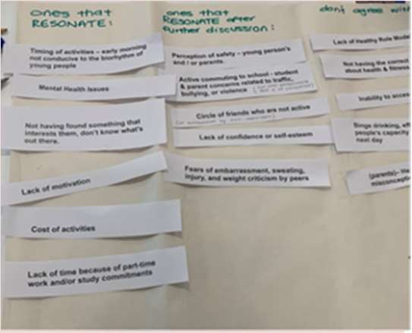
Common Challenges
- Cost of activities, high casual usage fees or long term commitment
- Lack of motivation
- Lack of confidence or self-esteem
- No companion or other people to participate with
- Circle of friends who are not active
- Inability to access childcare
- Not having the correct knowledge about health & fitness
- Body image perceptions
- Not having found something that interests them, don’t know what they enjoy or what’s out there.
- Timing of activities – early morning activities often not conducive to the biorhythm of young people
- Lack of healthy role models (parents)– healthy versus skinny misconception
- Not having the rest/restorative sleep they need to meet the demands of daily life
- Mental health issues
- Identity stereotyping e.g. ‘I’m not a sporty person’, ‘Exercise isn’t my thing’
- Safety concerns – young person’s and / or parents, including injury, general safety in public, peer-to- peer violence, gender-based violence and harassment, sexual violence and harassment, and child abuse and grooming.
- Lack of time due to homework and /or part-time work, issues of work/life balance
- Perception- Is exercise self-care or a chore?
- Fear of running into acquaintances/peers who may judge
- Environment - quality of paths, lighting
- Public transport easier than active travel, lack of motivation to prepare for and undertake cycling
- Competition focus of sport deters continued involvement beyond childhood. “What’s the point?
- Perception that physical activity must be sport or gym

Opportunities for Council to increase youth levels of physical activity
- The social opportunities presented by sport should be as important as the competitive aspect.
- Rethinking how organised sport is promoted & delivered, including more flexible options for involvement
- Health promotion initiatives aimed at both young people and /or parents to dispel misconceptions and promote the healthy mind and body benefits of physical activity.
- Improved infrastructure to support Active Travel to school and places of work or play.
- Provision of low cost, casual commitment opportunities
- Provide different FUN, feel good, social options - “with great music”
- Provide online, tours, basic gym etiquette and usage information to lessen anxiety for new participants
- Simply providing information to youth about benefits, frequency, and duration of physical activity is not sufficient for enhancing physical activity behaviour. Subtle changes in framing physical activities can have a dramatic influence on youths' physical activity motivation and behaviours. Adults should encourage youth to participate in activities they find enjoyable, feel competent doing, have chosen to do, and that include positive social support—these conditions optimize their motivation for sustaining physical activity and thus the physical, social, and psychological health benefits afforded from such participation.³⁰

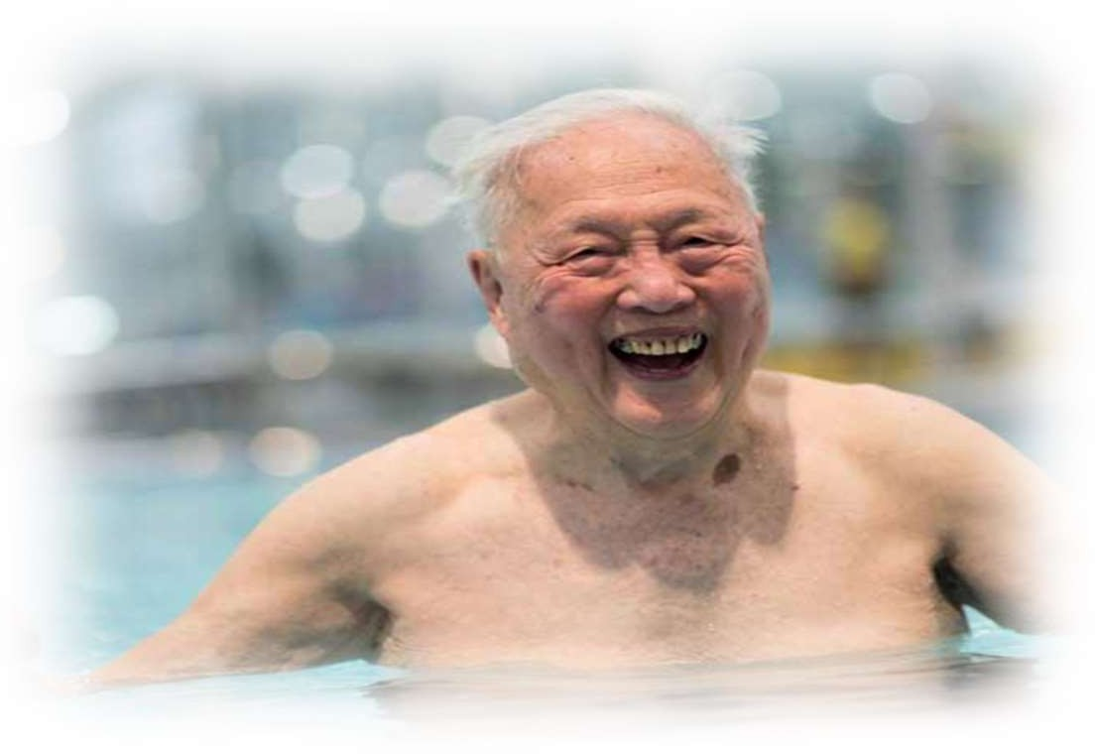
OLDER PEOPLE
Latest Census data highlights that approximately 27.6% of the Maroondah population is aged over 55 years.³¹ To support the needs of our older residents, Maroondah City Council is a member of the World Health Organisation’s Global Network of Age–friendly Cities and Communities Network. This network focuses on taking action at the local level to promote active and healthy ageing.

Council has also made a further commitment through
the endorsement of a Positive Ageing Framework and Action Plan 2021-2025.The Plan addresses the current challenges faced by an ageing population and plans ways to optimize opportunities for health, participation and security in order to maintain independence and enhance quality of life as people age.

Common Challenges
  - Physical constraints: Discomfort and pain are common barriers to exercise as well as illness, chronic health conditions and obesity.
  - Fear of injury: Injury is a very legitimate concern for older people however a lack of exercise can amplify general functional decline and balance issues.
  - Fixed income: Gym, swimming and personal training can be expensive for older persons on a fixed income.
  - Cognitive decline: Those who are experiencing memory loss or cognitive decline may face barriers to engaging in physical activity
  - Isolation: Lack of connection may limit knowledge of activities opportunities and limit motivation. Lack of transport may also contribute to isolation
  - Financial insecurity: Older people face a unique set of potential financial stresses as they enter retirement, which can impact on their ability to access to healthy food, physical activity and recreation, and services.³²

▪

Opportunities for Council to increase levels of physical activity

- Provision of green spaces, adequate seating and safe, pedestrian friendly, walkways
- Well-designed roads to assist the egress of pedestrians and their mobility aids.
- Safe & accessible public buildings and toilets
- Events and activities, that are planned and promoted with consideration of the needs of older adults
- Fostering community integration through encouraging multigenerational spaces and activities
- Promotion imagery includes older people, depicting them positively and without stereotypes.
- Regular and reliable distribution of information through accessible community platforms and media

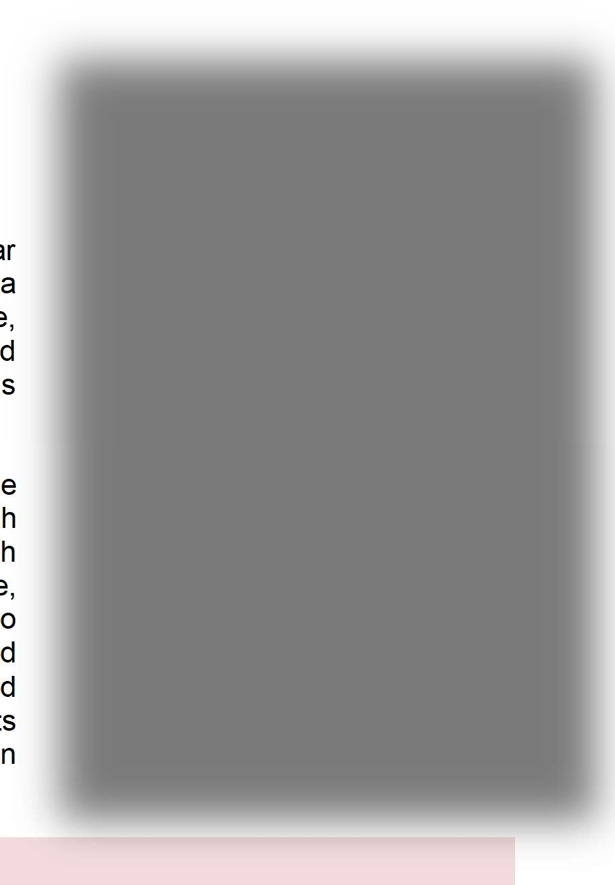
WOMEN AND GIRLS
According to the 2021 Census, 51.6% or 56,351 of Maroondah residents identified as female.

Maroondah has an increasing proportion of carers providing regular unpaid care with 8,066 women aged 15+ providing assistance to a person with a disability, long term illness or old age. Furthermore, 15,876 women aged 15+ reported that they undertake unpaid childcare as their primary role and of this 4,448 indicated that this included care for children other than their own.

Evidence highlights that there is no one approach to addressing the gender disparity in physical activity participation among Maroondah residents. Different female population cohorts within Maroondah experience different challenges to being as active as they should be, or would like to be, to maintain optimal health and wellbeing.³³ To understand the needs of women and girls, in 2019 Council developed the Equally Active, active participation strategy to develop targeted strategies to address low participation in specific population cohorts and to increase and sustain women and girls’ participation in traditionally male dominated sports.

Common Challenges
- Time poor
- Caregiving responsibilities leading to time & scheduling constraints, guilt and lack of energy
- Sensitivity to body image
- Girls are more likely to report barriers such as embarrassment, sweating, fear of injury, and weight criticism by peers and family members compared with boys³⁴
- A systemic fear of judgment of appearance, ability and/ or priorities
- Gender inequality in recreation and sporting settings
- Safety concerns, including gender-based harassment and violence
- Cultural Differences
- Financial priorities
- Newly arrived young women can experience additional settlement challenges including increased family responsibilities and duties, negotiation of different cultural expectations about gender roles, economic disadvantage, social isolation, lack of experience and knowledge about services and lack of confidence to engage with services.

Opportunities for Council to increase levels of physical activity
- Engagement with women and girls to ensure suitably scheduled, accessible activities
- Availability of activities popular with women
- Women only teams/program options
- Family friendly policies/ places
- Design sensitive to perceptions of security
- Provide and promote relatable active role models
- Representation of women in community sport, coaching & decision making roles
- Actively targeting and marketing participation to women and girls and those most vulnerable
- Incorporate specific design features to support women’s participation
- Support equitable access to facilities and resources through education and policy
- Support the provision of safe, non-judgemental spaces for independent exercise
- Support the provision of fun, social and non-competitive options
- Assist traditionally male-dominated sports clubs to undertake change initiatives to create and sustain inclusive, welcoming environments

LGBTIQA+
The LGBTIQA+ (Lesbian, Gay, Bisexual, Transgender, Intersex and Queer/Questioning, Asexual) community make up an estimated 10% of Maroondah’s population. Research shows LGBTIQA+ people have some of the lowest rates of participation in sport, recreation and physical activity out of any community in society.
Avoidance of participation in sport is often linked to poor experiences due to discrimination or harassment. An international study by Australian researchers³⁵ found that:

  - Over 80% of people have either witnessed or experienced homophobia in sport
  - Sport is considered hostile and unwelcoming to young people with diverse sexualities and genders

Common Challenges
- Lack of understanding the difference between gender and sex
- Lack of understanding of what is transgender
- Transphobia or homophobia or perceived transphobia or homophobia
- Verbal abuse and /or inappropriate sledging from players, officials, coaches, spectators
- Strict sport rules on gender and sex (leaving transgender people without a competition to play in)
- Some medically prescribed drugs transgender people require are on banned substance lists
- Mental health issues
- Physical abuse (from team-mates and rougher play on field)
- Lack of role models
- Change rooms can create feelings of angst and discomfort
- Negative past experiences
- Perception that physical activity must be sport or going to the gym

Opportunities for Council to increase levels of physical activity
- Education within sport and recreation clubs and promotion of support resources
- Facilitate discussions with sport leagues about updating gender and sex rules and uniform requirements
- Private spaces (cubicles) within change rooms and non-gendered options
- Encourage and support the development of policy for players, officials and spectators
- Support initiatives to celebrate and demonstrate support for LGBTIQA+ inclusion
- Messaging that physical activity may be accumulative segments of short activity including active travel

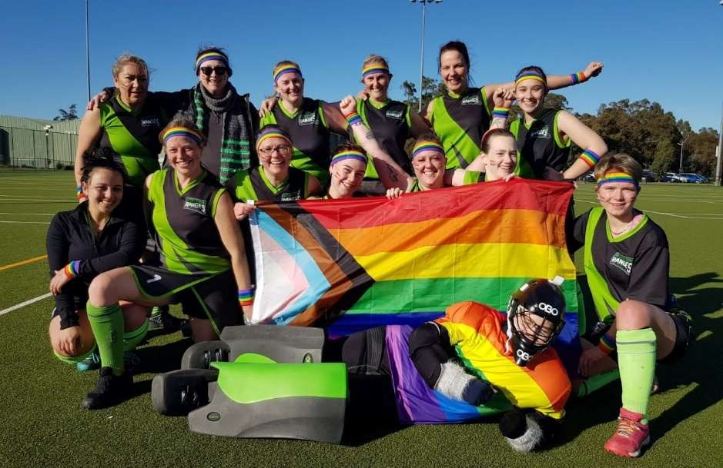

PEOPLE WITH DISABILITIES
Participation rates for people with disability are significantly lower than the general population. In 2021, 6,847 people (or 6.0% of the population) in the City of Maroondah reported needing help in their day-to-day lives due to disability.³⁶ Furthermore over 30,000 people live with some form of disability in Maroondah which is an estimated 29% of the population. Disability is defined as “an umbrella term, covering impairments, activity limitations and participation restrictions”. ³⁷

The latest ABS release on Physical Activity (2020/21 financial year) highlighted that Australians aged 18 years and over with disability were twice as likely as those without disability to have completed zero (0) minutes of physical activity in the last week (20.5% compared with 9.9%).

Common Challenges
- Cost was identified as a major factor due to limited disposable income. Costs included transport, equipment, registration fees, support to participate and other additional costs associated with disability ³⁸
- Attitudinal barriers are those that discriminate against people with disabilities or are perceived as unwelcoming.
- Physical barriers are features of buildings, play space or open spaces that impede access or participation by people with disabilities.
- Information or communications barriers happen when a person cannot easily access or understand information.
- Access to opportunities There are a limited number of activities for children with disability. Sometimes available activities run at inconvenient times, or have long waiting lists.³⁹

A person with a disability is more likely to face several challenges and barriers which require understanding as part of investigating practical solutions. For example:
- A person with a disability may have a particular medical condition that affects the body’s metabolism.
- Reduced mobility and lack of regular exercise.
- Reduced muscle tone.
- Medication that may increase appetite.
- Eating habits that may be affected by depression, anxiety, boredom or frustration.
- Dependence on family members of carers to provide nutrition, transport and activity support.

Opportunities for Council to increase levels of physical activity
- Raise awareness within the community of access and inclusion barriers, rights and inclusive practices
- Promote participation in Council recreation, arts, leisure and cultural activities and events ensuring all communication tools are accessible and DDA compliant
- Ensure access for people with disabilities is considered in the planning and design of play spaces and open spaces.
- Continue to deliver disability awareness training to Council staff particularly those involved program development, infrastructure planning and direct service delivery.

A strategy for a more active future

There are different factors that affect the physical activity levels of specific populations and therefore different strategies are required to overcome these. In the previous section the strategy has highlighted many of the common challenges inhibiting activity levels and opportunities which may have a positive impact on participation. To address the highlighted challenges and to make physical activity an easier option, the strategy focuses on four (4) key priority areas which highlight opportunities for Council action.

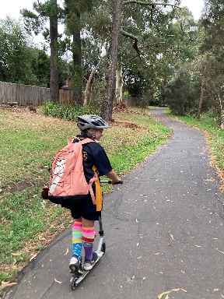  Increasing Active Travel  Despite the many benefits of active transport, physical and attitudinal barriers prevent people from extensively using active travel modes.  There are a range of improvement opportunities that Council can undertake to enhance the pedestrian and cycle network. These will include completion of the gaps, to facilitate greater continuity and connectivity, remove physical barriers, more pedestrian crossings , expansion of long and short stay bicycle parking and installing wayfinding signage. | 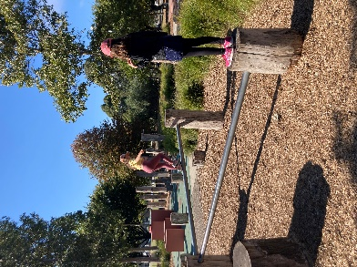  Spaces and places that encourage physical activity  Public Open Space is of high importance to Maroondah residents. This level of regard may be a key factor in promoting active living and providing opportunities for people to be more active.  The creation of vibrant, activated parks & reserves will generate greater volumes of users, assisting people to feel safer and be motivated to exercise, by the energy of others.
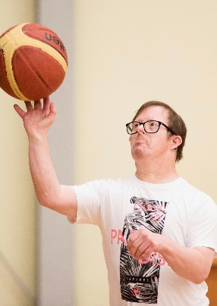  Supporting Diversity  in Sport  The demographic of Maroondah is becoming increasingly diverse. Our culturally, linguistically and gender diverse communities, women and girls and people with disabilities are looking for sporting options that are welcoming and inclusive.  It is Council’s intention to support inclusive sporting settings to achieve participation that reflects our diverse community. | 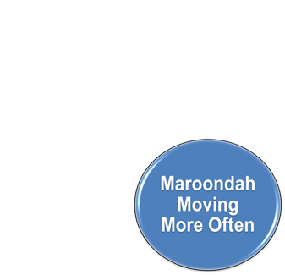  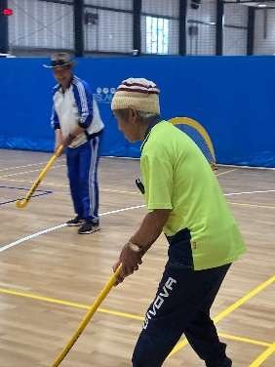  Connecting with our least active residents  Council has invested significant resources to improving the quality, access and safety of Maroondah’s open spaces, sports facilities, footpaths and trails.  This information needs to be widely disseminated using multiple targeted avenues along with reframed positive messaging to increase daily activity levels.

Increasing Active Travel

Outcome description
Council will continue to work with other partners to improve our streets, trails and spaces to be great places for people to walk, run, ride and play and choose active travel as a regular part of their daily life.

What the evidence tells us
People that walk, run, ride, scoot or skate as part of their everyday activities, participate in active modes of travel. Inherent in active travel modes is some level of physical activity. Active travel can be an important source of physical activity and contribute to reaching the necessary daily physical activity levels to stay fit and healthy. For example, public transport users in Melbourne achieve over 40 minutes of exercise a day, compared with less than 10 minutes for a car user.⁴⁰

The health and wellbeing benefits of physical activity that stems from active travel are well established and understood. Public health research shows that people that regularly walk, ride or wheel tend to be healthier, fitter, have better mental wellbeing and are a connected community.⁴¹
The co-benefits from greater physical activity are associated with reduced obesity, increased aerobic fitness, cognitive function and social inclusion. Importantly, the health benefits of walking or riding a bicycle outweigh the health risk associated with potential injury.

The active travel modes are low cost, low impact and zero emission transportation that in certain circumstances, over short distances, can be quicker than motorised travel. Due to the low cost and time flexibility, certain community groups that are less likely to participate in organised active pursuits, will walk for leisure and active travel. Therefore, active travel contributes to a reduction in health, mobility and society inequalities.

The active travel modes enable equity, connection and inclusion in our society and at places. It allows people of any age or ability the means to be independent and choose where they want to go. Active travel, aided through assisted mobility, is fundamental to preserve the mobility and independence of an aging community, people with disability and people that don’t drive. Likewise, active travel is also important to children and young people to take steps towards independent lives. In Outer Melbourne about a third (33.68%) of all journeys to education use active transport for at least part of the way (VISTA).

Active travel is done on its own or in combination with public transport. When done on its own, nearly all trips are walked over a short distance to reach local places for social, recreation, personal business, work and shopping purposes (VISTA). The average walking distance is 1.1 km and average time spent walking is 15 minutes. People will walk for longer distance and time for purposes of education, recreation, personal business reasons.

Participation in cycling is extremely low, constituting less than 1% of proportion of active travel trips. On average distance covered by a bike ride is 6.8 km and an takes 27.5 minutes. Cycling is most undertaken for social, recreation and work purposes.

Nearly every trip involving public transport made in Maroondah will include some active travel at either, the origin, transition between modes or destination. For 88.4% of Maroondah households buses are the closest public transport⁴². In Melbourne, 94% of trips to the bus stop are walked⁴³. The median walk to a bus stop is 390 meters. PTV station access data shows that walking is also important for accessing stations. In 2014, 63% of passenger’s walk to Heathmont Station, 46.1% to Ringwood East, 32.3% to Croydon and 25.8% to Ringwood⁴⁴ Cycling to stations across all stations is lower than 1.6% of passengers.

Overall, in 2020, more trips originating in the municipality were made by active transport (11.9%) than public transport (6.7%) (VISTA). A significant majority of active transport trips are walked (11.46%).

The online Strava Heat Map reveals the locations with the extensive walking and cycling volumes are along the trails, pathways and major roads. It highlights the importance of trails, pathways and footpaths to influences and facilitate participation in active modes of transport.

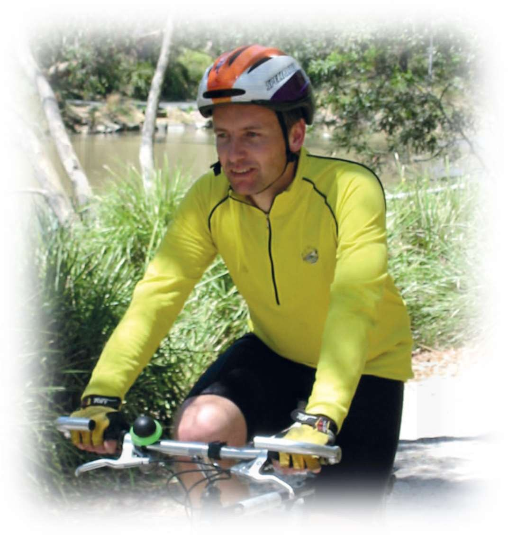
Many people living in Maroondah struggle to choose active travel modes for short trips to reach local destinations, services and activities. Known barriers that influence the likelihood and amount of participation in active travel are, where people live, their level of income, job and education access, the fabric of neighbourhoods, the street environment, personal safety concerns and the quality of public transport.

There is considerable potential to boost population levels of physical activity thought the encouragement of active travel. For the potential to be realised the conditions of our streets and neighbourhoods must be walkable, bicycle friendly and safe for everyone. Enhancement of community connections and access to local shops, education, medical and community services so active travel can be a mode of choice and the delivery of education to develop people’s skills to safely walk or ride a bike, scooter or skateboard.

What the community has told us
Communities across Maroondah have expressed views, expectations and attitudes towards active travel across several community engagements undertaken for a range of projects.

Strong community support for walkability neighbourhoods and better active travel options was a prominent and collective view. Requests included more footpaths, better connectivity and separation of bike and walking paths and public open space to be made safer after dark to support active travel and recreation. In particular, the community highlighted the need to provide opportunities to build active travel confidence, promote free public facilities and active transport networks which will support greater participation in all types of walking and bike riding. These calls encapsulate the community expectation for Council to provide more and quality active transport infrastructure, events and programs.

Good transport services and facilities were identified as the highest priority for current and future housing by the Housing Strategy Engagement Report. Most respondents would like a shared pathway, trails, footpath and bus stops to be within 5 minutes of their home. Over half of respondents were willing to travel either 10 or 20 minutes to a train station. The feedback is an acknowledgement of the high importance the community places on good access to sustainable transport in choosing a home.

The My Neighbourhood Café consultation highlighted the community’s varied experience of walking and bike riding across the 12 local centres. Respondents were asked to rate the quality of safe walking and cycling networks. The centres identified as having a low or medium quality active travel networks were Burnt Bridge, McAdam Square, Ringwood North and Ringwood East. The community gave 59 suggested enhancements to improve the network. The improvements can be categorised into four types: lighting, footpaths, bicycle paths and safe streets/spaces. The community values such facilities and wants the implementation to occur quicker than at the current rate. The consultation findings also called for more pedestrian and bike facilities which is consistent with the request letters received by Council. In 2022, Council receives 60 requests for new footpaths and 50 requests for lighting.

While there is strong support for active and public transport in the community it is by no means a consensus. It is acknowledged that the community contains diverse views, expectations and attitudes and some compete with active travel outcomes at the local level. The competition for space and accommodating community expectations is complex and will have to be balanced to be acceptable.

Priority Actions

Key Direction | Priority Actions | Lead Responsibility | Timeframe
1.1 Deliver behaviour change programs to increase confidence to walk and ride for short trips | 1.1.1 Link Council’s walking routes information to the Victoria Walks web platform and create  a communication plan. | City Futures Leisure | 2024/2025
 | 1.1.2 Partner with schools to organise cycling and pedestrian safety education programs and  events. | City Futures | 2023/Onward
 | 1.1.3 Partner with community organisations including Victoria Police to offer a bike education initiative focusing on bike etiquette  and safety. | City Futures Leisure | 2024/2025
1.2 Advocacy to other tiers of government for arterial road improvements for pedestrian access and safety. | 1.2.1 Review the Principal Pedestrian Network to reprioritise the provision of walking pathway and footpaths to improve access within activity  centres. | City Futures | 2024/2025
 | 1.2.2 Review the Maroondah Bicycle Network Plan to guide cycling infrastructure investment  within five priority local neighbourhoods. | City Futures | 2023/2024
1.3 Deliver safer, direct and connected on road and off-road cycling ways. | 1.3.1 Lobby the Victorian Government for  funding to facilitate the delivery of the Greenwood Avenue Shared User Pathway. | City Futures | 2023/Onward
 | 1.3.2 Develop and implement a real-time pedestrian and cyclist counter network to  supply continuous and robust data. | City Futures | 2025/25 Onwards
 | 1.3.3 Continue the implementation of Council’s capital works footpath construction and street  light enhancement programs | Engineering & Building Services | Ongoing
 | 1.3.4 Continue the implementation of Council’s capital works program for accessibility  improvements for all abilities. | Engineering & Building Services | Ongoing
1.4 Prioritise the provision of safe pedestrian and cycling facilities within 800 metres of stations and bus interchanges to realise the greatest outcomes from active transport. | 1.4.1 Complement the principal pedestrian network with well-placed crossings, street furniture, tree planting and optimize wayfinding signage. | Engineering & Building Services | Ongoing
Indicators of progress

Outcome | Indicators | Data Source | Base Metric | Frequency Reported
Increase in the percentage of trips made by people walking and riding a bike. | Mode share by number of trips (%) | Victorian Integrated Survey of Travel and Activity | 11.95%  (2020) | Biennial
Increase in community’s perception that streets are walkable. | The community score for level of satisfaction with  streets and footpaths. | Community Satisfaction Survey | 65 | Annual
Increase in the percentage of trips made by students walking or riding a bike to school. | Mode share by trip purpose split by number of trips (%) | Victorian Integrated Survey of Travel and Activity | 12.51%  (2020) | Biennial
Increase in the number of trips per a day that are walked for social and recreational walks and the average distance and time taken. | Number of trips per a day | Victorian Integrated Survey of Travel and Activity | 14,778  (2020) | Biennial
 | Weighted average (km) |  | 1.1km (2020)
 | Weighted average (mins) |  | 16.4 mins  (2020)

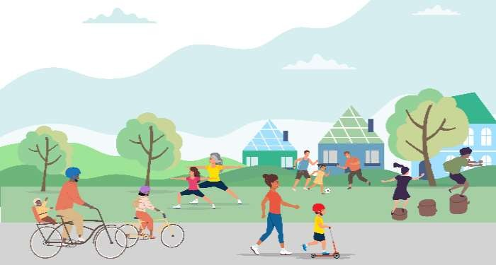
Spaces and places that encourage physical activity

Outcome description

Maroondah will have a network of high quality inclusive play and gathering places that cater for all cohorts within our community
and are designed and maintained to maximise participation and to support good mental and physical health.

What the evidence tells us
Physical activity levels can be strongly influenced by the places and spaces within the community. Open spaces include green space, parks, playgrounds, walking/bicycle trails, reserves, golf courses and public sporting/recreation areas. Vegetation and nature are important for wellbeing. Visual and physical contact with nature helps reduce stress, anxiety, blood pressure and muscle tension, improves self-esteem, encourages positive feelings, and helps us recover from mental illness. A network of safe walking and cycling routes that provide access to green spaces in an urban environment also encourages physical activity.

Residents living in neighbourhoods with good access to public open space are more likely to use such spaces and gain the associated physical activity, and mental and physical health benefits. There is considerable evidence that living within walking distance of parks and in neighbourhoods with more green public open space is linked to greater use of these areas and positive health outcomes.⁴⁵

72% of Maroondah dwellings are estimated to be within 400 metres of public open space, which is higher than both Knox (69%) and Yarra Ranges (53%).⁴⁶

What the community has told us
Within the Maroondah Liveability, Wellbeing and Resilience Strategy, our community highlighted the relationship between physical and mental health and the opportunities to facilitate and support social connection. Opportunities to connect with nature were highly valued and seen to provide benefits to mental wellbeing, physical health and social connection. The community would also appreciate more affordable facilities, free outdoor recreation options as well as active and passive activities that promote health and wellbeing for all.⁴⁷ A quote from a female Ringwood resident stated “We should all feel safe to go about our business, regardless of the hour of the day or day of the week. We should be able to walk the streets at night or early morning without fear or trepidation.”

Play and Gathering Places Strategy Engagement
In 2023, to help inform the inaugural Play and Gathering Places Strategy, Council undertook extensive community consultation. The community were asked to provide feedback on where, why, and how they play and gather in Maroondah. The “Connection Matters” campaign ran for 10 weeks from January to April 2023. During the campaign,1.5k people visited Council’s Your Say page with 719 people completing the online survey.
A summary of key findings included:

Our community are invested in and want to connect to these places more 35% respondents used places daily, 53% weekly
Our community want to be stewards of these places 66% respondents seeking community connections and 27% seeking stewardship
Maroondah’s Open Spaces are vital to the wellbeing of our communities 53% of respondents rated these extremely important
Our community value as a priority, a well-connected, planned and serviced Open Space network
87% respondents walk to these places

Key Direction | Priority Actions | Lead Responsibility | Timeframe
2.1 Provide activated, highly utilised spaces that are multiuse to maximise natural surveillance and community safety. | 2.1.1 In accordance with Council’s public lighting policy, support the installation, or upgrade to the quality of, sustainable lighting for improved safety and to support increased evening activity. | Projects and Asset Management | Ongoing
2.2 Design spaces which consider the feedback and lived experience of a wide range of ages, backgrounds and abilities to ensure equitable access with a priority being to reduce inequalities | 2.2.1 Develop targeted engagement activations that will gain feedback representing the widest range of community perspectives | Service Areas | Ongoing
 | 2.2.2 Undertake internal training to understand intersectionality and how to  utilise this lens to guide future planning. | Equal Opportunity Committee | 2025/2026
2.3 Advocate for improved Maroondah sporting facility construction to cater for people of all abilities to provide a welcoming/inclusive environment. | 2.3.1 Continue to advocate for improved community facilities, that have flexible spaces to accommodate the diverse needs of the community | Sport & Recreation Community Services, | 2024-2029

Indicators of progress
Victorian Child Health and Wellbeing Survey (VCHWS) - Proportion of Young People and proportion of children living in neighbourhoods with good parks, playgrounds and play spaces.

Development of and /or increased usage of open space feedback mechanisms Collation and interpretation of usage data
Incorporate cultural and/or heritage aspects in all new Council facility developments or enhancements. Where applicable, Gender Impact Assessments are undertaken, and findings actioned.

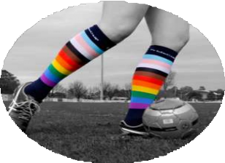
Supporting Diversity in Sport

Outcome description
Sports settings will be welcoming and inclusive of all genders, cultures and abilities by providing accessible facilities, safe, inclusive club environments and participation opportunities, to ensure that no one is excluded or fearful of discrimination.

What the evidence tells us
While Victoria’s current physical activity profile highlights that the majority of Maroondah residents, roughly 70%, do not currently participate in organised sport and may not hold a desire to do so, sport still plays an important role in the community, for health and fitness, social interaction and social cohesion. Sport teaches important values and involvement can provide a rewarding opportunity to interact with others as a participant, volunteer, leader, or supporter.

Sports organisations need however, to consider that they may not be accessible to all and that there is a need to embrace new ways of delivering sport to a diverse range of cultures, genders and abilities who want to be involved. Council in partnership with sporting leagues and associations, and industry experts, need to provide education and resources to support club committees, existing participants, officials and coaches to foster cultural change.

Maroondah is home to a diverse range of communities including, but not limited to, people with disability, cultural and linguistic diverse (CALD) communities, Aboriginal and Torres Strait Islanders, people from a range of faiths, and community members with different gender and sexual identities.⁴⁸ These communities may experience barriers to their participation in physically active endeavours. When different parts of a person’s identity or circumstances – such as age, race, culture, disability, gender, socioeconomic status or religion intersect it can further impede a person’s ability to access or feel welcome in activities such as community sport. Sporting organisations need to be aware of this concept of intersectionality and understand that while addressing one barrier, there still maybe other factors impeding an individual’s participation. Programs should be co-designed with people with lived experience of a range of different aspects of diversity to ensure intersectionality is considered. Co-design is different to consultation as it is a process whereby relevant stakeholder views contribute not only to the thinking but also the making of decisions.49

With a growing preference for active pursuits without the commitment of training and competition, supporting the expansion of social or informal sport options into a wider variety of sport settings will support increased participation. Social sport can provide a non-gendered, non-competitive or less competitive environment, where participants can enjoy exercise and social interaction with less structure, or no structure and less administration and officiating resources required.

What the community has told us
In the recent 2022/2023 Change Our Game - State of Play⁵⁰ survey of 670 Victorian respondents, 29% of respondents identified Racism in sport and 32% identified Fair and Equal participation opportunities for women and men as key current issues. 90% of women vs 66% of men said gender inequality is still an issue in sport that needs to be fixed.
Youth Sense, Year 13 & Visa Inc. conducted a nationwide survey in April 2023 with 1250, 13-23 year olds. Overall, 43% of teenage girls and young women were found to not play sport. Of the top 10 reasons they gave for not playing, I’m not good enough (34%), body insecurities (31%), I don’t like the competitive side of sport (30%), I feel inadequate compared to the top players and athletes (29%), my physical fitness wasn’t adequate (28%), and too much pressure (26%) 51 all were key factors. These factors aligned with feedback from a workshop held with the Maroondah Youth Wellbeing Advocates Group.
Proud to Play, inclusivity in sport advocacy organisation states that “Many LGBTQI+ people are disengaged from sport and recreation, as these environments have not kept up with societal change”.

Key Direction | Priority Actions | Lead Responsibility | Timeframe
3.1 Support the expansion of social sport opportunities | 3.1.1 Encourage and support local clubs to apply for funding to pilot social sport initiatives | Sport & Recreation | Ongoing
 | 3.1.2 Promote open space areas available for informal sport | Sport & Recreation | Ongoing
3.2 Provision of safe, accessible and welcoming spaces and community facilities | 3.2.1 Incorporate best practice access and inclusion design principles in the upgrade and enhancement of community facilities, to ensure safe, accessible, and welcoming spaces | Projects and Asset Management | Ongoing
 | 3.2.2 Partner with inclusion advocacy organisations to provide awareness training on inclusion and provision of culturally safe  spaces | Leisure  City Futures | June 2025
 | 3.2.3 Partner with Tennis Victoria to develop an Access & Inclusion strategy for Tennis in Maroondah | Sport & Recreation | July 2025
3.3 Fair allocation of sporting facilities for all genders | 3.3.1 In partnership with the Melbourne East Regional Sport & Recreation network of Local Government organisations, develop a Fair Access Policy to guide and measure the gender equitable allocation of sporting infrastructure. | Melbourne East Region Sport and Recreation Strategy Network (MERSRS) | June 2024
 | 3.3.2 Utilise Council’s Community Facilities booking and reporting processes to capture usage data by gender. | Sport & Recreation | Ongoing
3.4 LGBQTIA+ inclusion education and advocacy for gender diverse and transgender sports participation | 3.4.1 Work with local leagues and associations to support local clubs to understand the needs of gender diverse and transgender participants and promote initiatives to improve/grow inclusion. | Sport & Recreation | 2025/2026
3.5 Support promotional opportunities that encourage people of all abilities to be active. | 3.5.1 Support community awareness of existing accessible sporting and recreational programs and accessible infrastructure. | Leisure  Community Services, Communications and Citizen Experience | Ongoing

Indicators of progress
Increased demographic information collection for Maroondah Leisure memberships Peak sporting body participation data
Comparison to Sports Demand analysis 2017 gender baseline data Creating a Place for Women in Sport - Post Completion Survey data

Connecting with our least active residents

Outcome description

Council will disseminate information highlighting the value of incremental movement and the range of local active opportunities, using a range of accessible formats. Council will seek to, and support others to, engage with low participatory cohorts when designing programs and/ or communications.

What the evidence tells us
Communities are not homogenous, and to reach as many individuals as possible, it is important to consider how different cohorts of the community will receive and process messaging.

The diverse range of needs in our community must be considered when planning, and activating public spaces and places, including accessible communications and wayfinding. When developing communication for events, programs or facilities thought should be given to who will want to use the space or place and take into consideration all needs; people with vision, hearing, mobility, cognitive and psychosocial disability as well as carers, parents with prams and people for whom English is a second language.⁵² Where possible utilise local networks and multiple formats of communication to disseminate information.

Council will not rely on public notices or general advertisements to reach the whole community, given that there is different messaging required to reach Maroondah’s most inactive residents. Positive messaging supporting the benefits of small incremental segments of activity has the ability to empower people leading sedentary lifestyles to move more often.

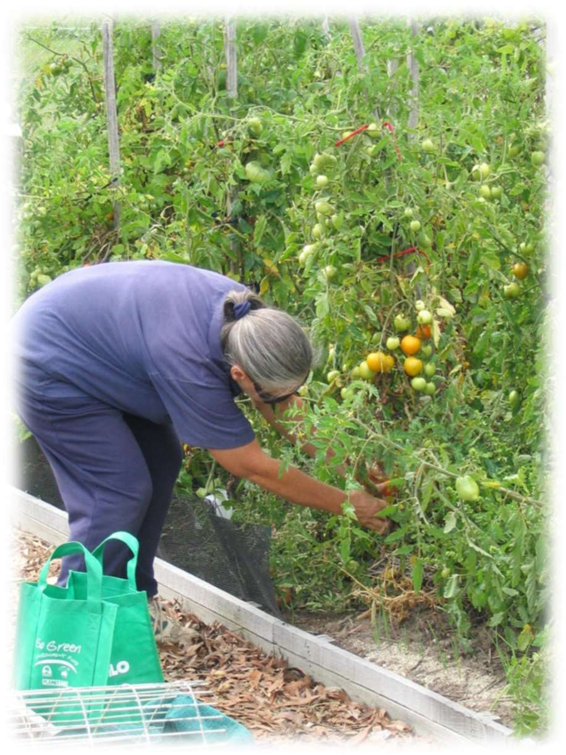
What the community has told us
Community feedback during the COVID 19 restrictions highlighted that many residents had previously never realised the breadth of open space opportunities within walking distance of their homes. The 5km restrictions coerced families to explore their local neighbourhoods many noting that they had no idea of the extent of walking tracks, parks and other facilities within their neighbourhood. While it is hopeful that we will never again face lockdown travel restrictions, the situation has highlighted that greater promotion and effective wayfinding is required for residents to realise the local opportunities available to them.

Furthermore, in undertaking consultation with the community, conversations and feedback often reverted to barriers to attending the gym or sports with little recognition that physical activity can be simply moving more and sitting less in everyday lives. The guilt from not prioritising formalised activity often led to people doing nothing at all, feeling a hopelessness due to lack of time and/or motivation. This feedback highlights the need for Council to invest in awareness promotions on the value in moving more often, even in short bursts, and reducing time sitting.

Key Direction | Priority Actions | Lead Responsibility | Timeframe
4.1 Collaborate with Community networks and Council Advisory Group Committees that represent or are connected to the people that we are trying to reach. | 4.1.1 Regularly attend the Eastern Volunteers Network Community of Practice, Migrant Information Centre’s Community Leaders Meeting, Maroondah Emergency Relief Network, Maroondah Reconciliation Partnership Group, Disability Advisory Committee, and other networks and Advisory Committees to understand needs, share opportunities and determine effective avenues for promoting campaigns. | City Futures  Sport & Recreation | Ongoing
 | Capitalise on existing State and Federal Campaigns such as the Get Active Platform and Heart Foundation Walking Platform to benefit our community | Sport & Recreation | Min 1 per calendar year
 | 4.2.2 Develop a targeted MOVING campaign to assist residents to understand movement options and the benefits of increased daily activity and decreased sitting. | Sport & Recreation | October 2025
 | 4.2.3 Develop a process for the design and testing of targeted campaigns and promotions to ensure that it is reaching and resonating with  the intended market. | Sport & Recreation Communications City Futures  Community Services | March 2025
 | 4.2.4 Develop and evaluate Communication and Engagement Plans for infrastructure upgrade completions and programs including the development of accessible social scripts and other important access information. | Communications and Citizens Experience | Ongoing
4.3 Support sports, recreation & social groups to increase their connection and profile within the community | 4.3.1 Provide a series of club development training opportunities to understand the needs of, and ways to reach marginalised groups. | Sport & Recreation | Min 1 per year
4.4 Utilise responsible pet ownership campaigns as a mechanism to promote increased physical activity. | 4.4.1 Link social media messaging of ‘Why being active with your dog is beneficial’, to the Ok my dog’s friendly campaign.  Include messaging in the Responsible Pet owner packs and web information. | Local Laws | April 2025

Indicators of progress
Review analytics of specific Council ‘Active’ webpages and social scripts

Utilise data and technology tracking measures to obtain and review baseline data on open space utilisation Number of Maroondah walkers registered on the Heart Foundation Walk initiative.

Tracking our progress
The specific priority actions and projects outlined in this Strategy will be monitored as they are implemented and reported to Council on a bi-annual basis with Strategy review commencing in the fourth year. Council will continue to work with the State and Federal Governments, key stakeholders including peak sporting bodies and health agencies, local sports and recreation providers and other community networks to make Maroondah’s places, spaces and opportunities as welcoming and suitable as possible to the least active members of our community.

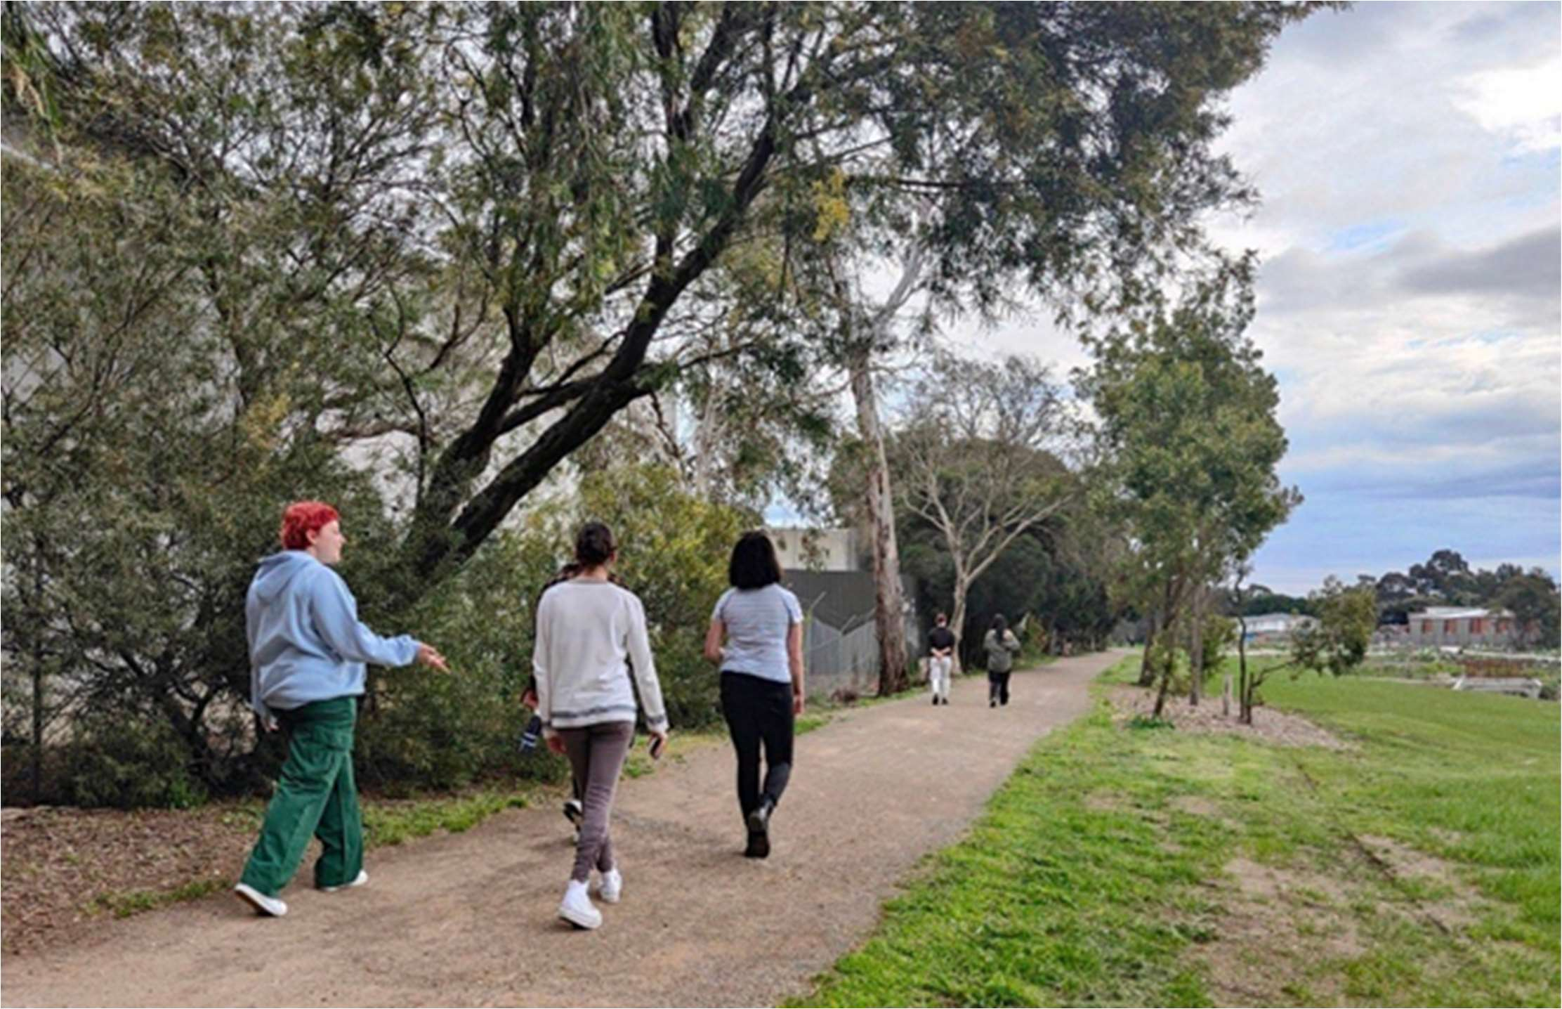

Glossary and References

Glossary

Physical Activity | World Health Organisation defines physical activity as any bodily movement produced by skeletal muscles that requires energy expenditure – including activities undertaken while working, playing, carrying out household chores, travelling, and engaging in recreational pursuits.¹
Active Living | A way of life that integrates physical activity into daily routines
Sport | The Australian Sports Commission defines sport as: 'A human activity capable of achieving a result requiring physical exertion and/or physical skill which, by its nature and organisation, is competitive and is generally accepted as being a sport'.¹
Incidental Physical Activity | Physical activities performed that are undertaken as part of carrying out normal daily chores.
Sedentary Behaviour | The Department of Heath describes ‘Sedentary behaviour’ as a term used to describe time spent doing physically inactive tasks that do not require a lot of energy.¹
Pedestrian | A person who travels by foot.
Intersectionality | Describes how different parts of a person’s identity or circumstances – such as age, race, culture, disability, gender, socioeconomic status or religion – intersect and combine to shape people’s life experiences, including unequal outcomes, privilege and discrimination1
COVID 19  Pandemic | The COVID-19 pandemic was a global outbreak of coronavirus, an infectious disease caused by the severe acute respiratory syndrome coronavirus.

References

- VICHEALTH www.vichealth.vic.gov.au/our-work/encouraging-regular-physical-activity accessed 27/3/2023
- Maroondah City Council (2014) Physical Activity Strategy Household survey
- Inside Edge MESRS Melbourne East Region Participation Data - Top 18 Sports
4 Atlas.id.com.au/maroondah
5 Department of Health and Aged Care (2014) Australia’s Physical Activity and Sedentary Behaviour Guidelines Accessed 16/03/23
6 https://profile.id.com.au/maroondah/overseas-arrivals accessed 15/5/23
- Australian Sports Commission and Volunteering Australia (2021) Partnership to bring the sector together.
- Victorian Government -Department of Health (2020) Victorian Population Health Survey
- Australian Institute of Health and Welfare Mental health services in Australia: Mental health: prevalence and impact - (aihw.gov.au) Access 11.05.2023
- Australian Government (2023) AusPlay (2021-22) Data tables - July 2022 to June 2023
- https://www.reviews.org/au/mobile/2022-mobile-phone-usage-statistics accessed 18.05.2023
- Deloitte (2021) Media Consumer Survey
- https://aifs.gov.au/resources/short-articles/too-much-time-screens Accessed 18/5/23
- Maroondah City Council (2021) Maroondah Liveability Wellbeing and Resilience Strategy 2021-2031 pg39
- Australian Institute of Health and Welfare Physical activity snapshot - (aihw.gov.au) release 19/5/2023
- Australian Bureau of Statistics (2023) Physical activity, 2020-21 financial year (abs.gov.au)
- Australian Bureau of Statistics (2022) ABS National Health Survey 2020/2021 release 21/3/22
- VicHealth (2021) Sport participation in Victoria 2015–2021 The impact of COVID-19 and the recovery of participation in sport
- Resilient Youth Australia (2023) STUDENT RESILIENCE SURVEY Snapshot Report Maroondah Wellbeing Cluster
- Australian Bureau of Statistics (2023) Physical activity, 2020-21 financial year (abs.gov.au)
- Australian Government (2023) National Sport and AUSPLAY Physical Activity Participation Report October 2023
- Football Australia Factsheet Culturally and Liguistically Diverse Communities
- BERII MEK City Council How to reach CALD population Fact Sheet http//Active.merri-bek.vic.gov.au
- ABS, 4715.0 2018–19 National Aboriginal and Torres Strait Islander Health Survey 2019
- Nelson A.L., Macdonald D., Abbott R.A. A risky business? Health and physical activity from the perspectives of urban Australian Indigenous young people. Health Risk Soc. 2012
- Resilient Youth Australia (2023) STUDENT RESILIENCE SURVEY Snapshot Report Maroondah Wellbeing Cluster Aug 2023
- Macniven R, Elwell M, Ride K, Bauman A & Richards J 2017. A snapshot of physical activity programs targeting Aboriginal and Torres Strait Islander people in Australia. Health Promotion Journal of Australia 28:185-206.
- Dahlberg E, Hamilton S, Hamid F, and Thompson S,*Indigenous Australians Perceptions’ of Physical Activity: A Qualitative Systematic Review 2018
29 Australian Bureau of Statistics, Census of Population and Housing 2016 and 2021. Compiled and presented by .id (informed decisions).
³⁰ The Convergence Partnership Fund of the Tides Foundation, (2010) Fostering Physical Activity for Children and Youth
31 Australian Bureau of Statistics, Census of Population and Housing 2016 and 2021. Compiled and presented by .id (informed decisions). 32 Arnott, C & Porteous, S. (2017). Health and wellbeing needs of older people living in the Eastern region of Melbourne, Inner East Primary Care Partnership, Melbourne.
33 Maroondah City Council (2019) Equally Active Strategy
34 Australian Bureau of Statistics (2022)ABS National Health Survey 2020/2021 release 21/3/22
- Outonthefields.com accessed 26.05.2023
- https://profile.id.com.au/maroondah Accessed 17/3/2023
- Australian Government Disability Discrimination Act 1992
38 Australian Sports Commission (2010). Getting Involved in Sport. Participation and Non Participation of people with a disability in sport and active recreation
39 Dr Nora Shields and Ms Anneliese Synnot La Trobe University (2010) Barriers & facilitators to physical activity & community sports for children with disability
- Bus Association of Victoria. Public transport use – a ticket to health. Briefing paper. Port Melbourne, VIC; 2010.
- Burke M., Stanley J., Duncan M., et al. Action area 4: Active transport. In: Blueprint for an Active Australia. 3rd ed. Melbourne: National Heart Foundation of Australia, 2019.
- Department of Transport (2010), Metropolitan Bus Service Review: Knox/Maroondah/Yarra Ranges, Booz&Co, Melbourne
- Eady, J and Burtt, D (2019). Walking and transport in Melbourne suburbs. Victoria Walks, Melbourne, Nov.2019
- PTV 2015, Passenger Activity by Metropolitan Stations 2008 - 09 to 2013 - 14.
- Healthyactivebydesign.com.au/design-features/public-open-spaces/evidence
- Maroondah City Council,(2021) Maroondah Liveability Wellbeing and Resilience Strategy 2021-2031 pg19
- Maroondah City Council, (2021) Maroondah Liveability Wellbeing and Resilience Strategy 2021-2031 pg39
- Maroondah City Council, (2021) Maroondah Liveability Wellbeing and Resilience Strategy 2021-2031
49 Purple Orange. (2021) Guide to Co-Design with people living with disability.
50 Victorian Government. Change Our Game State of Play Survey 2022-23
51 https://youthsense.com.au/parents/whats-driving-teenage-girls-away-from-playing-sport accessed 26/05/2023
52 Inclusive SA Accessible Wayfing and Signage Toolkit, https://inclusive.sa.gov.au/resources accessed 6.6.23
PHYSICAL ACTIVITY STRATEGY | 39

To contact Council
- phone 1300 88 22 33 or (03) 9298 4598
- SMS 0480 020 200
- visit our website at www.maroondah.vic.gov.au
- email maroondah@maroondah.vic.gov.au
Translating and Interpreter Service
13 14 50
National Relay Service (NRS)
13 36 77
MaroondahCityCouncil maroondahcitycouncil
Maroondah City Council CityofMaroondah
Maroondah City Council









mcc871-Apr24

