Council have implemented an online booking system to manage all sporting facility bookings excluding Maroondah Leisure facilities (Aquahub, Aquanation, Croydon Memorial Pool, Maroondah Edge, Maroondah Nets, The Rings, Dorset Golf and Ringwood Golf), these include:

* One off, casual bookings
* School bookings - one off, term and interschool bookings
* Private/commercial bookings
* Club seasonal allocations

This guide is to assist with using the booking system. If you require further assistance, please contact the Sport and Recreation team on 9294 5717.

Maroondah Bookable web address: https://maroondah.bookable.net.au/

Step 1: Create an account  
**Existing users:** If you booked a Council facility in 2024 on a regular basis, Council will have created an account for your organisation and emailed you a password. Use this email address and password to log in.   
  
**New users:** Create an account by clicking on the register button and filling in your details. If you receive a message saying 'Congratulations, your registration has successfully been submitted. Once your account has been verified you will be notified by email ' this means that your account registration needs to be approved by the Sport and Recreation team. Please allow 3 business days for your registration to be approved.

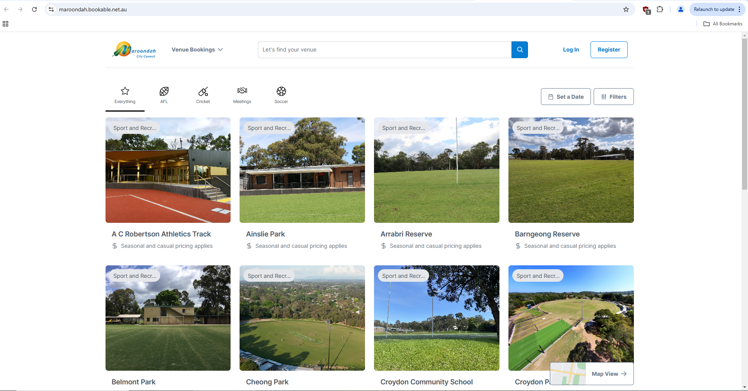

Step 2: Log in   
Once your account is active log in by entering your email and password.

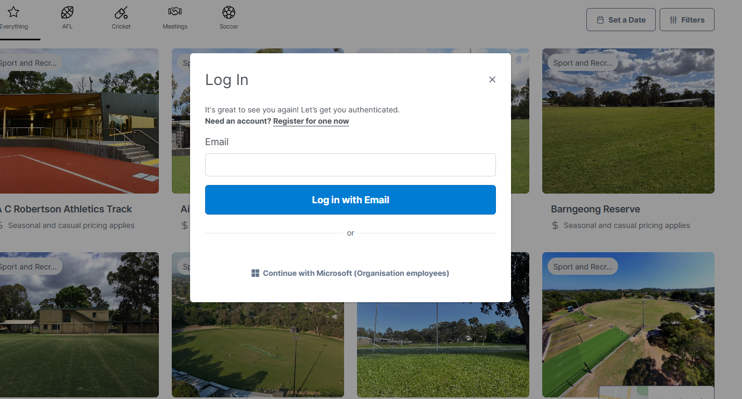

Once you have logged in it will show your name instead of the register button, as shown below.

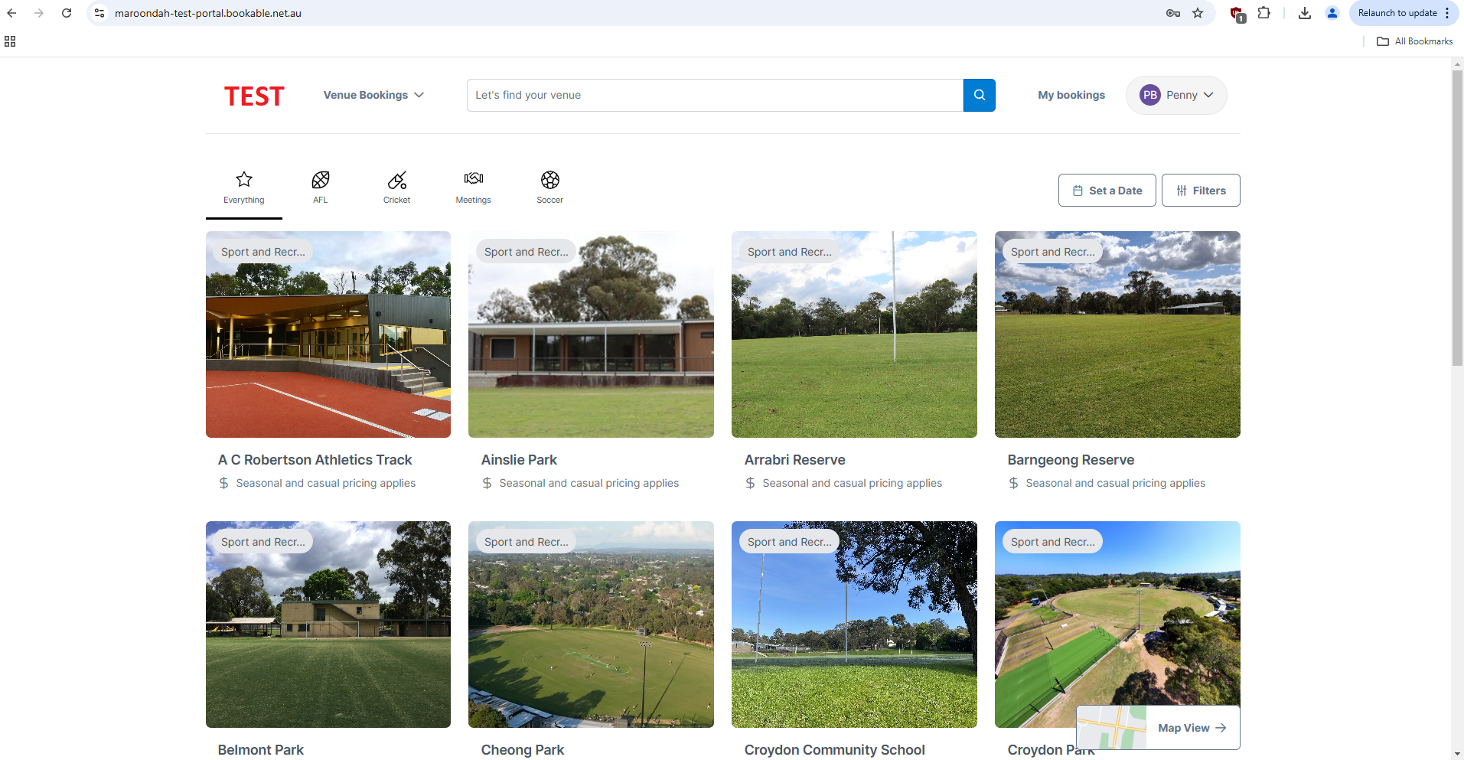

Click on the drop down arrow next to your name to see your account information including future bookings, past bookings and financial transactions.

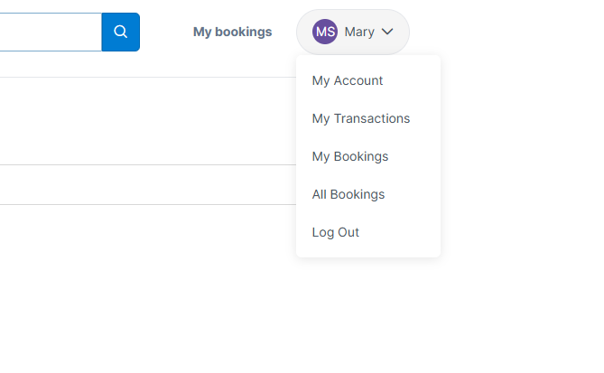

## Step 3: find a venue

There are multiple ways to find a venue:

* Use the search bar to find a venue by name.
* Click the sport icons to search venues that cater for each sport.
* Click ‘Set a Date’ or ‘Filter’ to search by available dates or venue facilities.

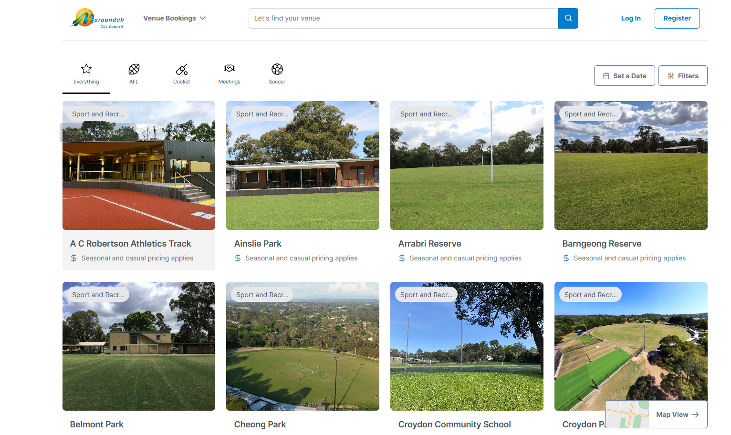

Click on the venue you want to book. You will be taken to the venue page.



The venue page displays all the facilities that are available to book at the venue. Select the date you want and, if available, click the green book button.

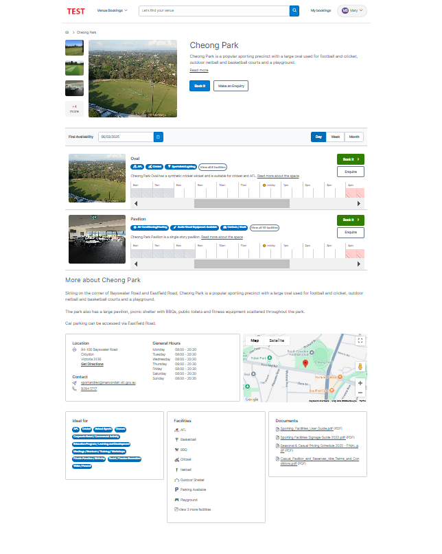

Shows here if the facility is available for booking.

Venue details and location.

Supporting documents and booking conditions.

Available facilities.

Select your booking date.

Step 4: Complete a booking  
You will be taken to the booking page to complete the casual booking details. Under Purpose of Booking select ‘Casual Use’.  
**For Maroondah Schools only** - there are two additional booking purposes for you to chose from:

* Select ‘Interschool Tournaments’ for single day use bookings between multiple schools.
* Select ‘Weekly Term Bookings’ for a recurring term booking. Skip to page 8 for instructions on weekly term bookings.

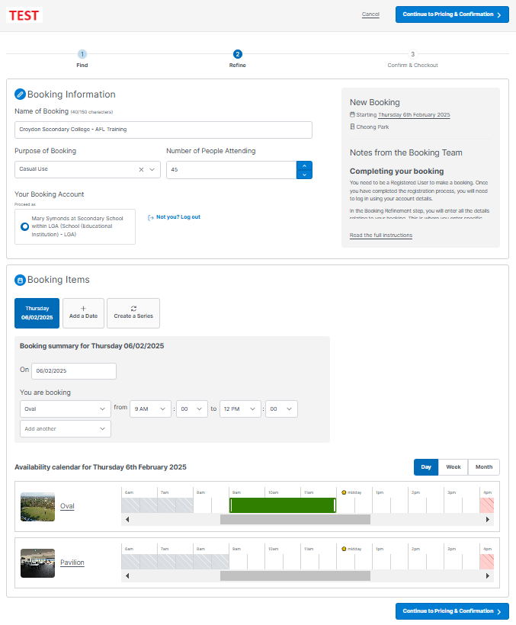

Add the name of the booking.

Select the relevant facility you want to book. Shown here is the oval or pavilion.

Once all details are entered and correct, click ‘Continue to Pricing and Confirmation’.

Select the start and end times of the booking.

Select ‘Casual Use’ in the purpose of booking.

Step 5: Confirm the booking  
You will be taken to the pricing and confirmation screen. You will see confirmation of what is being booked and the fee (depending on your organisations category) and will be required to upload your Public Liability insurance (minimum $20M required).

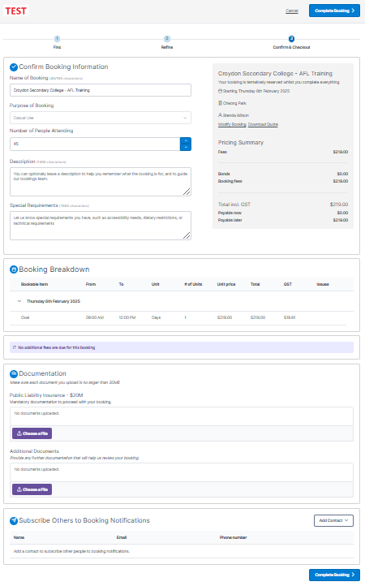

You will be required to upload your Public Liability insurance. Once uploaded, it will be saved for future bookings.

Once all details are correct click ‘Complete Booking.

Your organisation will receive an invoice for the booking fee seven days prior to your booking date.

Breakdown of your booking and fees.

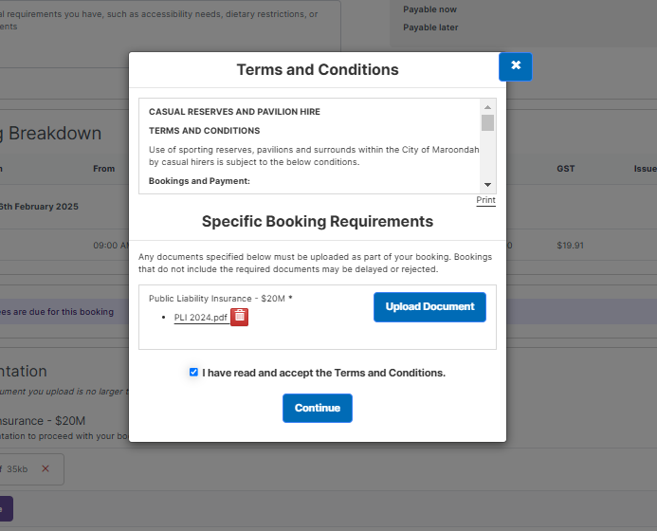

Read and accept the Terms and Conditions.

The booking is now complete and will be sent to the Sport & Recreation team for review.   
Note that the booking is not confirmed until approved by the Sport & Recreation team. Please allow 3 business days for the booking to be reviewed and approved.

You will receive an email stating the booking has been received and is tentative. Once approved you will receive an email with a booking confirmation and a copy of the booking Terms and Conditions.

Seven days prior to your booking date you will receive a booking reminder and invoice for the fees. Fees are payable within 14 days of invoice.

This booking will now sit within your current bookings and can be changed or cancelled up to seven days from the date of booking.

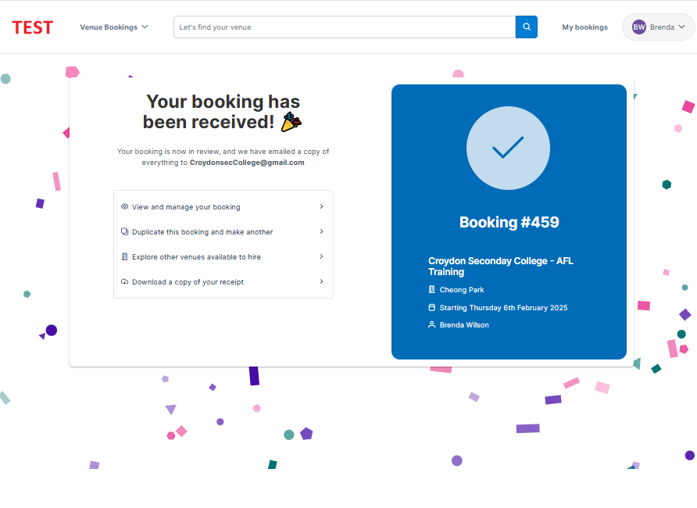

**For Maroondah Schools only** -   
  
Weekly Term Bookings - for bookings held weekly at the same time/day for the school term. Select ‘Weekly Term Booking’ in the Puporse of Booking section, then select ‘Create a Series’.

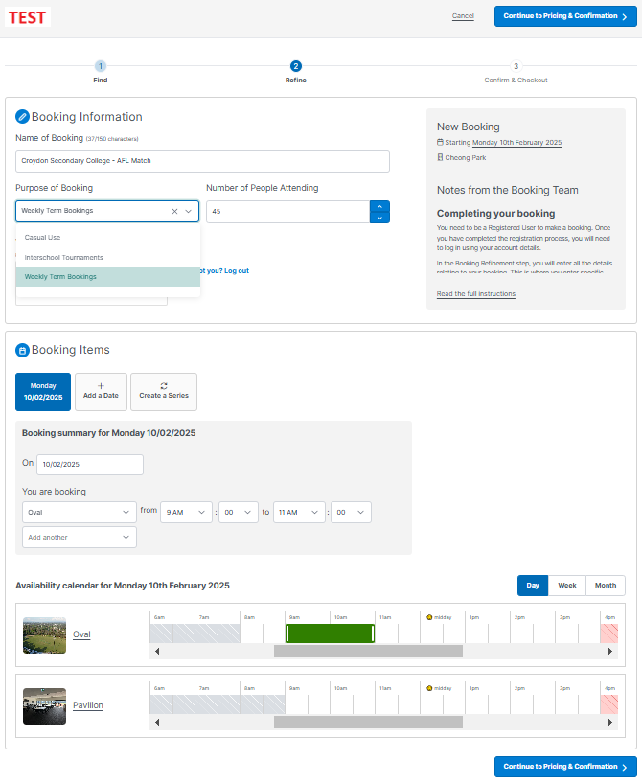

Select ‘Weekly Term Bookings’.

Click ‘Create a Series’.

The repeating series box will appear. Add your required day and times for the recurring booking.

Please note: The system requires you to book one recurring series per booking only. E.g., You can’t book a Monday and Wednesday together as a recurring booking. Each day needs to be booked as a separate booking, so the Monday recurring would be one booking, and the Wednesday recurring would be another booking.

Once complete click ‘Save’.

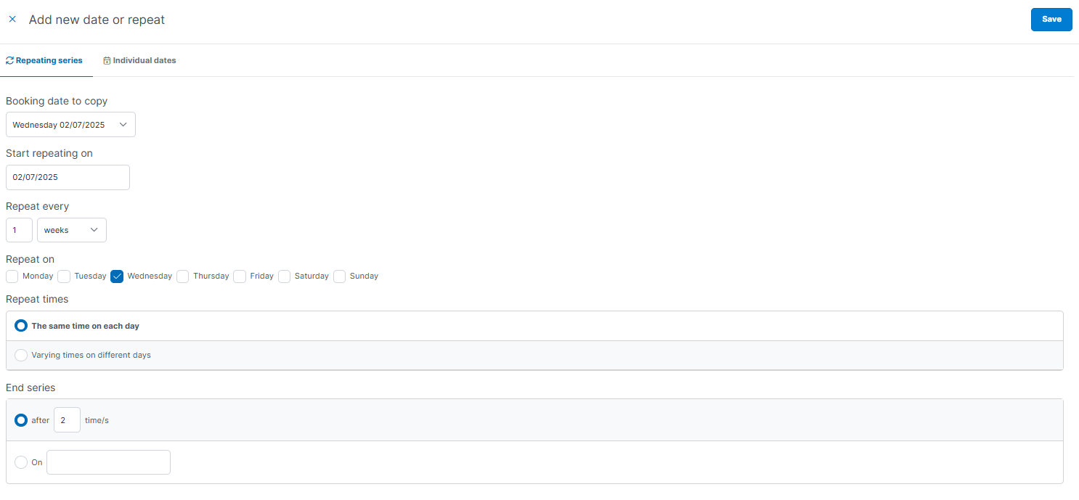

The system will confirm that the dates requested are available and list the dates in the booking series. Click ‘Continue to Pricing & Confirmation’.

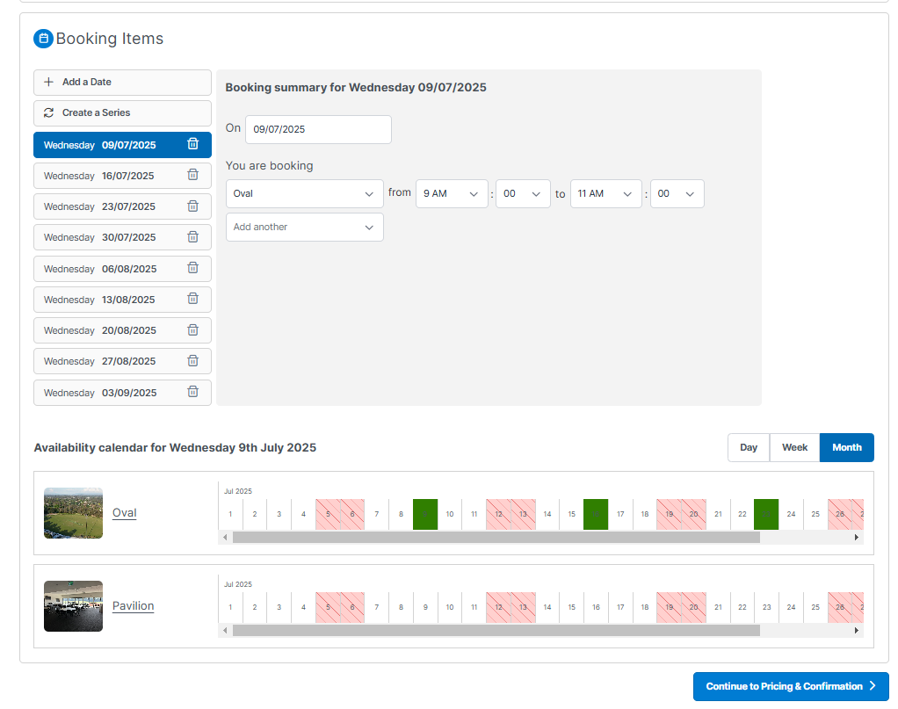

Return to step 5 on page 5 for instructions on completing the booking.

The dates to be booked are listed along with a breakdown of fees. Complete the remainder of the of the booking the same as a casual booking outlined previously.