**Exhibition Application Form 2025/26**

**MAROONDAH FEDERATION ESTATE GALLERY**

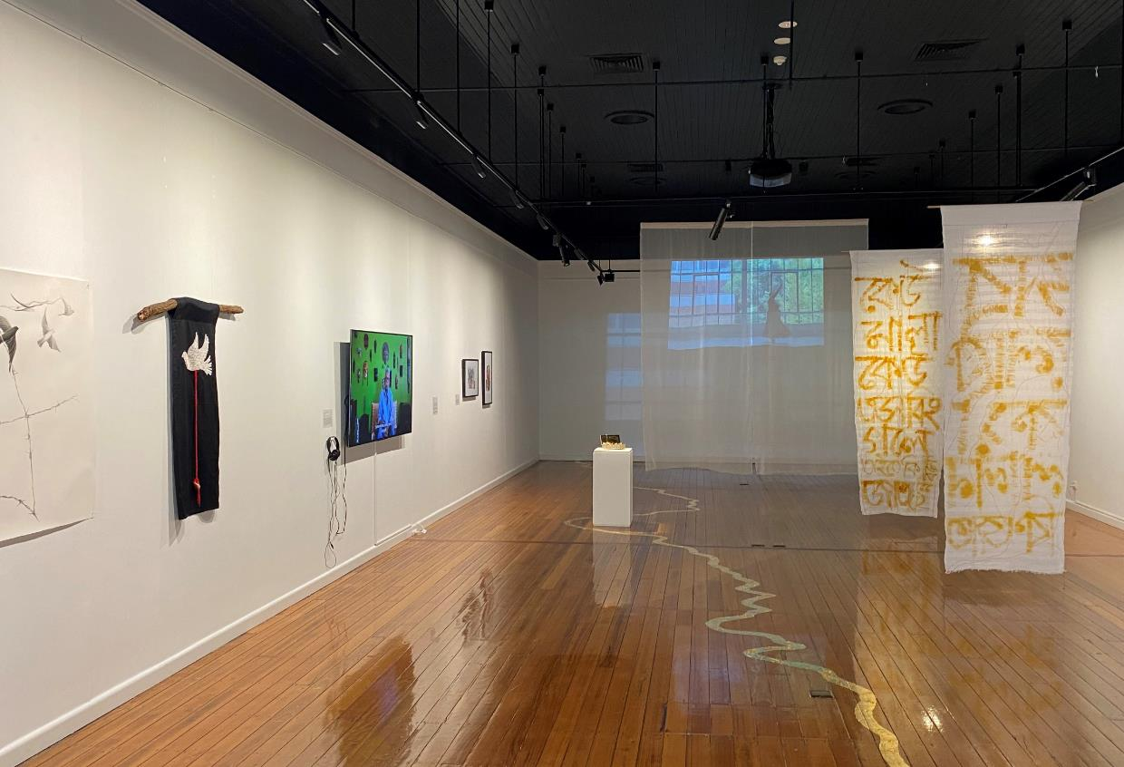

*Epar Opar*, Group Exhibition in Gallery 1 at MFEG, 2024



**ABOUT THE GALLERY**

Established in 2001, the Maroondah Federation Estate Gallery is owned and managed by [Maroondah City Council](http://www.maroondah.vic.gov.au/). The Gallery is an outstanding exhibitions venue with strong links to the local community and to Melbourne’s dynamic arts scene.

Maroondah Federation Estate Gallery (MFEG) is part of the City of Maroondah's network of arts sites and facilities within the Ringwood Arts Precinct. The gallery program encompasses a broad range of contemporary and traditional visual arts practice including painting, sculpture, ceramics, printmaking, drawing, photography, video, design, jewellery, installation as well as scope for performance and multi-media artworks.

The Gallery is situated prominently at the entrance of Maroondah Federation Estate, 32 Greenwood Avenue, Ringwood. Maroondah Federation Estate is a community and cultural facility within an attractive outdoor setting, with a wide range of user groups and visitors. There is car parking for visitors and signage marks the location clearly. The Gallery is easily accessible, including by wheelchair, and is close to public transport (Ringwood Station 650m). Admission to the Gallery is free.

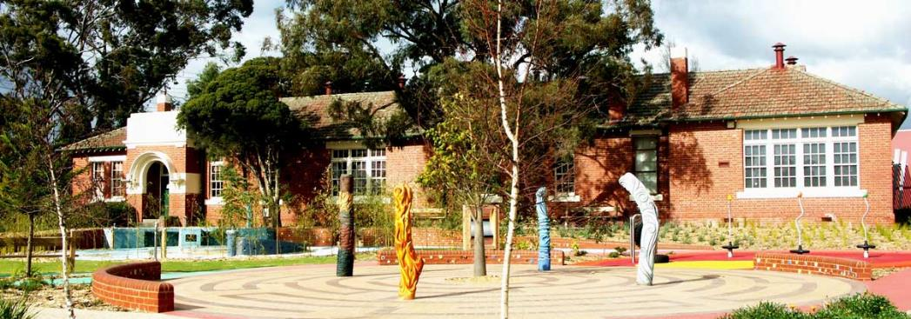

Exterior view, MFEG building, Playspace area designed by Robert Tickner

**GALLERY ADDRESS**

Maroondah Federation Estate

32 Greenwood Ave Ringwood VIC 3134

03 9298 4553

[maroondah.vic.gov.au/MFEG](http://www.maroondah.vic.gov.au/MFEG)

**GALLERY HOURS:**

Monday to Friday 9.00am – 5.00pm

Saturday 12.00noon – 4.00pm (when artist arranges to invigilate gallery)

Sundays and Public Holidays closed except by prior arrangement

**GALLERY STAFF**

Gareth Syvret, Curatorial Program Lead

Andrew Duong, Curatorial Program Officer

**EXHIBITION SELECTION PROCESS**MFEG makes an annual callout for Exhibition Proposals from artists, curators, collectives, groups and organisations wishing to stage exhibitions.

Priority is given to:

* Exhibitions that present a coherent body of work of high visual and conceptual quality to articulate a theme / idea / narrative
* Proposals that demonstrate understanding of local context or connection to local community
* Exhibitions that contribute to a diverse and inclusive annual program, giving representation to Aboriginal and Torres Strait Islander artists, LGBTQIA+ artists, artists with disabilities and achieving overall balance of gender equity, cultural and linguistic diversity and engaging a broad age range
* Work that is professionally presented to deliver a high standard exhibition
* Proposals that demonstrate strong audience engagement and public program plans

**SELECTION PANEL**

Proposals will be assessed according to the above criteria by a selection panel. Please be aware that MFEG receives a high number of applications and there are limited exhibition slots .

**EXHIBITION SUPPORT INCLUDES**

Gallery staff provide a range of supports and advice to the artist/exhibitor as follows:

* Advice and assistance with exhibition development and design
* Installation of the artworks by professional art technicians
* Advice regarding the artist/exhibitor’s planning and development of public programs and associated activities that complement and expand the potential audience for each exhibition/presentation
* Design and installation of exhibition signage including wall texts, labels or room sheet
* Use of the following equipment:
  + Audio-visual equipment including projection
  + Installation equipment
  + Sound system for the opening launch
  + Access to a variety of plinths and display cases

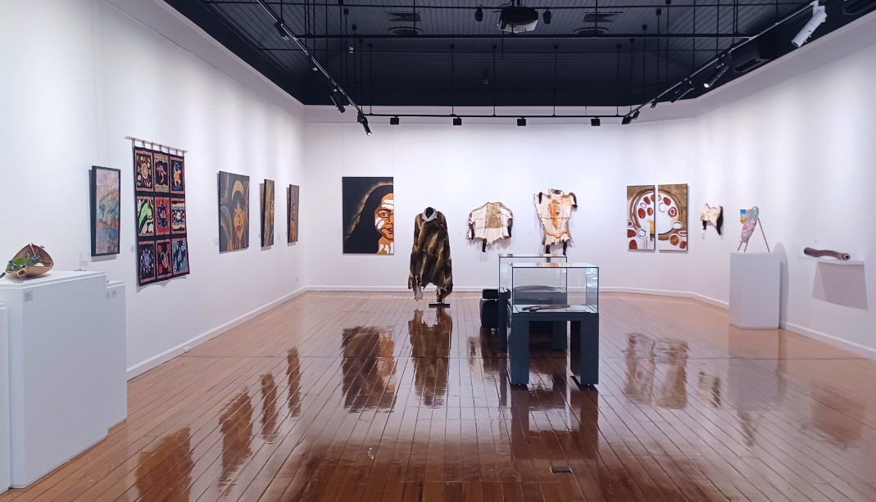

*The Artistic Magnitude of Mullum Mullum,*

group exhibition by Mullum Mullum Indigenous Gathering Place in Gallery 1 at MFEG, 2022

**MARKETING**

The Gallery will provide the artist/exhibitor with:

* Design of e-invitation and distribution through our extensive networks
* Listings in Art Guide Australia
* Advice on other marketing and promotions for the exhibition
* Inclusion of exhibition details on Council's website and the ‘artsinmaroondah’ facebook page and Instagram
* Artists/exhibitors are responsible for all costs associated with advertising or promotional activities not stated above
* In addition to the gallery support outlined above, artists/exhibitors are expected to actively promote their exhibition through their own networks and channels. All marketing and communications must include approved use of logos and acknowledgements as determined by Council and must be provided to Council for approval prior to distribution

**INSTALLATION**

In order to limit down-time between exhibitions, the Gallery requires that artists/exhibitors adhere to strict schedules for installing and dismantling exhibitions. Schedules will be discussed and agreed upon with the gallery staff who will roster professional art technicians to provide up to three (3) days of hands-on support across both gallery spaces for the installation of works.

**ARTIST/EXHIBITOR RESPONSIBILITIES**Artists/exhibitors are responsible for:

* Providing relevant information about the exhibition to Gallery staff for publicity purposes no later than three (3) months before the exhibition opening
* Providing digital images suitable for publicity and or reproduction purposes three (3) months prior to the exhibition
* Providing wall texts and artwork label information no later than four (4) weeks before the exhibition opening

**EXHIBITION SALES**

Work may be offered for sale by artist/exhibitor. Commission is not taken by the Gallery. All sales enquiries and sales made over the duration of the exhibition must be processed directly by the artist/exhibitor. Council will not be party to the negotiation or sale of artworks.

**CARE OF ARTWORKS**

Please note that whilst Maroondah Federation Estate is staffed and equipped with closed circuit surveillance, there is no direct invigilation of the Gallery space. Council holds Fine Arts insurance which covers the risk to artworks of physical loss, damage or fire. This insurance covers works of art on loan for exhibitions, insured for consignment value only.

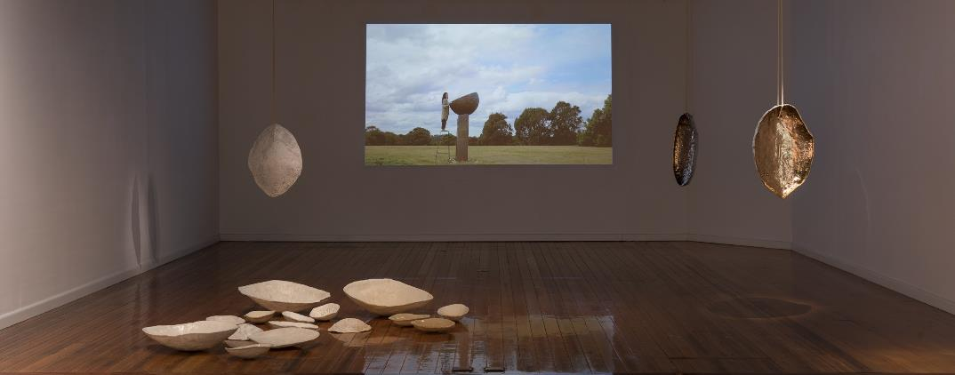

Katie Stackhouse, *Sound and Syncopation,* Exhibition in Gallery 1 at MFEG, 2023  
Photography by Andrew Curtis (detail)

**EXHIBITION OPENING**

All artists/exhibitors are required to hold an exhibition opening event. A small amount of catering service and non-alcoholic beverages will be provided. This may need to be suplemented by the artist/exhibitor. If desired, alcohol must be supplied by the artist/exhibitor. A certified RSA staff member is included to serve any alcoholic beverages if required.

**EXHIBITION PERIOD**

Exhibitions are open for approximately seven (7) weeks.

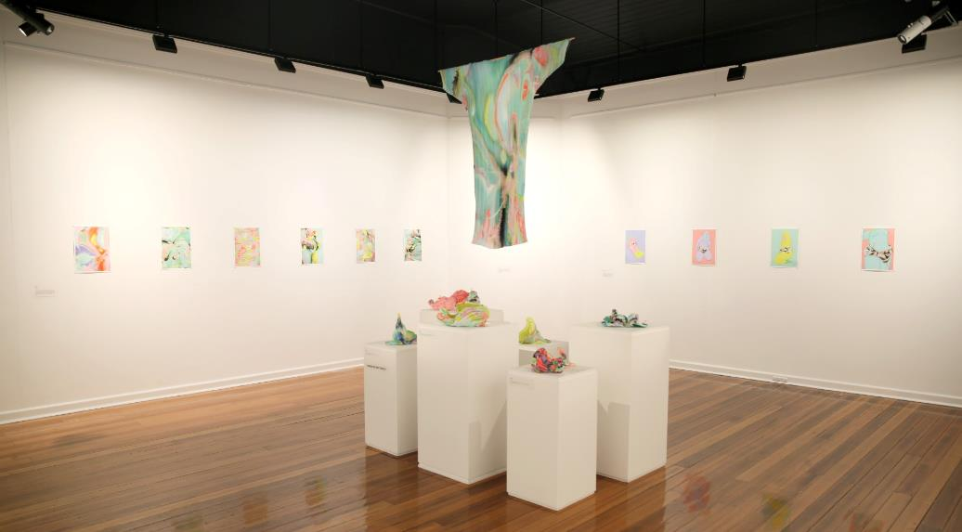

*In/Visible,* Persephone Thacker, Exhibition in Gallery 2 at MFEG, 2023

**EXHIBITION FEES**

There is no gallery hire charge to the artist/exhibitor for exhibiting at Maroondah Federation Estate Gallery. Any additional requirements over and above the benefits stated above are at the expense of the artist/exhibitor.

**QUESTIONS AND SUPPORT**

If you have any questions relating to this Application Form or require assistance completing the form, please contact the Gareth Syvret or Andrew Duong on 0417 915 347 or email:   
[gallery@maroondah.vic.gov.au](mailto:gallery@maroondah.vic.gov.au)

**GALLERY 1 FLOORPLAN**

(diagram not to scale)

7.2 metres x 16 metres or 115.2 metres square

Total = 38.8 running metres

Wall height = 3 metres

16.1m

1.8m

6.1m

Entry

Gallery 1

2.3m

1.5m

1.5m

5m

walkway 7.5m

1.5m

5.3m

1.5m

|  |
| --- |
| 4.5m |

Gallery 2

6m

1.1m

5.3m

**GALLERY 2 FLOORPLAN:**

(diagram not to scale)

7.2 metres x 8 metres or 57.6 metres square

Total = 25.5 running metres

Wall height = 3 metres

**Application Form**

# Please complete all sections of this form

# CONTACT DETAILS

Name (primary contact):

Names of all exhibiting artists:

Address:

Email:

Telephone:

**EXHIBITION DETAILS**Exhibition Title:

Preferred month for exhibition start (Between June 2025 to June 2026):

Note: Maroondah Federation Estate Gallery will be closed from 25 January to 30 April 2025 for building maintenance.

|  |
| --- |
| **Description of exhibition including media and theme / idea / premise / narrative etc. explored (300 words max):** |
| **Physical description of work and proposed installation. If more than one artist, please state how the works relate, and how they will be exhibited together** **(300 words max):** |
| **Please state how your proposal demonstrates understanding of local context or connection to local community (300 words max):** |
| **Please describe any associated activities, events, public programs or audience engagement initiatives, e.g. floor talk, lectures, workshop (300 words max):** |

**ARTWORK LIST**

|  |
| --- |
| **Please provide 6-10 high-res numbered jpeg images by email attachment or via web link (max file size 4mb each and max 10 images):** |

|  |
| --- |
| **Are these works part of the exhibition?**  Yes  No |

|  |  |  |  |  |  |
| --- | --- | --- | --- | --- | --- |
| No. | Artist’s Name | Title of Work | Year | Medium | Dimensions (cm) |
| 1 |  |  |  |  |  |
| 2 |  |  |  |  |  |
| 3 |  |  |  |  |  |
| 4 |  |  |  |  |  |
| 5 |  |  |  |  |  |
| 6 |  |  |  |  |  |
| 7 |  |  |  |  |  |
| 8 |  |  |  |  |  |
| 9 |  |  |  |  |  |
| 10 |  |  |  |  |  |

# FURTHER EXHIBITION/APPLICANT DETAILS:

1. Which gallery space(s) are you applying for (please refer to above gallery floor plans)?

Gallery 1

Gallery 2

Galleries 1 & 2 (entire space)

1. Is your body of work complete or in progress?

Complete

In progress

1. Is your proposed exhibition dependent on grant funding?

Yes

No

1. If you answered yes to question 3 above, please provide details of any grant funding, including whether funding has been secured or proposed, and dates when outcomes will be known:
2. Are you an artist/s living, working or studying in the City of Maroondah?

Yes

No

1. How did you find out about this opportunity?

|  |  |  |  |  |  |
| --- | --- | --- | --- | --- | --- |
| Facebook |  |  |  | Email |  |
| Instagram |  |  |  | ArtsHub |  |
| Maroondah Arts Collective |  |  |  | Art Almanac |  |
| Council website |  |  |  | Other: | |

1. Do you identify with any of the following groups or communities:

|  |  |  |  |  |  |
| --- | --- | --- | --- | --- | --- |
| Aboriginal and/or Torres Strait Islander |  |  |  | Living with a disability |  |
| LGBTQIA+ |  |  |  | Young person (15-25) |  |
| Culturally and Linguistically Diverse |  |  |  | Other: |  |
| Prefer not to say |  |  |  |  |  |

1. Additional comments

**SUBMITTING YOUR PROPOSAL**

Please return your completed application form, a current artist CV (for all artists included in the application) and sample images to:

[**gallery@maroondah.vic.gov.au**](mailto:gallery@maroondah.vic.gov.au)

Subject line - ‘2025/26 MFEG Proposal’

**OR hard copy by post to**

MFEG Exhibition Applications 2025/26

Maroondah Federation Estate Gallery

PO Box 156

Ringwood Vic 3134

**Applications close 5pm Tuesday 26th November 2024**

**CHECKLIST BEFORE SENDING**

Before sending please make sure you have included:

Application form

Artist(s)’ CV

Images

All applications will be acknowledged by email upon receipt. Applicants will be notified of the outcome of their proposal by mid-January 2025. A formal agreement/contract between successful artists/exhibitors and Council will be completed.