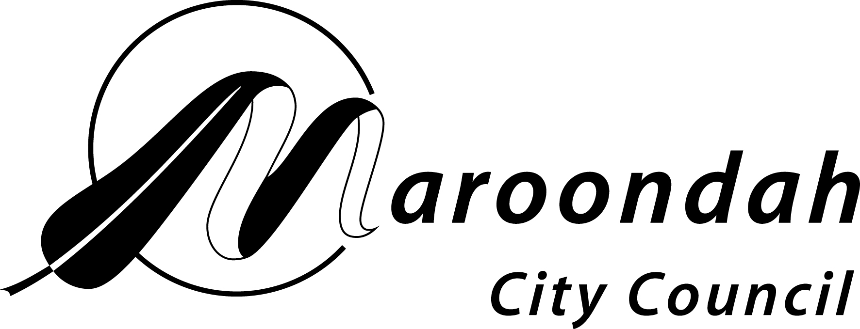
AUSTRALIA DAY AWARDS 2025

NOMINATION FORM

Young Citizen of the Year
Maroondah City Council is seeking nominations for the Young Citizen of the Year Award for an individual who has made an outstanding contribution to the community of Maroondah during 2024.

Nominees for the Young Citizen of the Year Award must be at least 16 years of age and under 26 years of age on the date the awards are presented (26/01/2025).

Details of person being nominated:
Surname:
First names:
Home address:
Email address: |  | Mobile no:
Telephone: | BH: | AH:
Occupation:
Date of birth:
Contribution/s to the community by the person that is being nominated:
Other significant contribution/s or achievements

Past and present membership of community/sporting/professional bodies etc.

Other relevant background information:
Other people that may be contacted for further information about the nominee:
Name: |  | Name:
Position: |  | Position:
Address: |  | Address:
Postcode: |  | Postcode:
Phone: |  | Phone:
Email: |  | Email:
To be completed by person submitting nomination:
Name:
Address:

Postcode:
Organisation represented (if any)
Phone:
Email:
Signature:
Return forms:
Completed forms must be returned by SUNDAY 1 SEPTEMBER 2024 to:
Councillor Support Officer
Maroondah City Council
PO Box 156
Ringwood. 3134

OR emailed to Councillor.support@maroondah.vic.gov.au

