Purpose
The purpose of this Complaints Policy is to outline how Maroondah City Council (Council) manages complaints.

Background / Context
The City of Maroondah is home to over 118,000 residents, 9,700 businesses and welcomes thousands of visitors into its municipality each day.

Maroondah has developed into a thriving metropolitan area, home to progressive educational facilities; world-class sporting and leisure facilities; green leafy open spaces; public transport hubs; arts and cultural centres; and a range of high quality commercial, industrial, community, and retail hubs.

Complaints are an opportunity for customers to tell us when their experience with Council has not met their expectations. We see complaints as customer dissatisfaction requiring a response and a resolution. The complaint may relate to a decision, service experience or behaviour of a Council employee and assist Council to enhance or improve services.

Anyone who has been affected by a decision or action (including a failure to make a decision or take action) can make a complaint directly to Council. Council’s complaint handling process can be initiated via telephone or various online service channels. We accept and respond to anonymous complaints, provided we have received enough information to do so.

Delivering the Maroondah Experience
Increasingly, customers expect local governments to provide services that use modern technology; to be convenient and accessible; and that customer service delivery matches the offerings of other private and government organisations.

Our previous service commitments have delivered a foundation that influences an exciting organisational customer service direction – one that is agile and evolves with changing times and customer expectations.
Achieving consistently high levels of customer service across the entire organisation has been an ongoing objective and this policy is a tool for all employees to achieve and deliver this standard into the future.

Connecting Council’s many services to a customer experience is essential and plays an important role in supporting Council’s brand and reputation.

There is an emphasis on highly responsive customer service across the whole organisation that matches Council’s world class facilities and services which continues to be a focal point across all Council service areas. The organisation continues to seek best customer service practice in all that it does.

Scope
This policy applies to all customers, employees, Councillors, contractors, agents and volunteers of Council.

This policy does not apply to decisions or processes once other legislative processes are in place or those that are bound by specific legislative procedure. Examples of these decisions or processes include, but are not limited to, the following:

- Complaints relating to a Council or Committee resolution
- Complaints relating to a planning application or decision
- Complaints relating to compliance infringements: parking, local law, animal management, health, planning or building
- Complaints relating to building, health and food services
- Complaints relating to a Councillor when not performing their role as a Councillor
- Complaints alleging fraud, corruption or other criminal behaviour
- Freedom of Information requests
- Work related grievances from a Council employee (i.e. complaints relating to their employment)
- Complaints already reviewed by an external agency.

Where a compliant is outside Council’s service responsibility, the complainant will be directed to the appropriate authority or service provider.

Objectives
This policy aims to:

- enhance an open and transparent complaint handling system
- specify the key performance indicators to which we will hold ourselves accountable
- establish our timeframes for resolving complaints
- clarify the roles and responsibilities of employees
- ensure staff handle complaints fairly and objectively
- set out how employees record and analyse complaint data to identify where we can improve our services.

Policy Principles
Council is committed to the following principles set out in the Victorian Ombudsman’s Councils and Complaints: A Good Practice Guide 2nd edition (July 2021) and the Local Government Act 2020, section 106- Service performance principles.

- Commitment
We are committed to resolving complaints and have a culture that recognises an individual’s right to complain. We value complaints and recognise them as being part of our business of serving our communities and improving service delivery.

- Accessibility
People with a range of needs can easily complain and employees actively assist them to navigate the complaints process.

- Transparency
We make it clear how to complain, where to complain and how the complaint will be handled. The steps taken to respond to a complaint are recorded and will stand up to scrutiny.

- Objectivity and fairness
Complaints are dealt with courteously, impartially, within established timeframes and are assessed on merit.

- Privacy
Complaint information is handled according to privacy laws and other relevant legislation. We provide clear information about how we handle personal information. Complaint data is de-identified if reported on more widely.

- Accountability
We are accountable internally and externally for our decision making and complaint handling performance. We provide explanations and reasons for decisions and ensure that our decisions are subject to appropriate review processes.

- Continuous improvement
Acting on, learning from and using complaint data helps us identify problems and improve services.

Relationship to the Maroondah 2040 Community Vision

Community Outcome: | A well governed and empowered community
Key Directions: | Provide enhanced governance that is transparent, accessible, inclusive and accountable  Foster a culture of innovation, cooperation, commitment, communication and continuous improvement that positions Maroondah City Council as a leader in local government  Work in partnership with key agencies and other levels of government to provide leadership in emergency preparedness, response and recovery processes

Alignment with Council’s mission and values
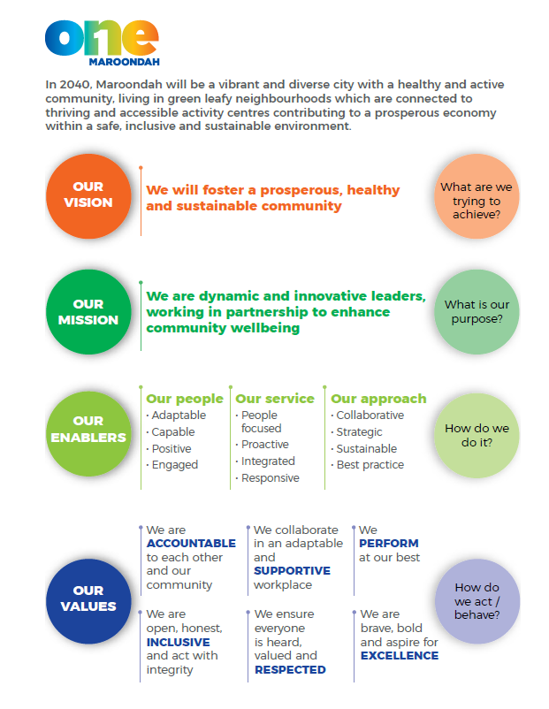

Roles and Responsibilities

Council Employees
Employees with access to Council’s Customer Request System are responsible for ensuring that the complaint is recorded accurately, flagged as a complaint and, if possible, resolved at first point of contact. If the complaint can’t be resolved at the first point of contact, the receiving officer will be responsible for recording details of the complaint.

Managers and Directors
Managers and Directors will escalate complaints that have not been resolved at the first or second contact within their team, along with providing any required oversight of the complaint’s management process.

Chief Executive Officer (CEO), Mayor and Councillors
All complainants who directly contact the Office of the Mayor or the Office of the CEO will be forwarded to a Director to investigate and provide a resolution back to the complainant via the most appropriate level of management. These complaints are also to be recorded as part of Council’s Customer Request System.

Related Legislation
- Local Government Act 2020
- Charter of Human Rights and Responsibilities Act 2006
- Freedom of Information Act 1982
- Independent Broad-based Anti-Corruption Commission Act 2011
- Privacy and Data Protection Act 2014
- Public Interest Disclosure Act 2012

Related Policies, Strategies, Procedures and Guidelines
- Maroondah 2040
- Council Plan 2021-2025
- Customer Service Strategy 2021-2025
- Guide to Service Standards and Complaint Handling
- Good Practice Guide to Dealing with Challenging Behaviour, Victorian Ombudsman, May 2018
- Complaints: Good Practice Guide for Public Sector Agencies, Victorian Ombudsman, September 2016
- Councils and complaints - A good practice guide 2nd edition, Victorian Ombudsman, July 2021
- Employee Code of Conduct HR06-06.

‘Complaint’ Compared to a ‘Service Request’
- requesting something additional or new (a service request)
- reporting what they believe to be a failing or a shortfall (a complaint)
- complaining about a Council’s response to a service request (a complaint)

The table below provides some context of a complaint compared to a service request.
Complaint/ Service request examples
Complaint | Service request
My bin was out but wasn’t collected this morning. Can you pick it up?  (complaining that Council did not provide a service) | I forgot to put my bin out, can someone collect it?  (requesting a service because of their own mistake)
Council’s investigation into noise from a business wasn’t rigorous and didn’t look at peak times. More investigation is needed. | My neighbour’s business is very noisy. Can you make it stop?
A pothole I reported to Council two months ago hasn’t been fixed and is getting worse. | Could Council fill in a pothole in my street?
You haven’t sent my rates notice. | Can you tell me when my next rates payment is due?

Submitting a Complaint

All complaints received will be entered into the Customer Request System as a request, or if this is not available, they can be forwarded via email to maroondah@maroondah.vic.gov.au. All anonymous complaints received will be treated in the same way as identified complaints.
All reasonable effort will be made to assist complainants with specific needs. This may include providing an interpreter or translator, ensuring customers can be represented by an advocate of their choice, and providing straightforward and easy to read information in plain language

A Council employee will acknowledge the complaint within 10 business days and will endeavour to resolve the complaint at the earliest opportunity or at most within one month. Where the matter is more complex this time may be extended. The complainant will be kept informed throughout the process.
Complaints addressed to the CEO and/or Councillors, will be forwarded to the relevant department
for investigation and response and managed in accordance with this policy.
Council has many channels by which a complaint can be received, including:
- telephone
- face-to-face
- email
- online forms
- downloadable forms on our website
- live chat
- written letter
- social media.

Translating or interpretation service accessibility
Council officers will ensure that access to the TIS interpreting services will be made available. The TIS National's interpreting service can be contacted on 13 14 50.

Complaint handling and escalation
The escalation process of handling a complaint consists of four levels and is as follows:

Levels | Action
1 | The service area involved will manage your request. The review must be independent of:  - The person who took the action; and/or  - The person who made the decision; and/or  - The person who provided the service.  If you are dissatisfied with the outcome, you can request for further consideration or referral to level 2.  Escalation to level 2 must detail:  - why the complainant felt that the complaint was not appropriately managed; and/or  - to which Council policies were not adhered
2 | The Customer Service Coordinator will raise the request with the service area concerned on your behalf. You will then receive notice of the outcome. If you are dissatisfied with the outcome you can request referral to Level 3.
3 | The Director of the relevant service area will review the complaint and provide a response in no more than 10 days. If you are dissatisfied with the outcome you can request referral to Level 4.
4 | The Chief Executive Officer will review the complaint and make a final decision.
Right of Appeal | Complainants can contact the Victorian Ombudsman at any stage for further advice and information.

Complaints regarding a Councillor
Complaints regarding Councillor(s) will be referred to the Mayor. If the complaint is about the Mayor, the complaint will be referred to the Chief Executive Officer. In each instance, the Councillor(s) who are the subject of the complaint will be notified by the Mayor or Chief Executive Officer after the complaint details have been established.

The complaint will be recorded in writing and all interactions with the complainant will be documented.

Complaints lodged via Councillors
When a complaint is addressed to a Councillor from a member of the public, the information is forwarded to the Councillor Support Officer to ensure the complaint is officially recorded. The Councillor Support Officer will record the complaint in Council’s Corporate Management System and action the complaint to the appropriate Director for investigation.

Councillors are not responsible for the response to any operational complaint. Councillors must ensure that complaints and issues directed to an employee for response are clear and contain enough information for the complaint/issue to be addressed.

Inappropriate complaints or behavior by Complainant
Unreasonable complainant conduct is any behaviour by a current or former complainant which because of its nature or frequency raises substantial health, safety, resource or equity issues for:
- Council
- Councillors
- Council employees
- contractors, agents or volunteers, and/or » other service users.

Unreasonable complainant conduct can be divided into five categories of conduct:
- unreasonable persistence
- unreasonable demands
- unreasonable lack of cooperation
- unreasonable arguments, and
- unreasonable behaviours.

Some types of behaviour are never acceptable and can include:
- verbal abuse
- offensive behaviour
- threats
- violence.

Council requires all employees to be respectful and responsive in all their communications with members of the public and expect the same when members of the public are communicating to Council employees.
Council may change the way communication is provided if behaviours or conduct is deemed to raise health, safety, resource or equity issues for Council employees involved in the complaints process. This will be communicated clearly with the complainant including the reasons why and the methods of communication.

Statutory Review
Council has the discretion to refuse to deal with a complaint that is otherwise subject to a statutory review. Council may determine that a complaint is more appropriately dealt with via a Statutory Review process where one exists. This may arise in circumstances where a matter is complex in nature or when a decision has already been made by Council or via delegation. In some instances, certain legislation will not allow Council to deal with a complaint if it is being dealt with via another external review process.

This could mean complaints where there is a review or appeal to a tribunal, i.e. Victorian Civil and Administrative Tribunal (VCAT) or a court, under an Act or regulation. Complaints of this type usually concern a particular subject matter, such as, infringements, planning or public health.

Privacy
When a complainant considers there has been a breach of privacy by the Council, a complaint is made via Council’s Privacy Officer. Refer to Council’s Privacy Policy for the handling process for complaints regarding breach of privacy.

Council respects individual’s privacy and is committed to protecting the personal and health information that is provided by individuals under the Privacy and Data Protection Act 2014, the Health Records Act 2001 and other applicable legislation.

Any personal or health information collected will only be used for the primary purpose for which it was collected, or for a permitted secondary purpose as stated under the Privacy and Data Protection Act 2014. If Council is required to collect personal or health information, it will only be collected by lawful and fair means and not in an unreasonably intrusive way.

Other Avenues for Complaints
If a complainant is not satisfied with the process or outcome of the internal review, they have the right to take their complaint to an external agency. There are several organisations that can consider matters relating to Victorian councils. Each of these organisations have specific roles and limitations.

Local Government Inspectorate
The Inspectorate accepts complaints about Council operations and potential breaches of the Local Government Act, including:
- misuse of position
- conflict of interest
- disclosure of confidential information
- electoral offences.

Victorian Ombudsman
The ombudsman can take complaints about the actions and decisions of Councils, including complaints about:
- services
- communication
- complaint handling
- compliance with policies, procedures or law
- other actions or decisions which may be unreasonable.

Independent Broad-based Anti-Corruption Commission (IBAC)
IBAC accepts complaints about suspected corruption and misconduct in the public sector and Victoria Police, including:
- taking and offering bribes
- using a position of influence dishonestly
- committing fraud or theft
- misusing information from the work place.

Other Agencies
Occasionally Council will receive a complaint involving neighbours which in many instances cannot be resolved by Council. On these occasions Council may direct complainants to other resources including:
- Dispute Settlement Centre of Victoria
- The Law Handbook

Equal Opportunity and Human Rights Commission
The Victorian Equal Opportunity and Human Rights Commission is a statutory body that promotes equality of opportunity in Victoria, educates people about their rights and responsibilities under equal opportunity laws, and provides free and impartial dispute resolution services for people with disputes.

Definitions
Complaint: an expression of dissatisfaction with the quality of an action taken, policy or decision made, or service provided by an agency or its contractor, or a delay or failure in providing a service, taking an action, or making a decision by an agency or its contractor.

Complainant/customer: A person or group that utilises the services of the Council and/or makes a compliment, request for service or complaint.

Employees: all employees, including contractors, agents and volunteers authorised by Maroondah City Council.

Compliment: An expression of praise for employees, processes or services provided and the experience of the interaction.

Unreasonable complainant conduct: Unreasonable complainant conduct is any behaviour by a current or former complainant which because of its nature or frequency raises substantial health, safety, resource or equity issues for Council, its employees and associated parties.

